***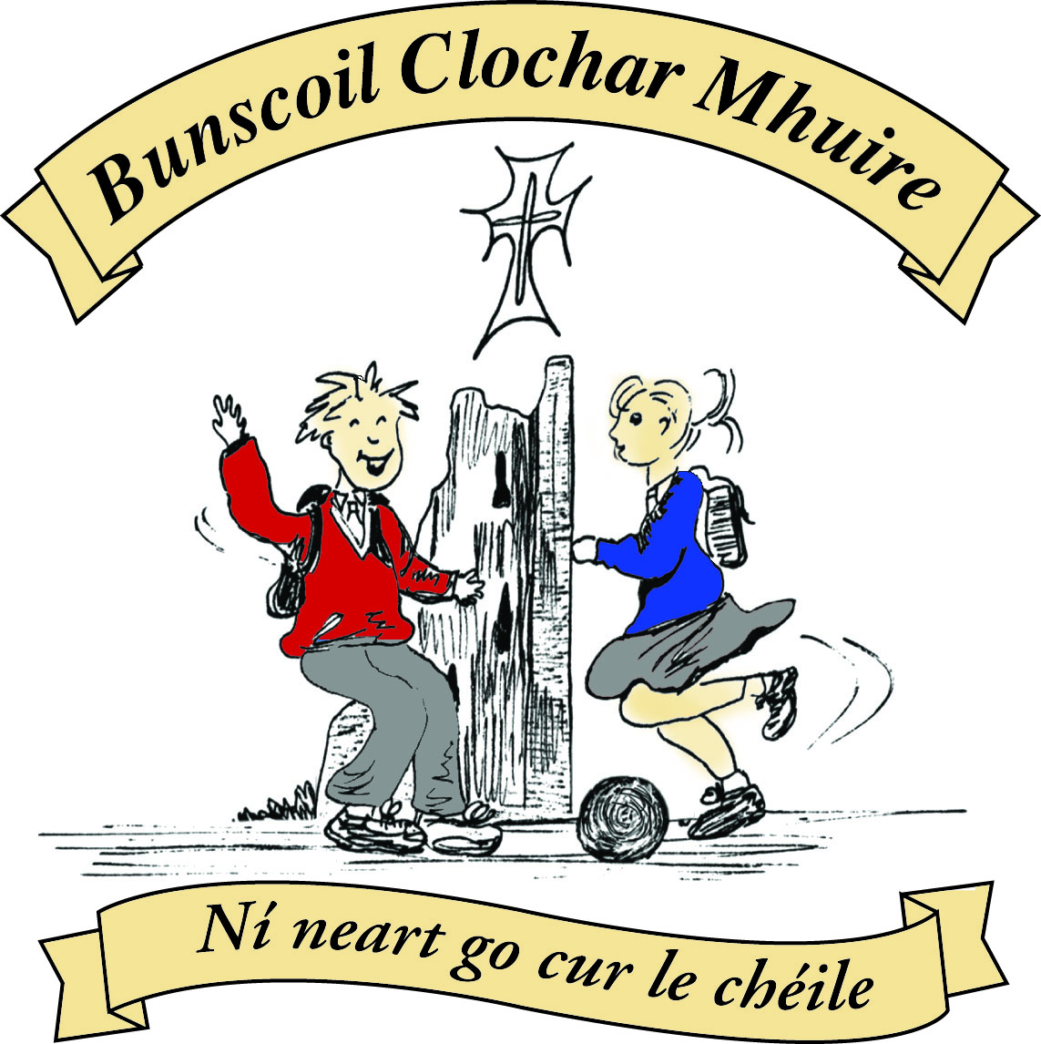* St Mary’s Convent Primary School**

***Bunscoil Clochar Mhuire***

***Trim, Co. Meath.  
Fón: (046) 9431919 ⦁ Faics: (046) 9437942  
Ríomhphost:*** [***marystrim@eircom.net***](mailto:marystrim@eircom.net) ***⦁ Website:*** [***www.stmarystrim.ie***](http://www.stmarystrim.ie) ***Uimhir Rolla: 16646O***

Awarded Green Flag  
June ‘05/’07/11/13

***Imlitir 17***

10th January, 2017

A chairde,

*Athbhliain faoi shean is faoi mhaise do gach duine.* (Happy New Year to all.)

Thanks also for all the support for our Nativity Plays and Pageant. A total of €1,473 was raised for the local **St Vincent De Paul** and **Trim Meals on Wheels.**

Pupils are requested to go directly to the playground in the mornings and not to line up outside their classrooms. School starts at 9.20 a.m. and pupils need to be in the playground by this time. When the teachers arrive out to collect the lines please stand well back and allow pupils access and right of way at all times. May I stress that parents/guardians do not drive through the staff car park at any time, as this endangers the safety of our pupils.

Our Annual **Open Day** will be on Thursday January 19th 11:00- 12:30. All prospective and existing parents/ guardians are welcome to visit and see our school in action. Just come to the Dr Reilly Hall @ 11:00am.

For safety reasons no rollerblading or cycling is permitted within the school grounds. Pupils who come to school on bikes/roller blades etc. are asked to walk to and from the school yard.

**Registration Forms** for children starting school in September 2017 are now available from Helen, in the office. Please note that the date for return of forms is Friday 27th January. The first round of place offers will be posted on Friday 3rd February. Please note that, by agreement of the local school, theses dates are earlier this year to facilitate applications by the schools for special education supports.

*St. Mary's Parents Association will hold their next meeting on Wednesday 18th of January at 8pm in the school staff room. All parents/guardians of children attending the school are invited to attend. We look forward to seeing you there,*

*Caroline Smith, Secretary*.

Finally, we are still looking for volunteers for our fundraising venture: OSKARS. If you can act or would like to be trained to do so and take part in the production of a movie scene, please contact the school. If you can help out on the fundraising committee or can secure some adverts/sponsorship for us, please let us know. Thanks.

Mise le meas,



Cóilín Ó Coigligh, Príomh Oide.

**Community News**

**Nathanna na Seachtaine:** Athbhliain faoi mhaise duit! Happy New Year

**Seanfhocal na Míosa:** Ní hé lá na báistí lá na bpáistí

**Dates to Remember**

**Assembly: Whole School Assembly Friday @ 9.20am**

**Banna Ceoil:** Restarting Tuesday 17th Jan 3.00 – 4.00pm

**Meitheal:** Every Tuesday morning 9.30-10.30.

**Badminton:** Mondays 3-4pm for 3rd & 4th Classes. No Fee.

**Communion:**  Sat May 13th @ 11.00

**Confirmation:**  Sat 11th March

**Community Notices**

**Go Bounce bouncy castle hire**. Based in Trim, fully insured and safety certified. Check out our Facebook page [www.Facebook.com/gobouncemeath](http://www.facebook.com/gobouncemeath), website [www.gobounce.ie](http://www.gobounce.ie), contact us on 086-8398099 or email [enquiries@gobounce.ie](mailto:enquiries@gobounce.is)

**Mini Me Yoga Classes with Nat.** New term starting Wed 11th Jan – Wed 15th Feb. 6 weeks at €42 or pay as you go at €8. 2pm – 2.45pm Jun & Sen Infants. 3pm – 3.45pm 1st Class upwards. Collection available from School. Call 087-6202199 for more details.