***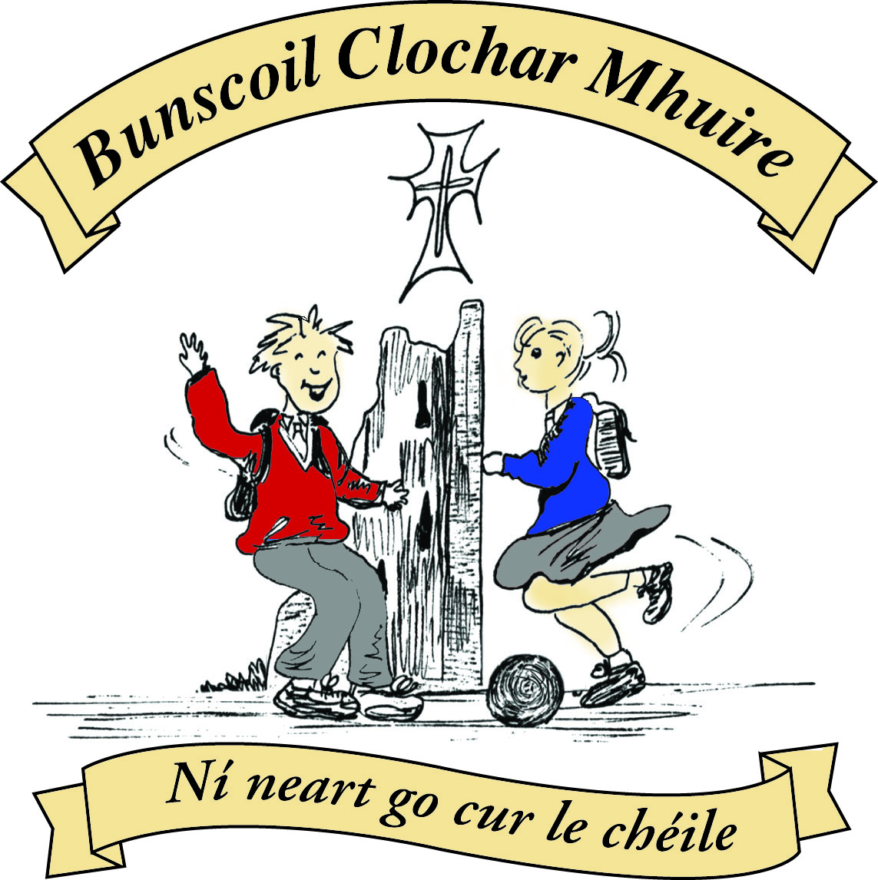* St Mary’s Convent Primary School**

***Bunscoil Clochar Mhuire***

***Trim, Co. Meath.  
Fón: (046) 9431919 ⦁ Faics: (046) 9437942  
Ríomhphost:*** [***marystrim@eircom.net***](mailto:marystrim@eircom.net) ***⦁ Website:*** [***www.stmarystrim.ie***](http://www.stmarystrim.ie) ***Uimhir Rolla: 16646O***

Awarded Green Flag  
June ‘05/’07/11/13

Imlitir 16

19th December, 2016.

A chairde,

I would like to take this opportunity to wish you all a very Happy Christmas and Joyous New Year.

**Szczeslimych Swiat**



**Maligayang pasko**

**ക്രിസ്തുമസ് ആശംസകള്‍**



**Nollaig Shona**

**کرسمَس مبارک**

**Счастливого рождества**

**Linksmu Kaliedu**

***Please note that School closes for the Christmas Holidays on Thursday December 22nd @ 12.30 p.m. and re-opens on Monday 9th January 2016 @ 9.20 a.m.***

***Every Day Counts at St Mary’s Convent Primary School***

***12th Dec – 16th December 2016***

|  |  |  |  |  |  |  |  |
| --- | --- | --- | --- | --- | --- | --- | --- |
| **Room** | **Attendance** | **Room** | **Attendance** | **Room** | **Attendance** | **Room** | **Attendance** |
| 01 | 97% | 08 | 95% | 16 | 88.9% | 26 | 92% |
| 02 | 89.2% | 09 | 96.1% | 17 | 90.7% | 27 | 99.2% |
| 03 | 95.7% | 10 | 95.6% | 18 | 95.8% | 30 | 96.9% |
| 04 | 86.7% | 12 | 94.5% | 19 | 92.9% | 31 | 92.9% |
| 05 | 94.6% | 13 | 94.7% | 20 | 93.6% |  |  |
| 06 | 93.6% | 14 | 97.9% | 23&24 | 90% |  |  |
| 07 | 96% | 15 | 96.4% |  |  |  |  |

*Well done to Rooms 27 on nearly having full attendance last week.* *Please note that notification in writing to the teacher is required for all absences. A letter or note in the homework journal will suffice.*

Congratulations to Room 18 for having the best termly attendance (Senior Classes) and Room 13 (Junior Classes) this term and to Rooms 12,14, 15 & 26 who were next best. They have earned a homework pass for the week that they come back in January. The class decide which day that week. A total of 137 individual pupils have had perfect attendance since September which is excellent. Well done to all for their efforts. Certs will be presented to them by their class teachers tomorrow. There will be another attendance assembly before the Easter and Summer Holidays and we hope that there will still be a large number with perfect attendance by the end of the year.

*On behalf of the Parent's Association we'd like to say a huge "THANK YOU" to everyone who supported our bunsale last Friday. A total of €1,057.00 was raised! This will now go directly to the School Sport's Fund to purchase some much needed equipment. Happy Christmas to you & all the best for 2017  
 Sarah Madden - Treasurer*

**Christmas Pageant Ticket Sales:** There are plenty of tickets left for our 1.00 performance but only 23 left for the 6.00. To avoid “six o’ clock disappointment” please purchase your tickets in advance. Thanks.

Many thanks to our Parents’ Association who have contributed €1,057.00 to our Sports Fund. This will be spent on Sports and P.E. equipment and we will let you know as it happens.

***Santa Dash***

*Thursday 22nd December, Junior Infants 🡪First Classes @ 10.00*

SANTA014

*Senior Classes 10.30 a.m.*

*All pupils must wear school tracksuit along with Santa Hat/Christmas themed*

*Jumper with runners. Parents/guardians are welcome to come and watch and*

*get into the festive spirit. One condition you need to wear a Santa Hat or*

*Christmas themed jumper. Wishing you a Merry Christmas.*

*Ms Elaine Maguire and Ms Eimear Murray.*

**Enrolment Forms** for September 2017 are now available from Helen in the office.

I hope everybody has a great “Santa Dash” on Thursday @ 10.00am. Let’s hope the weather holds or we will end up “Dashing Through the Rain!”

Finally, we are looking for volunteers to take part in **Oskars**, our Fundraising event which takes place next year. Volunteers will be trained by a qualified drama coach and will be filmed in a scene from famous movies. They get to dress up and go to an Awards Evening in Knightsbrook Hotel where the following awards will be made:

Best Supporting Actress

Best Supporting Actor

Best Actor

Best Actress

Highest grossing Movie.

Best Movie

Please contact us if you are interested in finding our more.

Like “Strictly St Marys” last year, we are again looking for Gold, Silver and Bronze Sponsors as well as adverts. Please contact us for further details, if you or a company you are connected with, can be of assistance.

***Nollaig faoi shéan agus ath-bhlian faoi mhaise daoibh go léir.***

Mise le meas,



Cóilín Ó Coigligh, Príomh Oide

**Community Notices**

**Green News**

***Nath na Seachtaine*** NollaigShona Duit agus Athbhliain faoi mhaise duit!

Merry Christmas and a Happy New Year

Seanfhocal na Míosa: Mol an Óige agus tiocfaidh sí

Praise the youth and they will blossom

**Dates to Remember**

**Santa Dash: Thursday @ 10.00am**

**Meitheal:** Every Tuesday morning 9.30-10.30.

**Communion:**  Sat May 13th @ 11.00

**Confirmation:**  Sat 11th March

**Green News**



# As we approach the Big Day, we would like to wish all our green friends a very Happy Christmas and a very Green New Year! 2016 has been another successful year. We have completed over half of our Global Citizenship theme and have continued to reduce, reuse and recycle at school. Global Citizenship nurtures personal respect and respect for others, wherever they live. It encourages us to think deeply about what is equitable and just and to minimize harm to our planet. Thank you all for your continued support with matters green in the school. Previous generations didn’t need to be trained or instructed in recycling and reusing as they had fewer possessions and were mindful of not wasting anything. Sadly, being green has to be taught nowadays but we can safely say that here at St Marys, our staff, pupils and parents are aware of how important it is not to waste things that can be reused in other ways. Respecting our environment and having gratitude for the natural resources we have in our country is built in to our curriculum here at St Mary’s. It is not just a school subject, it is a lesson for life.

Please remember to recycle your used Christmas cards here at school and any postage stamps that come on the envelopes. Leave a little paper surrounding the stamp. We have charities which will benefit from these recycled items.

Our WOW (Walk on Wednesdays) initiative is going really well thanks to the teachers who keep it going every week and the COW (Cycle on Wednesday) will continue in the spring.

Our Siopa Glas which was so generously supported by you all generated funds to help a local charity as well as a special Needs School in Zambia.

Have a very happy, peaceful and green Christmas.

***Remember Green is cool at home, at school and around the globe!***

**Community Notices**

**ZUMBA &  ZUMBA KIDS** classes are finished for 2016.  Big thanks to all the mammies & smallies that have come to class over the past year and supported the various fund-raising events we have run.  Wishing you all a lovely Christmas and looking forward to dancing with you in the new year.  Lorraine *;) winking

**Basketball** at St Mary’s School. Boys (8-12) every Tuesday from 4-5pm. Girls (8-12) every Wednesday 4-5pm. Limited Spaces Contact [etcprojectsie@gmail.com](mailto:etcprojectsie@gmail.com) or 087-9134334.

**School Cleaner** required to cover sick days. Contact Helen in the office for further information 046-9431919.

**AFTER SCHOOL CLUB**

Taking place in St. Mary's School Trim from 2-3pm Only €5 a day or €20 for 5 days Mon-Fri

Application forms available in room 6 2-3pm or reception. Booking required at least a day in advance to insure space, and rebooking and payment made the previous Thursday.

Kids will be entertained with Lego, Art & Craft, Board games, quizzes, card games, puzzles and lots more fun activities!  Run by an experienced Childcare Professional Parent who is fully Garda Vetted and Insured.

Contact Julie O'Donohue to book your child's space by texting 0868505310, emailing [juliekerins@hotmail.com](mailto:juliekerins@hotmail.com) or via a PM on our Facebook page: [www.facebook.com/TrimAfterSchoolClub](http://www.facebook.com/TrimAfterSchoolClub)

**Trim Parent, Baby & Toddler Group**

Running Monday and Wednesdays during school term 9.45-11.45am upstairs in Trim GAA

Only €4 per family

Fun toys, colouring in, play doh, tea, coffee, juice and biscuits with a little sing along at the end.

All welcome......first time parents, grandparents, child minders.....anyone looking to get out and keep the little ones entertained while you can chat and enjoy a cuppa too!