***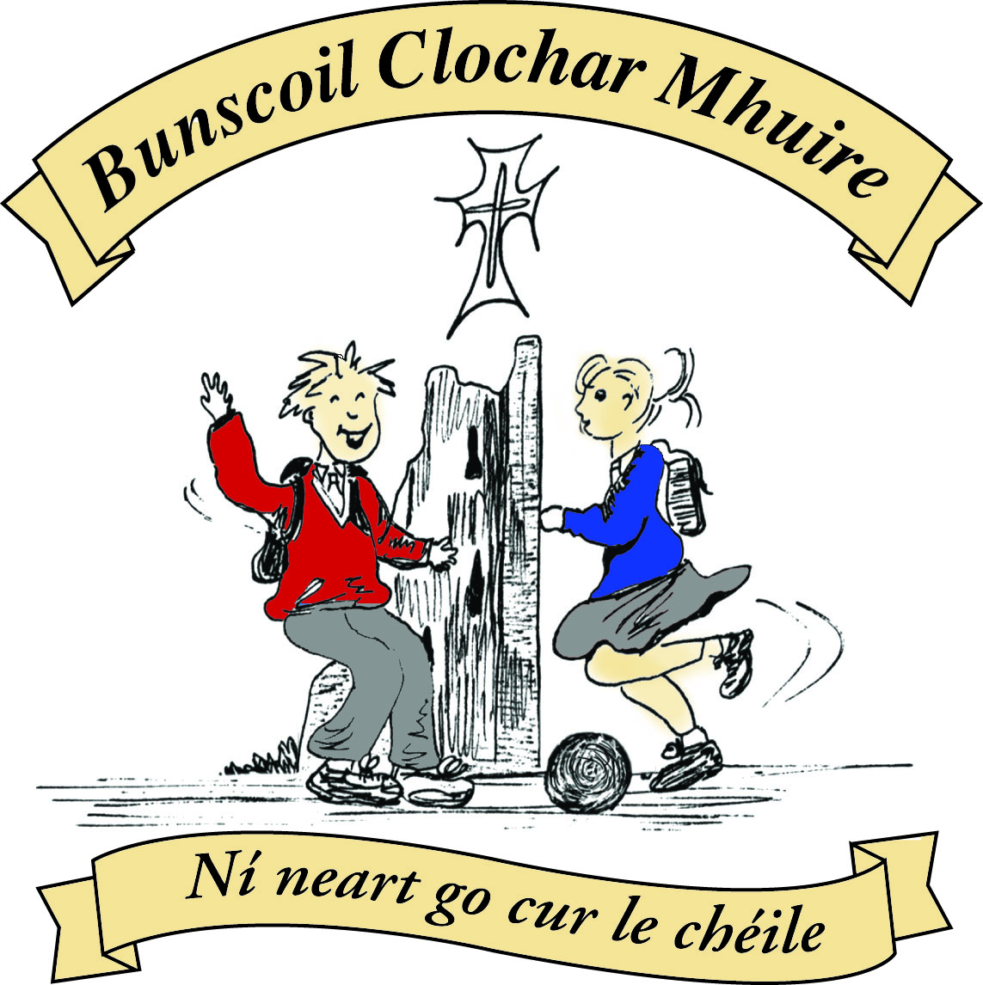* St Mary’s Convent Primary School**

***Bunscoil Clochar Mhuire***

***Trim, Co. Meath.  
Fón: (046) 9431919 ⦁ Faics: (046) 9437942  
Ríomhphost:*** [***marystrim@eircom.net***](mailto:marystrim@eircom.net) ***⦁ Website:*** [***www.stmarystrim.ie***](http://www.stmarystrim.ie) ***Uimhir Rolla: 16646O***

Awarded Green Flag  
June ‘05/’07/11/13

Imlitir 16

14th December, 2015.

***Every Day Counts at St Mary’s Convent Primary School***

***7th Dec – 11th December 2015***

|  |  |  |  |  |  |  |  |
| --- | --- | --- | --- | --- | --- | --- | --- |
| **Room** | **Attendance** | **Room** | **Attendance** | **Room** | **Attendance** | **Room** | **Attendance** |
| 01 | 94.1% | 08 | 92.1% | 16 | 94.8% | 26 | 94.8% |
| 02 | 96.2% | 09 | 99.1% | 17 | 96% | 27 | 95% |
| 03 | 96% | 10 | 93.6% | 18 | 98.6% | 30 | 94.5% |
| 04 | 88.5% | 12 | 91.5 % | 19 | 95.7% | 31 | 93.8% |
| 05 | 91.4% | 13 | 91.5% | 20 | 90.8% |  |  |
| 06 | 95.7% | 14 | 89.6% | 23 | 97.1% |  |  |
| 07 | 94.6% | 15 | 96% | 24 | 93.3% |  |  |

There will be an Attendance Assembly on Monday morning next @ 9.20. Pupils with perfect attendance to date will be presented with their certs. There will be a prize also for the class with the best attendance since September.

**A chairde,**

**Pageant:** Our annual Christmas Pageant takes place in The Dr Eileen Reilly Hall @ 1.30 and 7.00 on Wednesday next. Tickets still available. We will keep you updated as they begin to sell out. The story of Christmas as told by children is not to be missed. The Third and Fourth Classes have been busily preparing for the last number of weeks and I am sure that it will bring the house down. Our thanks to the teachers Ms Conaty; Mrs O Hare; Ms Leavy and Mrs Hoey for the great work they have put in to preparing the children with the costumes, singing and acting. Thanks also to all the teachers in Banna for helping with music and Ms Debby for helping with just about everything.

Please return outstanding Readalong cards A.S.A.P. All proceeds go to our MUGA Fund.

We have a large amount of clothes in **Lost & Found** at the moment. Please check for any missing items by Monday 21st December. All unclaimed items will be donated to charity.

Division of the playground has not taken place yet due to the wet weather.

**Strictly tickets**: there are only 150 left and they are now on general sale. Contact Helen or any of the dancers.

***Santa Dash***

*Tuesday 22nd December, Junior Infants 🡪First Classes @ 9.45*

SANTA014

*Senior Classes 10.15 a.m.*

*All pupils must wear school tracksuit along with Santa Hat/Christmas themed*

*Jumper with runners. Parents/guardians are welcome to come and watch and*

*get into the festive spirit. One condition you need to wear a Santa Hat or*

*Christmas themed jumper. Wishing you a Merry Christmas.*

*Ms Elaine Maguire and Ms Eimear Murray*.

Please note the times for Nativity Plays below. We will be collecting for Trim St Vincent de Paul, so keep an eye out for the Student Council Members with collection boxes.

|  |  |  |  |  |  |  |  |  |  |  |  |
| --- | --- | --- | --- | --- | --- | --- | --- | --- | --- | --- | --- |
| **Date** | **Day** | **Rm NO** | **Time** | **Rm NO** | **Time** | **Rm NO** | **Time** | **Rm NO** | **Time** | **Rm**  **No** | **Time** |
| 15th Dec | Tuesday | 12 | 2.10 pm | 4 | 1.10 pm |  |  |  |  |  |  |
| 16th Dec | Wednesday | 23/24 | 11.30 am |  |  | 6 | 1.30 pm |  |  |  |  |
| 17th Dec | Thursday | 17 | 11.45 am | 3 | 1.00pm | 9 | 1.30 pm | 10 | 2.10 pm |  |  |
| 18th Dec | Friday | 8 | 1.00 pm | 7 | 1.15 pm | 5 | 1.30 pm | 13 | 2.10 pm | 26&27 | 9.30 &  2.20 |

**Last Chance** to get a copy of the **Súgradh, Spraoi, Siamsa and Sonas Christmas Annuals:** Friday is the last day to purchase the Annuals. The cost is €4.00.

**Enrolment Forms** for September 2016 are now available from Helen in the office.

I hope everybody enjoys the “Santa Dash” on Tuesday 22nd.

Mise le meas,



Cóilín Ó Coigligh, Príomh Oide

**Community Notices**

**Green News**

***Nath na Seachtaine*** Nollaig Shona Duit!  (Happy Christmas)

Seanfhocal na Míosa: Ní hé lá na báistí lá na bpáistí. A wet day is not for children (or adults)

**Dates to Remember**

**Meitheal:** Every Tuesday morning 9.30-10.30.

**Banna Ceoil:** Tuesday @ 3pm for 5th and 6th Class only

**Confirmation:**  Saturday 13th February

**First Communion:** Saturday 28th May @ 11 a.m.

**Christmas Pageant:** Wednesday @ 1.30 and 7.00 pm inThe Dr Eileen Reilly Hall

**Assembly:** Friday 18th By 5th Class

9.30 for Junior Classes and Parents

2.20 for Senior Classes and Parents

**Santa Dash:**  Tuesday 22nd Dec

**Green News**

With little over a week remaining until the Christmas holidays, we would like to remind you that you can recycle your Christmas cards and used stamps here at St Mary’s after the holidays. We thank you for your recycling efforts all year and look forward to even greater resolutions in the New Year. Our clothes and shoes drive was smaller than usual but we will host another one early in 2016 so you can be preparing for that along with our annual Siopa Glas in March.

Remember the items we recycle at school are batteries, ink cartridges, mobile phones, postage stamps, card, toilet rolls, cans and eye glasses.

WOW continues every Wednesday. A great big thanks to all who make this initiative happen each week. Perhaps in the New Year more people will take part.

The Christmas Plays are in full swing. It is great to see all the homemade outfits and sharing of props. Well done all!

Once again a reminder that our Green theme is Global Citizenship with an emphasis on Litter and Waste. The children are making a special effort to recycle as much as possible in their classrooms. All foods that they don’t consume are being brought home in their lunch boxes.

***Remember Green is cool at home and at school!***

**Community Notices**

**Christmas Camps at the Elements Holistic Centre Trim** 3 different Camp days available 1st Camp: 12th December 2nd Camp: 20th December 3rd Camp: 23rd December Suitable Age: 5 - 13 years Each camp is from 11 am - 3pm Price is 40€ per camp day (20€ deposit required to guarantee the booking) We do Art's and Craft , singing Christmas Songs, drinking hot chocolate, telling Christmas stories and much more.  
Please bring packed Lunch ☎ to book a place please call Stefanie under 086 028 4862