***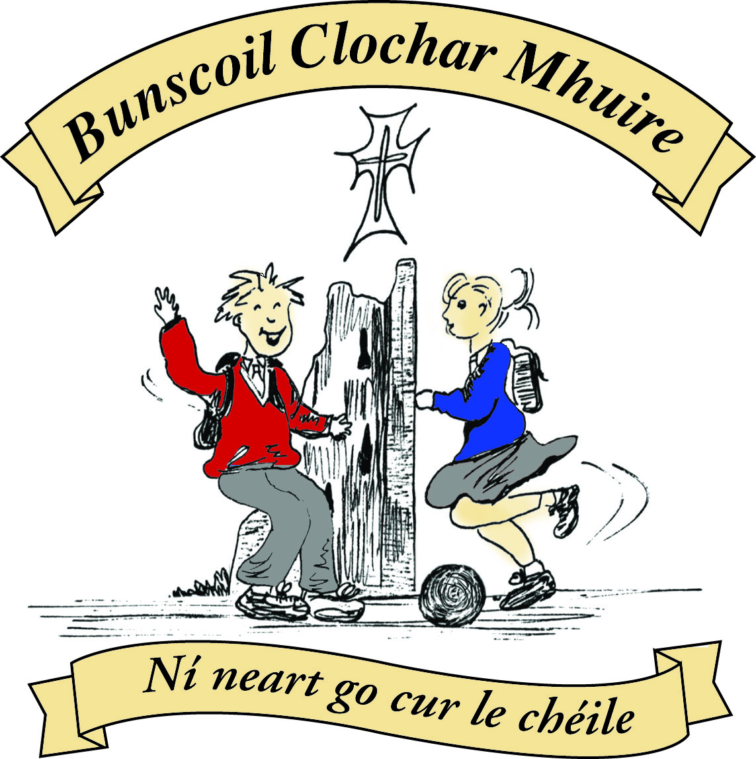* St Mary’s Convent Primary School**

***Bunscoil Clochar Mhuire***

***Trim, Co. Meath.  
Fón: (046) 9431919 ⦁ Faics: (046) 9437942  
Ríomhphost:*** [***marystrim@eircom.net***](mailto:marystrim@eircom.net) ***⦁ Website:*** [***www.stmarystrim.ie***](http://www.stmarystrim.ie) ***Uimhir Rolla: 16646O***

Awarded Green Flag  
June ‘05/’07/11/13

Imlitir 15

7th December, 2015.

***Every Day Counts at St Mary’s Convent Primary School***

***30th Nov – 4th December 2015***

|  |  |  |  |  |  |  |  |
| --- | --- | --- | --- | --- | --- | --- | --- |
| **Room** | **Attendance** | **Room** | **Attendance** | **Room** | **Attendance** | **Room** | **Attendance** |
| 01 | 91.1% | 08 | 90.7% | 16 | 91.9% | 26 | 92.6% |
| 02 | 96.9% | 09 | 97.8% | 17 | 90% | 27 | 92.1% |
| 03 | 92.8% | 10 | 88.6% | 18 | 97.1% | 30 | 96.6% |
| 04 | 86.9% | 12 | 93.8% | 19 | 94.8% | 31 | 89% |
| 05 | 85% | 13 | 85.9% | 20 | 96.7% |  |  |
| 06 | 91.4% | 14 | 96.3% | 23 | **100%** |  |  |
| 07 | 85.4% | 15 | 85.6% | 24 | 80% |  |  |

Congratulations to Room 23 on having full attendance last week. Their teacher will let them know this week what their prize is.

**A chairde,**

**Light of My Life:** many thanks to our Parents’ Association who organised a beautiful remembrance ceremony on Friday last. Thanks also to Fr Declan and all the staff members who assisted.

Many thanks for assisting with our **Readalong**. As well as raising funds for our Multi Use Games Area (MUGA) the pupils have benefited from the extra reading. Please continue to assist your child/ren with reading. Have you considered books as a Christmas presents? Please return outstanding cards.

***Banna Ceoil***

*Tomorrow, Tuesday 8th December is the final Banna Ceoil practice for 2nd, 3rd and 4th classes. Next week’s practice is for 5th and 6th class only as they are playing in the Christmas Pageant. There will be no Banna Ceoil practice for 2nd, 3rd and 4th next week.*

*R. McGale*

*Vladimir is starting a new violin class in Trim. This is a great opportunity to learn from one of the top performers on the Irish Classical scene. Please see separate email and attachment for details. There is a discount for Banna Ceoil members and we are expecting these classes to be in demand and to fill up quickly.*

*R. McGale*

***Book Club***

*Every Monday at 12.30 in the Library, under the guidance of Ms. Coakley, Book Club is held. Book Club is open to pupils from 4th – 6th class. Currently we are reading “Broken Glass” by Sally Grindley. We look forward to Mondays to review what we have read during the week.*

*Méabh Tully, 6th Class*

*11 O’clock mass tomorrow in the church is for the Feast of the Immaculate Conception. Children from 2nd – 6th class will be attending. Parents are welcome.*

*S. Nally*

***Clothes and Shoes Collection – Dec 10th***

*This Thursday we will have a clothes and shoe collection day. Please leave your bags in on Wednesday afternoon or first thing on Thursday morning.*

*S. Nally*

*Our school choir was very fortunate to be the only school chosen in County Meath to sing as part of a 32 - County Children's Choir at a special event as part of the Ireland 2016 State Centenary Programme with a showcase Peace Proms performance at the Convention Centre Dublin on 1 January 2016. The Cross Border Orchestra of Ireland has been invited by Minister Heather Humphreys and the Department of Arts, Heritage and the Gaeltacht to host this special event.*

*2016 will mark the centenary of the 1916 Easter Rising, a key moment on Ireland’s path to independence. The Government has launched a wide-ranging and ambitious national commemorative programme embracing an extensive programme of events. The aim of Ireland 2016 is to remember 1916, to reflect on the Republic 100 years on, and to re-imagine our future.*

*This landmark event, which will be hosted by Minister Heather Humphreys T.D. and performed before an audience of over 2,000 invited guests, will be recorded for national broadcast.*

*Below is a picture of the girls who will be representing our school.*

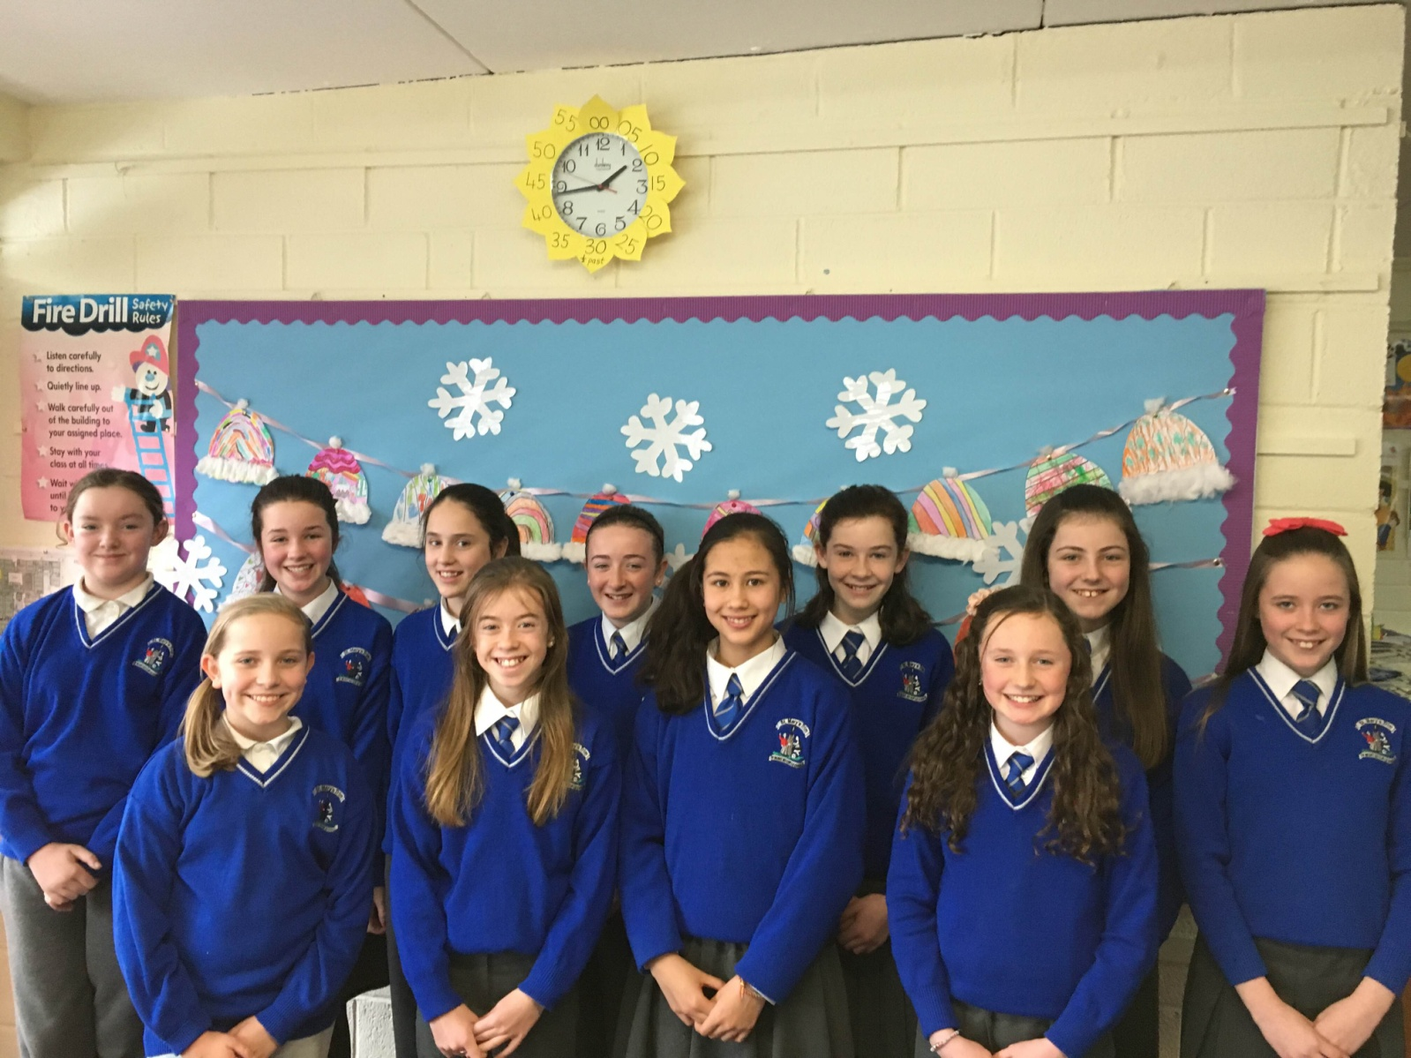

Back Row: Aisling O'Toole, Jennifer Collins, Lauren Farrell, Julieanne Murtagh, Róisín Dineen, Emma Darby, Jill McInerney

Front Row: Kelci White, Ava Costello, Sofia Rooney, Lucy Talbot

*St Mary's School Choir sang in the Solstice Arts Centre last Thursday night for their Annual Christmas Concert. We were very lucky to be partnered with Enfield Primary School and together we gave the audience a great night. The sixty-five girls, together with Ms McKenna and Ms O'Connor, sang some beautiful Christmas songs to kick-start the Christmas Season.*

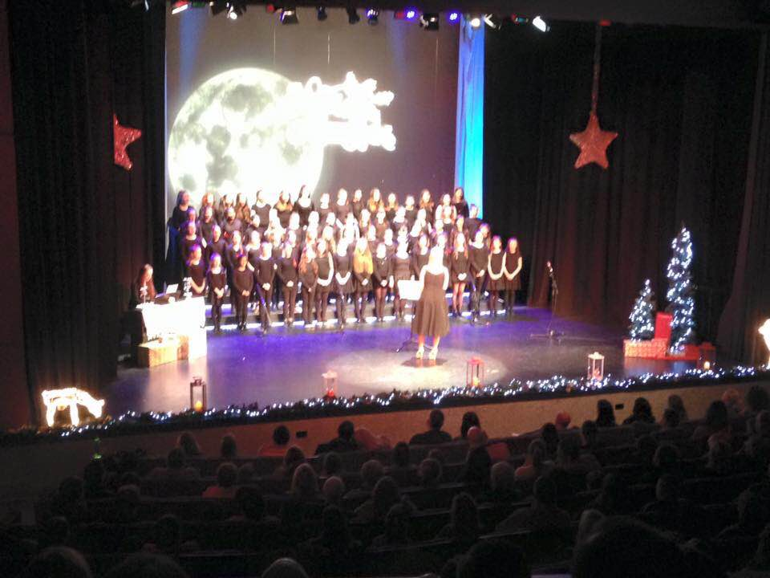

*S. McKenna*

Please note the times for Nativity Plays below. We will be collecting for Trim St Vincent de Paul, so keep an eye out for the Student Council Members with collection boxes. Proceeds from our annual Christmas Pageant will go towards same. Tickets @ €4 are now on sale for the 1.30 and 7.00 shows. Book your tickets now to avoid disappointment.

|  |  |  |  |  |  |  |  |  |  |
| --- | --- | --- | --- | --- | --- | --- | --- | --- | --- |
| **Date** | **Day** | **Rm NO** | **Time** | **Rm NO** | **Time** | **Rm NO** | **Time** | **Rm NO** | **Time** |
| 10th Dec | Thursday | 2 | 1.00pm |  |  |  |  |  |  |
| 11th Dec | Friday |  |  | 1 | 1.00 pm |  |  |  |  |
| 15th Dec | Tuesday | 12 | 2.10 pm | 4 | 1.10 pm |  |  |  |  |
| 16th Dec | Wednesday | 23/24 | 11.30 am |  |  | 6 | 1.30 pm |  |  |
| 17th Dec | Thursday | 17 | 11.45 am | 3 | 1.00pm | 9 | 1.30 pm | 10 | 2.10 pm |
| 18th Dec | Friday | 8 | 1.00 pm | 7 | 1.15 pm | 5 | 1.30 pm | 13 | 2.10 pm |

**Súgradh, Spraoi, Siamsa and Sonas Christmas Annuals:** Friday is the last day to purchase the Annuals. The cost is €4.00.

**Enrolment Forms** for September 2016 are now available from Helen in the office.

Mise le meas,



Cóilín Ó Coigligh, Príomh Oide

**Community Notices**

**Green News**

***Nath na Seachtaine:*** Tá an Nollaig ag teacht. Christmas is coming

Seanfhocal na Míosa: Ní hé lá na báistí lá na bpáistí. A wet day is not for children (or adults)

**Dates to Remember**

**Meitheal:** Every Tuesday morning 9.30-10.30.

**Banna Ceoil:** Every Tuesday @3pm.

All Classes finish @ 4pm.

**Do this in Memory Mass: For 2nd class this Sunday 13th December @ 11 a.m.**

**Confirmation:**  Saturday 13th February

**First Communion:** Saturday 28th May @ 11 a.m.

**Green News**

**Green News December 7th, 2015**

Last week two delegates from our Green Flag committee joined a cohort from Trim Tidy Towns who travelled to Skerries to accept an award in recognition of the great work our local committee do to keep Trim looking beautiful. St Mary’s have a long-standing close relationship with Trim Tidy Towns and has work alongside its committee over the years on different projects, so it was our pleasure to be part of the ceremony last week. Minister James Reilly presented our girls with the award which you can view below.

WOW (Walking on Wednesdays) will go ahead this week if it is deemed safe enough. Generally the WOW teachers and pupils walk in all conditions but with the wild winds we’ve had, we need to exercise caution. Well done to all those who brave the elements walking to school. Keep warm and wear your hi-viz vest for extra safety. When walking, keep well in from the edge of the path.

**Clothes and Shoes Collection – Dec 10th**

This Thursday we will have a clothes and shoe collection day. Please leave your bags in on Wednesday afternoon or first thing on Thursday morning. The school wishes to thank all those who participate in these recycling initiatives.

Regular recycling continues at school. We recycle batteries, ink cartridges, mobile phones, postage stamps, card, toilet rolls, cans and eye glasses. Please retain the stamps that you receive on Christmas mail and send them in for our reused stamp collection in aid of the Blind. The Christmas Plays will be coming up very soon. We would encourage you to use homemade costumes from recycled clothing where possible. They can be the cutest of all.

A reminder that our Green theme is Global Citizenship with an emphasis on Litter and Waste. The children are making a special effort to recycle as much as possible in their classrooms. All foods that they don’t consume are being brought home in their lunch bags.

***Remember Green is cool at home, at school and around the globe!***

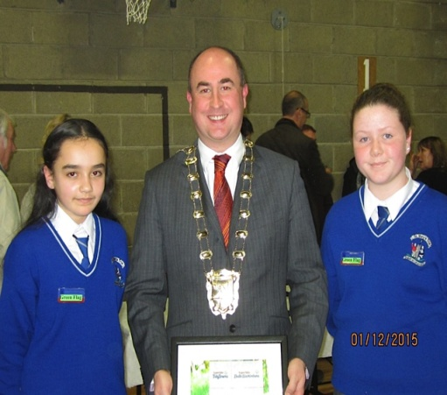 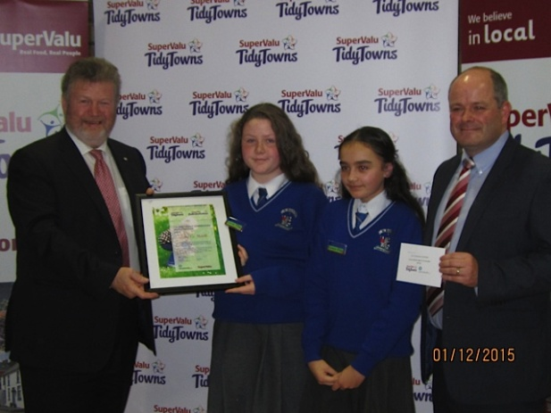

TWO DELEGATES FROM OUR GREEN COMMITTEE RECEIVING AN AWARD ON BEHALF OF TRIM TIDY TOWNS COMMITTEE

**Community Notices**

**Christmas Camps at the Elements Holistic Centre Trim** 3 different Camp days available 1st Camp: 12th December 2nd Camp: 20th December 3rd Camp: 23rd December Suitable Age: 5 - 13 years Each camp is from 11 am - 3pm Price is 40€ per camp day (20€ deposit required to guarantee the booking) We do Art's and Craft , singing Christmas Songs, drinking hot chocolate, telling Christmas stories and much more.  
Please bring packed Lunch ☎ to book a place please call Stefanie under 086 028 4862

**CHRISTMAS WORKSHOP**  
Sunday 13th December 11.00am - 4.00pm  
Christmas stories, Christmas crafts, Christmas Baking, Christmas themed puppet show, Christmas singing... everything to do with Christmas and all the fun that goes with it. Suitable for children aged 4 to 8 years. Packed lunch required. €24 per child. Places are limited. For booking....email [limelighttheatrics@gmail.com](mailto:limelighttheatrics@gmail.com) or contact Carmel on 0863923334

**Parents’ Association**

Many thanks to all who sent in buns for the recent Bun Sale. Our nominated bakers were from 2nd, 3rd and 4th classes. €900 was raised and all of this will be going towards the MUGA fund. Many thanks to you all for your continued support.

Well done to St. Mary's Choir who recently performed in The Solstice in Navan, we heard you were terrific, keep up the good work.

Last Friday we had the Light of my Life ceremony in the hall. Many thanks to Fr. Declan, Ms. Nally and all the teachers and children involved in this ceremony. Special prayers and thoughts were given to our departed relatives and friends. Our Christmas tree was blessed and the lights were turned on by two children from 2nd class.  The Christmas Tree has now been moved to the front reception.

Lastly, the Christmas Cards designed by the children are on their way back to the school and will be given to the children ASAP, the gifts however will be a little later, but not much. I know you are all eager to get your cards posted.

Many thanks again for all your support

Regards

Parents’ Association