***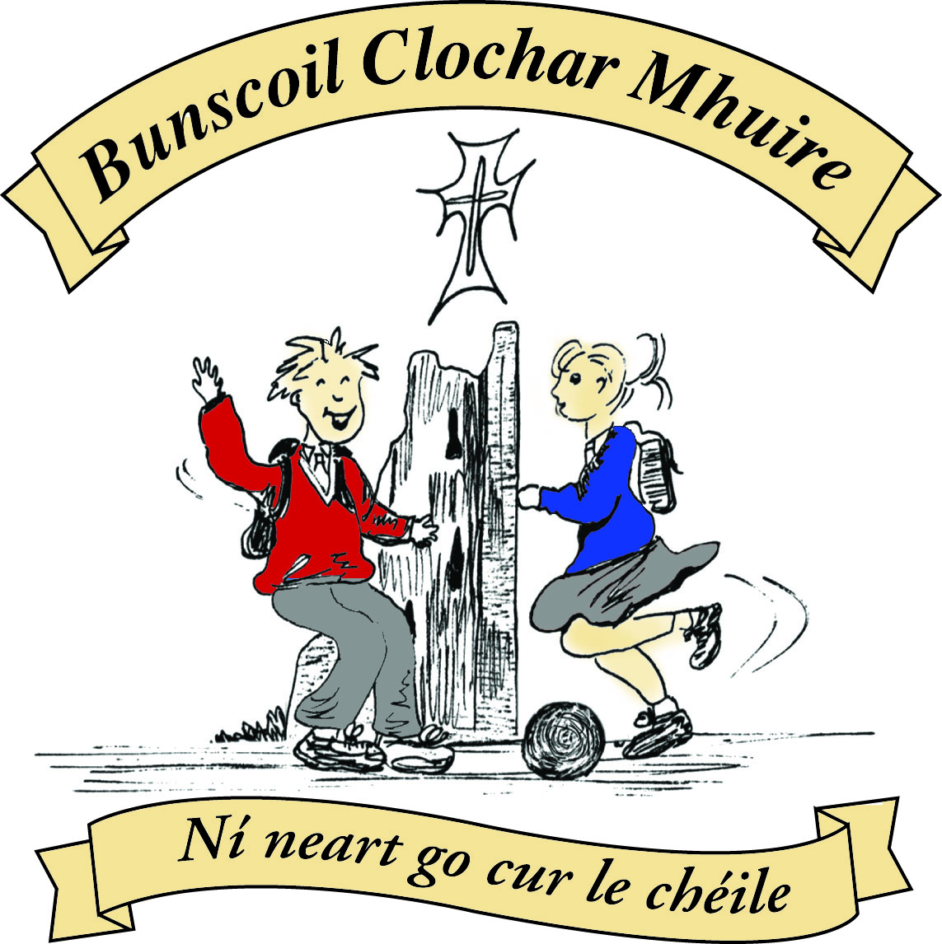* St Mary’s Convent Primary School**

***Bunscoil Clochar Mhuire***

***Trim, Co. Meath.  
Fón: (046) 9431919 ⦁ Faics: (046) 9437942  
Ríomhphost:*** [***marystrim@eircom.net***](mailto:marystrim@eircom.net) ***⦁ Website:*** [***www.stmarystrim.ie***](http://www.stmarystrim.ie) ***Uimhir Rolla: 16646O***

Awarded Green Flag  
June ‘05/’07/11/13

***Imlitir 15***

11th December, 2017

***Every Day Counts at St Mary’s Convent Primary School***

***4th Dec – 8th Dec 2017***

|  |  |  |  |  |  |  |  |
| --- | --- | --- | --- | --- | --- | --- | --- |
| **Room** | **Attendance** | **Room** | **Attendance** | **Room** | **Attendance** | **Room** | **Attendance** |
| 01 | 93.8 % | 08 | 94.8% | 16 | 94.3% | 26 | 91.9% |
| 02 | 91.7% | 09 | 96.2% | 17 | 93.3% | 27 | 97.7% |
| 03 | 95.9% | 10 | 92% | 18 | 92.1% | 30 | 92.8% |
| 04 | 86.9% | 12 | 92.8% | 19 | 83% | 31 | 91.2% |
| 05 | 96.8% | 13 | 98.3% | 20 | 96.2% |  |  |
| 06 | 91.2% | 14 | 97.9% | 23 & 24 | 78.5% |  |  |
| 07 | 97.5% | 15 | 93.8% |  |  |  |  |

*Please note that notification in writing, with the reason for all absences, to the teacher is required. A letter or note in the homework journal will suffice.*

*There will be an Attendance Assembly on Friday morning next @ 9.20. Pupils with perfect attendance to date will be presented with their certs. There will be a prize also for the class with the best attendance since September.*

A chairde,

**Pageant:** Our annual Christmas Pageanttakes place in The Dr Eileen Reilly Hall @ 7.00 tomorrow Tuesday 12th December has SOLD OUT. So we had to add an extra show @ 1.30 tomorrow. Tickets are now on sale and will be available on the door. Anyone who wishes to swop evening tickets for the matinee may do so through Helen or Rebecca in the office. Our thanks to the teachers Mrs Hoey, Mrs Dixon, Mrs O Hare and Ms Coakley for the great work they have put in to preparing the children with the costumes, singing and acting. Thanks also to Ms Rhona, to all the teachers in Banna for helping with music, and to Frank and Ms Debby for helping with just about everything.

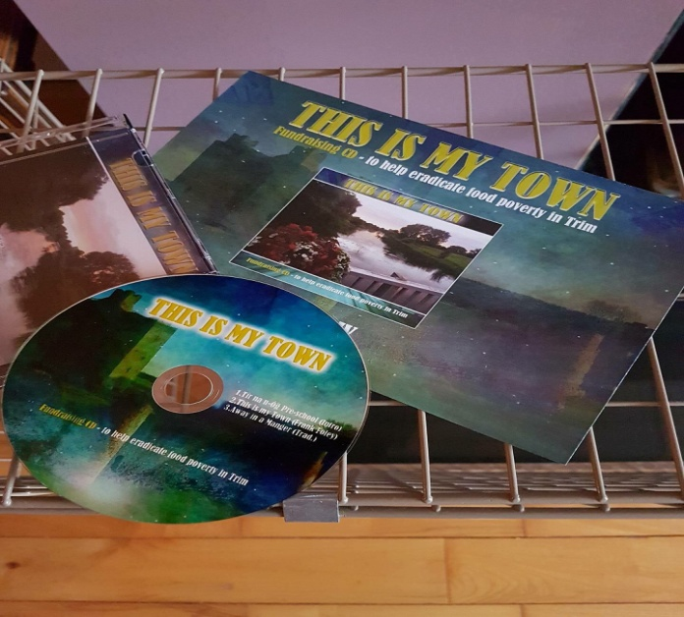

*The children in St Mary’s Choir have been very busy the past few weeks. We were asked to join in to release a charity CD ‘This is our Town’ for the creation of a Food Cloud/ Bank initiative in Trim. This is to help eradicate food poverty in this area. Various members of different community groups and musicians were involved in the making of this CD.*

*The CD will be launching in Dunderry Lodge on Wednesday 13th of December at 7:30pm.*

*The cost of the CD is €5 and you can contact Ms McKenna if you would like to purchase one. ALL PROCEEDS go towards the Food cloud Initiative.*

*Ms McKenna*

Please note the times for Nativity Plays below. We will be collecting for Trim St Vincent de Paul and Trim Meals on Wheels, so keep an eye out for our Student Council Members with collection boxes.

|  |  |  |  |  |  |  |  |  |  |  |  |
| --- | --- | --- | --- | --- | --- | --- | --- | --- | --- | --- | --- |
| **Date** | **Day** | **Room** | **Time** | **Room** | **Time** | **Room** | **Time** | **Room** | **Time** | **Room** | **Time** |
| **14th Dec** | Thursday | **3** | 1.15 | **4** | 1.15 |  |  |  |  |  |  |
| **15th Dec** | Friday | **8** | 1.15 | **12** | 1.30 |  |  |  |  |  |  |
| **19th Dec** | Tuesday | **6** | 1.15 |  |  |  |  |  |  |  |  |
| **20th**  **Dec** | Wednesday | **7** | 1.15 | **5** | 1.15 | **9** | 1.30 |  |  |  |  |
| **21st Dec** | Thursday | **10** | 1.30 | **13** | 1.30 |  |  |  |  |  |  |

Congratulations to Amy Rigney who launched her debut single “Rockin’ Around The Christmas Tree” on Thursday night last. By Friday she was number 9 in the Download Charts behind Pink! Fantastic achievement. I am sure that she would be delighted to receive the support of further downloads to move her further up the charts. Thanks also to Ms McKenna and Ms O’Connor and to our school choir for supporting Amy on the single. St Mary’s definitely has got talent!

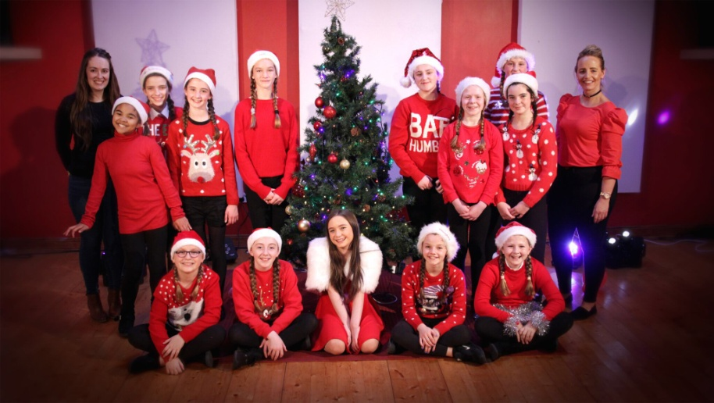

**Súgradh, Spraoi, Siamsa and Sonas Christmas Annuals:** Tomorrow is the last day to purchase the Annuals. The cost is €4.00.

Finally, last week we were unable to get substitute cover for teachers who were sick and had to divide up some classes who were entitled to cover. There is a huge shortage this year and the availability of subs is outside my control. We expect the shortage to continue to the end of the school year.

Mise le meas,



Cóilín Ó Coigligh, Príomh Oide.

**Green News**

**Community News**

***Nathanna na Seachtaine:*** *Tá Daidí Na Nollaig ag teacht*

***Seanfhocal na Míosa:*** *Ní hé lá na báistí, lá na bpáistí*

**Dates to Remember**

**Assembly:** Attendance Assembly @ 9.20 Whole School

**Meitheal:** Every Tuesday morning 9.30-10.30.

**Drama Club:** Every Thursday 3-4pm 4th – 6th Class

**Banna:** Tuesdays @ 3.000 – 4.00

**Communion: Saturday 5th May @ 11.00**

**Confirmation: Saturday 10th Feb @ 11.00**

St Mary’s Parents’ Association

The last 2 weeks before the Christmas Holidays. Tis the season for angel wings, Tea towels and animal costumes!

Dates for Your Diary:

**December 12th:** Tuesday 12th December: St Mary’s Christmas Pageant will be performed at 7pm in the Dr Eileen Rilley Hall by students from 3rd and 4th class. All proceeds going to St. Vincent De Paul and Trim Meals on Wheels. Tickets €4 for adults, €2 for children or €10 for a family of 4.

**December 15th**: A brief Parents Association Meeting at 9.30am in the Staffroom. All welcome to attend followed by tea/coffee and mince pies ☺ .

**December 22nd**: School finishes for the Christmas Holidays.

**December 24th:** Don’t forget to leave some goodies out for Santa and his Reindeer and get to bed EARLY! Santa is still checking his list!

<https://www.facebook.com/stmarysparentsassoc/>

Many thanks for your continued support.

Caroline Smith

Secretary

**Community Notices**

**Christmas Puppet Show: “Oops! Forgotten Something?”**

This Friday you are in for a treat. OMIreland are returning with their multimedia Christmas puppet show experience to Trim. All families are welcome to attend this great production, the latest in a series of newly written shows, which explain the meaning of Christmas. On two previous occasions RTE recorded and broadcast the puppet show. Admission free. Venue: St. Patrick’s Hall, Loman St. Time: 7:00pm, Friday 15th December. The show lasts 45 minutes. Refreshments served after the show.

**GO BOUNCE - BOUNCY CASTLE HIRE - 0868398099.**

Don't delay, book today to avoid disappointment in May. Now taking bookings for Holy Communions 2018. Book now and you'll have one less thing to worry about in the run up to the big day. Check out our castles on [Www.Facebook.com/GoBounceMeath](http://www.facebook.com/GoBounceMeath) or [www.GoBounce.ie](http://www.gobounce.ie/) or call us on 086-8398099

**AFTER SCHOOL CLUB** Taking place in St. Mary's School Trim from 2-3pm Mon - Friday in room 5. Only €6 a day or €25 for 5 days Mon-Fri Application forms available from reception. Booking required a week in advance of start date to insure space, and rebooking and payment made the previous Thursday each week after. Kids will be provided a small snack and entertained with Lego, Art & Craft, Board games, quizzes, card games, puzzles and lots more fun activities! Run by an experienced Childcare Professional Parent who is fully Garda Vetted and Insured. Contact Julie O'Donohue to book your child's space by texting 0868505310, emailing [juliekerins@hotmail.com](mailto:juliekerins@hotmail.com) or via a PM on the Facebookpage:[www.facebook.com/TrimAfterSchoolClub](http://www.facebook.com/TrimAfterSchoolClub)