***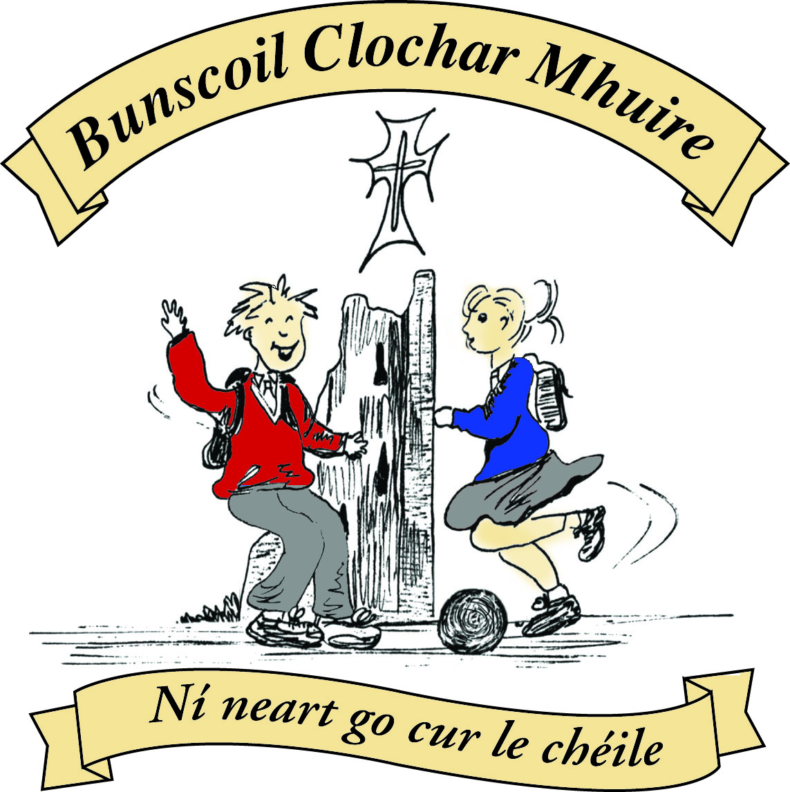* St Mary’s Convent Primary School**

***Bunscoil Clochar Mhuire***

***Trim, Co. Meath.  
Fón: (046) 9431919 ⦁ Faics: (046) 9437942  
Ríomhphost:*** [***marystrim@eircom.net***](mailto:marystrim@eircom.net) ***⦁ Website:*** [***www.stmarystrim.ie***](http://www.stmarystrim.ie) ***Uimhir Rolla: 16646O***

Awarded Green Flag  
June ‘05/’07/11/13

***Imlitir 14***

5th December, 2016

***Every Day Counts at St Mary’s Convent Primary School***

***28th November - 2nd December 2016***

|  |  |  |  |  |  |  |  |
| --- | --- | --- | --- | --- | --- | --- | --- |
| **Room** | **Attendance** | **Room** | **Attendance** | **Room** | **Attendance** | **Room** | **Attendance** |
|  |  |  |  |  |  |  |  |
| 01 | 91.9 % | 08 | 88.3% | 16 | 94.8% | 26 | 95.2% |
| 02 | 83.1% | 09 | 94.2% | 17 | 92.3% | 27 | 88.3% |
| 03 | 88.7% | 10 | 78.5% | 18 | 98.3% | 30 | 86.9% |
| 04 | 86.7% | 12 | 94.5% | 19 | 94.3% | 31 | 94.3% |
| 05 | 90.8% | 13 | 90% | 20 | 92.1% |  |  |
| 06 | 90.4% | 14 | 92.9% | 23 & 24 | 94.3% |  |  |
| 07 | 90.4% | 15 | 94.3% |  |  |  |  |

*Please note that notification in writing to the teacher is required for all absences. A letter or note in the homework journal will suffice*.

A chairde,

**Light of My Life:** many thanks to Mrs Nally who organised a beautiful remembrance ceremony on Friday last, on behalf of our Parents’ Association. Thanks also to Fr Declan and all other staff members who assisted.

Many thanks for assisting with our **Readalong**. The pupils have benefited from the extra reading. Please continue to assist your child/ren with reading. Have you considered books as a Christmas presents? Please return outstanding cards.

**Dyslexia Seminar**

A seminar on Dyslexia for parents and teachers will be held in Navan Education Centre on Monday the 5th of December from 6-9pm.

 Booking can be made through: [www.dyslexiaconsultant.com](http://www.dyslexiaconsultant.com) or by contacting Kathleen Sweeney on 085 820221

Please note the times for Nativity Plays below. We will be collecting for Trim St Vincent de Paul and Trim Meals On Wheels, so keep an eye out for the Student Council Members with collection boxes. Proceeds from our annual Christmas Pageant will go towards same. Tickets @ €4 are now on sale for the 1.00 and 6.00 shows. We had to bring forward the second show time from 6.30 to avoid clashing with Scoil Mhuire, who are now on at 7.00 in the church. Apologies for any inconvenience caused. Book your tickets now to avoid disappointment.

**Timetable for Christmas Plays Dec 2016**

|  |  |  |  |  |  |  |  |  |  |  |  |
| --- | --- | --- | --- | --- | --- | --- | --- | --- | --- | --- | --- |
| **Date** | **Day** | **Room** | **Time** | **Room** | **Time** | **Room** | **Time** | **Room** | **Time** | **Room** | **Time** |
| **8th Dec** | Thursday | **1** | 1.15 |  |  |  |  |  |  |  |  |
| **9th Dec** | Friday | **4** | 1.20 |  |  |  |  |  |  |  |  |
| **14th Dec** | Wed | **16/18** | 2.15 |  |  |  |  |  |  |  |  |
| **15th Dec** | Thursday | **20** | 11.30 | **3** | 1.00 | **2** | 1.15 |  |  |  |  |
| **16th Dec** | Friday | **23/24** | 10.00 | **6** | 1.15 | **7** | 1.15 | **12** | 1.15 | **19** | 2.15 |
| **19th**  **Dec** | Monday | **17** | 12.00 | **9** | 2.10 | **13** | 2.15 |  |  |  |  |
| **20th Dec** | Tuesday | **5** | 1.15 | **8** | 1.15 | **10** | 2.15 |  |  |  |  |

***Health Promoting Schools***

*Our school has decided to participate in the Health Promoting Schools Programme (HPS) which is supported by the HSE.*

*This programme is about giving schools an extra focus on health. It encourages teachers, students and parents/guardians to look at how health and wellbeing can be built upon within the school.*

*This means that we will be consulting with and involving students, staff and parents/guardians to explore what makes a school a healthy place in which to work, study and visit.*

*This will mean different things for each school: for example some schools have introduced nutrition policies, introduced increased levels of physical activity or developed school wildlife gardens.*

*Children spend a lot of time in school and it is an important influence in their lives. The evidence shows schools are much more effective in what they do and what they can achieve when their parents/guardians are supportive and involved.*

*As a parent/guardian we would encourage you to get involved and support our Health Promotion work. We will keep you updated throughout the year on our progress and how you can be involved.*

*S. Minogue HPS coordinator*

**Súgradh, Spraoi, Siamsa and Sonas Christmas Annuals:** Friday is the last day to purchase the Annuals. The cost is €4.00.

**Enrolment Forms** for September 2017 are now available from Helen in the office.

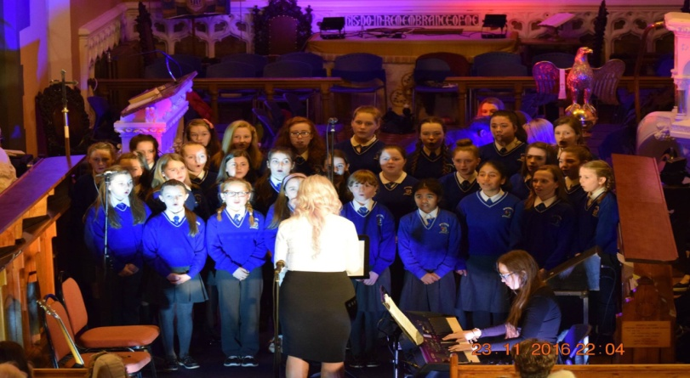

*The choir were asked to be a part of the Musical Evening for Beaumont Hospital's Richmond ICU in St Patrick's Cathedral on Wednesday, 23rd of November. The event was organised by Miriam Kelly Minogue and was a fantastic nights entertainment. There were a range of musical acts including Comhaltas Tlachtga, the Navan Silver Band, Don Baker, Nigel Connell, Frank Foley and ourselves; the St Mary's School Choir, led by Ms McKenna and Ms O'Connor. The choir were the talk of the evening with their harmonious sound and excellent stage presence. The event raised over €2,500 for Richmond ICU and we would like to extend a massive thanks to parents for their support.*  
Ms O'Connor and Ms

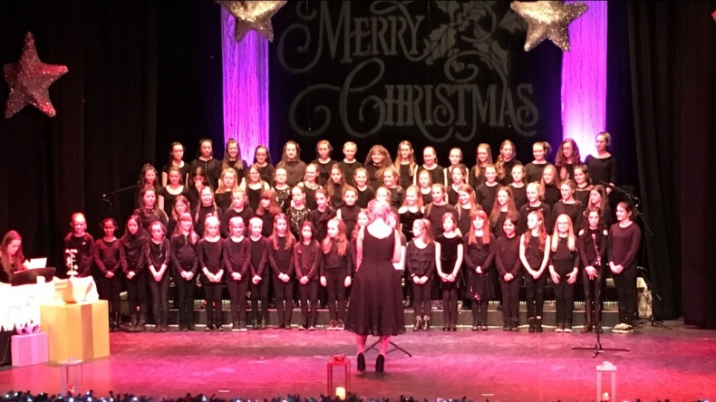 *Ms O'Connor and Ms McKenna*

*On Friday night, December 2nd, St Mary's School Choir of 69 girls travelled to the Solstice Centre in Navan to perform at the annual Christmas Concert. It was a great success and the girls were outstanding. A massive congratulations to all involved.*

*The first Bun Sale of this school year will be held on Friday 9th of December.  So we are asking all parents of 2nd, 3rd and 4th class children to be our bakers where they will be entered into a draw for a chance to win 1 of 3 Smyths Toy Vouchers. All buns can be dropped into the school hall from 9am on the 9th.  All buns are 50cent each and all proceeds go directly to the school's sports fund. If you are sending in your own cake or bun boxes please ensure they are labelled with your childs name and class so that we can ensure they are returned promptly to you. We would ask any parent that would like to stay and help set up and sell these buns to the children, please do. Its great fun and the children love seeing their parents working in the school. Children are invited to wear Christmas jumpers & Santa hats to school on Friday also.  We thank you for your continued support.   St . Mary's Parents’ Association*

Mise le meas,



Cóilín Ó Coigligh, Príomh Oide.

**Green News**

**Community News**

**Nathanna na Seachtaine: Ba mhaith liom.... (I would like)**

**Seanfhocal na Míosa: Mol an Óige agus tiocfaidh sí (Praise the youth and they will blossom)**

**Dates to Remember**

**Assembly: Green Flag Assembly** Friday. 9.20 Seniors & 9.40 Juniors

**All Welcome**

**Banna Ceoil:** Every Tuesday. **All classes will finish @ 4.00pm**

**Meitheal:** Every Tuesday morning 9.30-10.30.

**Badminton:** Mondays 3-4pm for 3rd & 4th Classes. No Fee.

**Communion:**  Sat May 13th @ 11.00

**Confirmation:**  Sat 11th March

**Green News**

Great news! The Siopa Glas was a huge success! Sincere thanks to all of you Parents and Guardians for supporting it through donations and contributions! The Siopadóirí did a marvellous job and used the ‘cúpla focail’ during the transactions! A total of €830 was collected. Some of this will go to the Civil Defence who will use is to assist local families with food and fuel for Christmas. The remainder will also go towards Sr Claudia’s Flamboyant Special Needs School in Zambia. This school was set up a few years ago with very few resources. When our Siopa Glas contributuions arrive, the school can do so much and are so very grateful to us. We hope to get Sr Claudia in to speak to us at one of our Green Assemblies very soon.

As Global Citizenship is our Green Flag theme this year it is nice that we can help other school children in another part of the globe. Míle buíochas arís libh go léir.

The theme of Litter and Waste Management is the element of Global Citizenship theme which we are dealing with this year. We try to recycle as much as we can here in St Marys. Our Siopa Glas was an example of this. We also recycle waste materials here at school. We accept small plastic bottles, mobile phones, postage stamps, toilet rolls, ink cartridges and cans.

Our WOW teachers are still walking to school on Wednesdays. Please feel free to meet up with either of them at the Matchbox or Mornington House at 9 am. Remember to wrap up well as the mornings are cold now.

***Remember green is cool at home, at school and around the globe!***

**Community Notices**

**ZUMBA  TOY  DRIVE :-    THIS WEEK !**!

Many of you may know Tina Fagan who does AMAZING work all year round with struggling families and those down on their luck. However at Christmastime, she turns into a cross between Wonder Woman and Santa Clause and really pulls out all the stops to ensure that the children in these families experience Christmas as children should.  
Following on from the HUGE success last Christmas, this year we are hoping to help again!   
Admission to all classes this week will be a toy.......age group & value is up to you :-  
  
Zumba        -  8pm  Monday 28th November,   
ZumbaKids -  3.15pm Tuesday 29th November and   
Zumba        -  8pm  Wednesday 29th November   
Let's help put smiles on kiddies faces on Christmas morning..........please help spread the word, SHARE the event  (see Facebook page  Zumba Trim Lorraine) and maybe drag a couple of friends or family with you to the class. Please note that the toys should be new.        Contact Lorraine 086 8693546

**Basketball** at St Mary’s School. Boys (8-12) every Tuesday from 4-5pm. Girls (8-12) every Wednesday 4-5pm. Limited Spaces Contact [etcprojectsie@gmail.com](mailto:etcprojectsie@gmail.com) or 087-9134334.

**School Cleaner** required to cover sick days. Contact Helen in the office for further information 046-9431919.

**AFTER SCHOOL CLUB**

Taking place in St. Mary's School Trim from 2-3pm Only €5 a day or €20 for 5 days Mon-Fri

Application forms available in room 6 2-3pm or reception. Booking required at least a day in advance to insure space, and rebooking and payment made the previous Thursday.

Kids will be entertained with Lego, Art & Craft, Board games, quizzes, card games, puzzles and lots more fun activities!  Run by an experienced Childcare Professional Parent who is fully Garda Vetted and Insured.

Contact Julie O'Donohue to book your child's space by texting 0868505310, emailing [juliekerins@hotmail.com](mailto:juliekerins@hotmail.com) or via a PM on our Facebook page: [www.facebook.com/TrimAfterSchoolClub](http://www.facebook.com/TrimAfterSchoolClub)



**Jiggle 'n' Jump**

Music & Movement classes for little ones (8mths-4yrs) running upstairs in Trim GAA on Tuesday 9.45-10.45am  €7 a class or 4 class card for €25

Also available for Kids Party Entertainment!

Various characters and themes with fun games, dancing, face painting and prizes!

Clown, Pirate, Princess, 80's Disco Diva and Super Hero available.

New Party Package insures 2 hours of non stop entertainment, with face painting by Linda (Flawless Facepaint) while I entertain the kids with singing, dancing, party games and non stop fun!!

Contact Julie on 0868505310 or on Facebook [www.facebook.com/jigglenjump](http://www.facebook.com/jigglenjump)

**Trim Parent, Baby & Toddler Group**

Running Monday and Wednesdays during school term 9.45-11.45am upstairs in Trim GAA

Only €4 per family

Fun toys, colouring in, play doh, tea, coffee, juice and biscuits with a little sing along at the end.

All welcome......first time parents, grandparents, child minders.....anyone looking to get out and keep the little ones entertained while you can chat and enjoy a cuppa too!