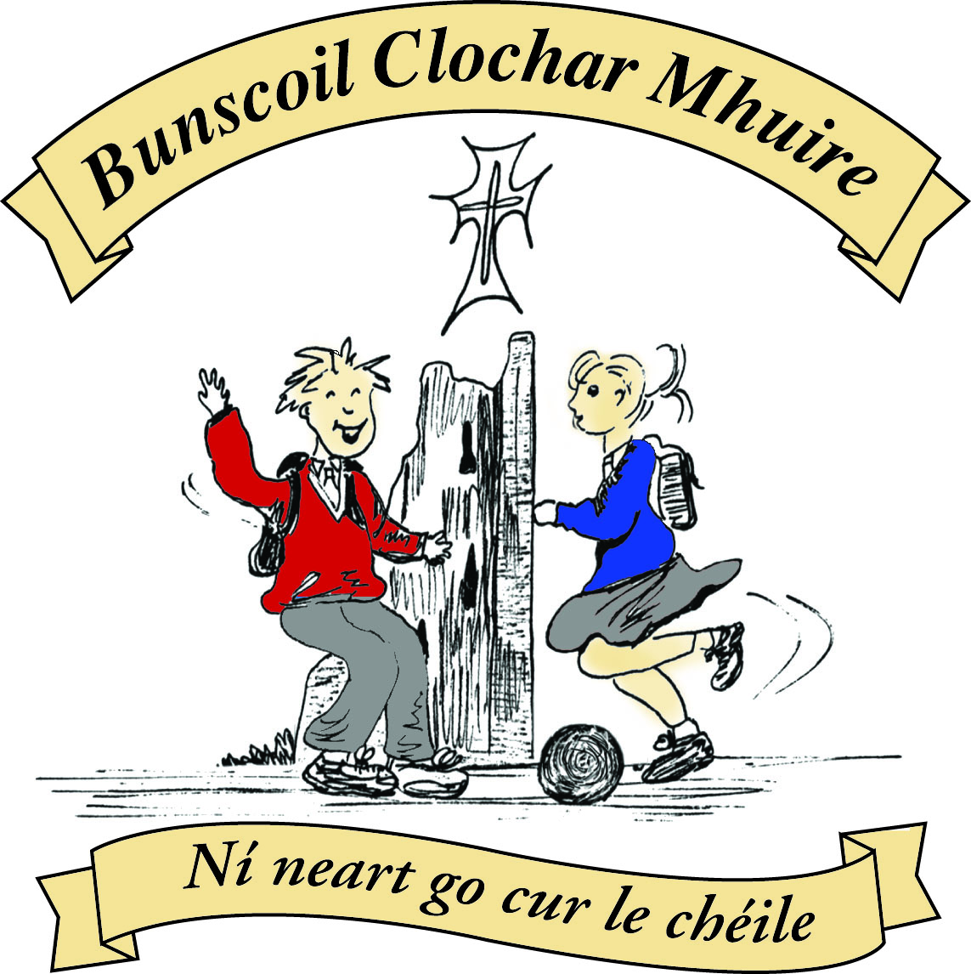

St Mary’s Convent Primary School
Bunscoil Clochar Mhuire
Trim, Co. Meath.
Fón: (046) 9431919  Faics: (046) 9437942
Ríomhphost: marystrim@eircom.net  Website: www.stmarystrim.ie
Uimhir Rolla: 16646O
Awarded Green Flag
June ‘05/’07/11/13

Imlitir 14
30th November, 2015.

Every Day Counts at St Mary’s Convent Primary School
23rd – 27th November 2015
Room | Attendance | Room | Attendance | Room | Attendance | Room | Attendance
01 | 89.6% | 08 | 95.7% | 16 | 98.5% | 26 | 95.6%
02 | 93.1% | 09 | 95.6% | 17 | 96% | 27 | 96.4%
03 | 96.8% | 10 | 96.4% | 18 | 95% | 30 | 95.9%
04 | 94.6% | 12 | 90% | 19 | 98.3% | 31 | 86.9%
05 | 96.4% | 13 | 95.4% | 20 | 95.8%
06 | 91.4% | 14 | 94.1% | 23 | 94%
07 | 83.8% | 15 | 94.4% | 24 | 100%

Congratulations to Room 24 on having full attendance last week. Their teacher will let them know this week what their prize is.

A chairde,

Readalong: many thanks for the sponsored reading this month. As explained, we have started fundraising for a Multi-Use Games Area (M.U.G.A.) and all monies will go into this fund. It was great to see so much reading done also. If there are cards lying at home un-returned, we would appreciate if you send them in. Please note that we discourage door-to-door gathering of sponsorship, so if you do not know the children, do not sponsor. Thanks.
If you have books at home in good condition that are no longer needed, we would be glad to accept them for our School Library. If you bring them in to the class teacher s/he will take it from there. Thanks.

Christmas Pageant: My apologies, the times last week should have stated 1.30 and 7.00 on December 16th. Tickets will go on sale shortly.

Parent Teacher Meetings: Many thanks again for your interest and I hope you all found the meetings worthwhile. The Junior Infants meetings will take place in February and you will be given advance notice of the dates.

New Board of Management: The following are the new members and area of nomination
Chairperson: Peter Higgins Patron’s Nominee
Fr Declan Kelly Patron’s Nominee
Cóilín Ó Coiglgih Teachers’ Nominee
Barbara Munelly Teachers’ Nominee
Yvonne Mc Ilhenney Parents’ Nominee
Pat O Donnell Parents’ Nominee
Assumpta Harvey O’Dowd Community Nominee
John Leonard Community Nominee
We wish them every success over the next four years.

Volunteers: We are still looking for volunteers to listen to the younger children reading. If you have an hour per week to spare, please contact Helen, in the Office. If you have more time to spare you might consider helping Junior Infants class with Team Teaching or helping out in our school library.

Zippy’s Friends: This is a programme for pupils’ emotional wellbeing suitable for six and seven year olds. We piloted it last year and will be doing it with Senior Infant and First Classes this year. On Thursday next @ 8.00 Anne Walsh from the HSE will give an explanatory talk. All welcome-not just those classes.

Date | Day | Rm NO | Time | Rm NO | Time | Rm NO | Time | Rm NO | Time
10th Dec | Thursday | 2 | 1.00pm
11th Dec | Friday |  |  | 1 | 1.00 pm
15th Dec | Tuesday | 12 | 2.10 pm | 4 | 1.10 pm
16th Dec | Wednesday | 23/24 | 11.30 am |  |  | 6 | 1.30 pm
17th Dec | Thursday | 17 | 11.45 am | 3 | 1.00pm | 9 | 1.30 pm | 10 | 2.10 pm
18th Dec | Friday | 8 | 1.00 pm | 7 | 1.15 pm | 5 | 1.30 pm | 13 | 2.10 pm

Enrolment Forms for September 2016 are now available from Helen in the office.

Folens Christmas Annuals available from Helen in the office €4.00 each.

Our Annual Light of My Life Ceremony to remember departed relatives and friends takes place on 4th December in the Dr Eileen Reilly Hall @ 9.30. See separate letter from our Parents’ Association.

Confirmation Commitment Ceremony for Confirmation pupils on Sunday, December, 6th at 11a.m in St. Patrick’s Church, Trim.
Mise le meas,

Cóilín Ó Coigligh, Príomh Oide

Green News
Community Notices
Nath na Seachtaine Tá mé críochnaithe (I am finished)
Seanfhocal na Míosa: Ní hé lá na báistí lá na bpáistí. A wet day is not for children (or adults)

Dates to Remember
Light of My Life Ceremony: Friday 4th December @ 9.30 in
Meitheal: Every Tuesday morning 9.30-10.30.
Banna Ceoil: Every Tuesday @3pm.
All Classes finish @ 4pm.
Confirmation Commitment
Ceremony: On Sunday 6th December @ 11am in St. Patricks Church.
Confirmation: Saturday 13th February
First Communion: Saturday 28th May @ 11.00

Green News

Winter is surely upon us. Remember to wrap up warmly when out and about and to conserve heat and energy when inside by keeping internal doors closed.
WOW (Walking on Wednesdays) is continuing for the winter. Well done to all those who brave the elements by walking to school. Keep warm and wear your hi-viz vest for extra safety.
Recycling continues at school. We recycle batteries, ink cartridges, mobile phones, postage stamps, card, toilet rolls, cans and eye glasses. We will be collecting clothing and footwear for a new Charity. We hope to have our collection on December 10th. The Christmas Plays will be coming up very soon. We would encourage you to use homemade costumes from recycled clothing where possible. They can be the cutest of all.
We would also encourage you to collect any stamps that come on Christmas mail and send them into school. The National Council for the Blind recycle them and help provide assistive technology to vision-impaired.
A reminder that our Green theme is Global Citizenship with an emphasis on Litter and Waste. This week, two delegates , Shona and Nikkita, from our Green Committee will represent Trim and St Mary’s in Skerries at an Award Ceremony on behalf of Trim Tidy Towns with whom we work very closely. We will have a photo for next week’s Green news.

Remember Green is cool at home, at school and around the globe!

Community Notices

ZUMBA :- ZUMBA :- No experience, partner or booking required
- 2 classes to choose from this week (please note NO TUESDAY CLASS this week)
MONDAY 8pm Trim GAA, THURSDAY 8pm Dance Force Academy
€8 per class Contact : Lorraine 086 8693546

PLEASE NOTE :- NO KIDS DANCE CLASS THIS WEEK
2 classes remaining in 2015 :- 8th December & 15th December
Contact : Lorraine 086 8693546 / Jo 086 3381159

Music Lessons.
Learn to play a Musical Instrument Locally. Music classes take place in St. Mary’s on Thursday afternoons. Practical and Theory of music taught. Preparation for Graded examinations. End of term concert. Flute, Saxophone, Keyboard and Violin classes, €200 for 20 lessons. Wind instrument rental, details available on request. Contact Kieran Holt 087-6267477

Kids Brick Club
Thursdays 4-5 in Diocesan Hall, Loman Street, All ages and abilities welcome. Also Athboy Convent Community Centre, Thursdays 6-7. Kathy 086-1700215

Helping ADHD with Homeopathy
Dr Jaume Costa MD MFHom on Thursday 3rd December in Trim Library at 7.00pm. Please leave your name at library desk or contact library on 9430614.

Jiggle ‘n’ Jump
Music and movement classes running for little ones on Tuesdays and Thursdays in Oaktree Business Park. Call Julie on 0868505310 or check Facebook page.

Art Club
Art Club has started in rooms 8 and 19. Children can join on Mondays between 3-4pm. All welcome (from Senior Infants to 6th Class)

Festive 5km Relay
On Sunday 6th Dec @ 10.30am. Location Trim Town. Teams: 1 adult and 4 young people. €20 per team. Festive dress is encouraged. Prize for best dressed team. To register contact Trish\Karen on 087-4146653. All proceeds to The Lorraine O’ Brien Trust.

Personal Bag Appeal
Trim Youth Club is calling on our Community for their support in helping the Homeless this winter. They are looking for donations of essential items and sleeping bags. New and unused please. Local Drop off point every Friday 7-9pm Trim Youth Club, Navan Gate. 085-1447929.

