 St Mary’s Convent Primary School**

***Bunscoil Clochar Mhuire***

***Trim, Co. Meath.  
Fón: (046) 9431919 ⦁ Faics: (046) 9437942  
Ríomhphost:*** [***marystrim@eircom.net***](mailto:marystrim@eircom.net) ***⦁ Website:*** [***www.stmarystrim.ie***](http://www.stmarystrim.ie) ***Uimhir Rolla: 16646O***

Awarded Green Flag  
June ‘05/’07/11/13

***Imlitir 13***

28th November, 2017

***Every Day Counts at St Mary’s Convent Primary School***

***20th – 25th November 2017***

|  |  |  |  |  |  |  |  |
| --- | --- | --- | --- | --- | --- | --- | --- |
| **Room** | **Attendance** | **Room** | **Attendance** | **Room** | **Attendance** | **Room** | **Attendance** |
| 01 | 91.7 % | 08 | 96.3% | **16** | **100%** | 26 | 91.9% |
| 02 | 93.1% | 09 | 88.5% | 17 | 91.6% | 27 | 94.6% |
| 03 | 96.6% | 10 | 96% | 18 | 95.7% | 30 | 95.2% |
| 04 | 96.6% | 12 | 97.6% | 19 | 88.9% | 31 | 97.6% |
| 05 | 93.6% | 13 | 95.7% | 20 | 97.7% |  |  |
| 06 | 94.4% | 14 | 95.7% | 23 & 24 | 92.8% |  |  |
| 07 | 90.8% | 15 | 94.5% |  |  |  |  |

*Well done to room 16 on having full attendance last week. Their teacher will let them know their reward. Please note that notification in writing, with the reason for all absences, to the teacher is required. A letter or note in the homework journal will suffice.*

A chairde,

I wish, on behalf of the children and of our Board of Management to express huge thanks to you the parents/guardians, our Parents’ Association, staff and also the business community of Trim for the total of €100,139 which now stands in our MUGA/All-Weather Pitch account. That we were able to raise that much in just over two years is a phenomenal achievement and a great reflection on your generosity and of all who gave so generously of their time in the various activities involved. To update you, we are awaiting final planning permission which is due in the next few weeks. Then we have to wait one month after that. Finally, there may be a lead-in time once we have allocated the contract to a company. We are currently negotiating with two companies with a view to reducing the price to get within budget. The Board of Management have pledged to make up the shortfall and to make an advance against our last three fundraising events: Easter Raffle this school year, and a sponsored walk and Bingo in the next school year. The project will take about 12 weeks to build, so realistically we are hoping to have it completed between Easter and Summer.

Many thanks to our **Parents’ Association** who have donated €1,500 to fund our new school badges. We had to bulk order 500 of them for Gaelbhratach, Green Flag, Active Schools, Digital Schools of Distinction and Student Council. This means that we do not have to charge for them. Pupils who have already paid are asked to contact the teacher concerned for a refund. All badges may be kept by the pupils at the end of the year.

**Readalong:** finishes on Thursday 30th.

**Christmas Pageant**: Tuesday December 12th at 7.00 p.m. in the Dr Eileen Reilly Hall. It will be performed, this year, by our Third and Fourth classes. Tickets will go on sale shortly. Proceeds to Trim Saint Vincent De Paul and Trim Meals on Wheels.

**Parent Teacher Meetings:** There was a fantastic response last week and I would like to thank you all for your interest and efforts. Thanks also to the staff who prepared so diligently. The online booking was a great success. The Junior Infants meetings will take place in February and you will be given advance notice of the dates.

**Volunteers:** We are still looking for volunteers to listen to the younger children reading. If you have an hour per week to spare, please contact Helen or Rebecca, in the Office. If you have more time to spare you might consider helping Junior Infants class with Team Teaching or helping out in our school library. The library helpers have really helped re-catalogue our books but we still have about 3,000 to do before we can re-open the library. We would welcome a few more on Thursday mornings 9.20-11.00.

**Enrolment Forms** for September 2018 are now available from Helen in the office.

**Folens Christmas Annuals** available from Helen in the office €4.00 each.

**Wet Mornings:** Please note that the school does not provide any supervision for the pupils, on wet mornings, prior to 9.10 when the wet bell goes.

**Our Annual Light of My Life Ceremony** to remember departed relatives and friends takes place on Friday 1st December in the Dr Eileen Reilly Hall @ 9.30. If you would like to have someone special remembered at this ceremory, please send their name(s) in on a piece of paper before Friday to be included in the basket. It will be streamed live on the Parents’ Association Facebook page. I don’t think that our new school Facebook page will be ready to stream, just yet. If that changes, we will let you know.

**Board of Management Agreed Report:** B.O.M. met on Tuesday 21st of November. A number of policies were reviewed, which are central in the day-to-day running of the school. Letters expressing our concern about the lack of adequate parking facilities near our school have been written to the Department of Education and Skills as well as to Meath County Council. An updated CCTV system is being priced at the moment for our school. Permission has been granted to a Polish School to rent a room for two hours on Thursdays. The Board will meet again on Tuesday 6th of February, but if required, will meet to finalise All-Weather Pitch contract.

***Confirmation Commitment Ceremony****: Sunday, December 3rd at 11am in St Patrick's Church, Trim. Pupils must wear the full school uniform and bring the Commitment Certificates with them on day.  Ms Lynch and Mr Galligan*

***Aidan Gray’s Science Energy Workshop.***

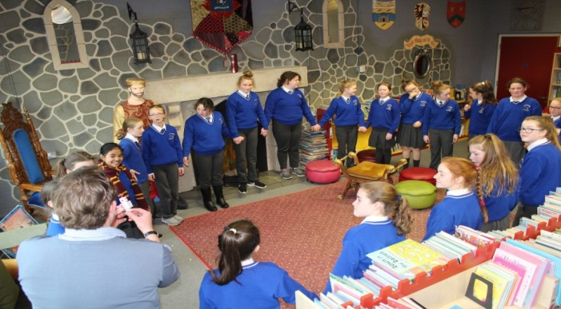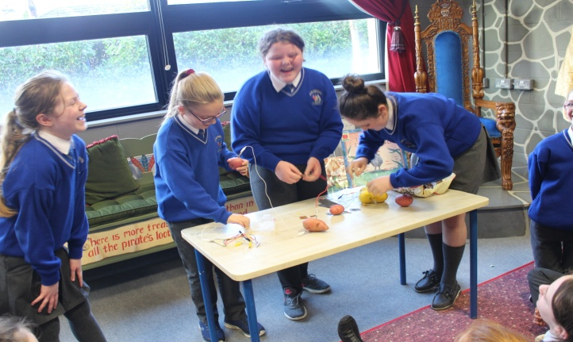

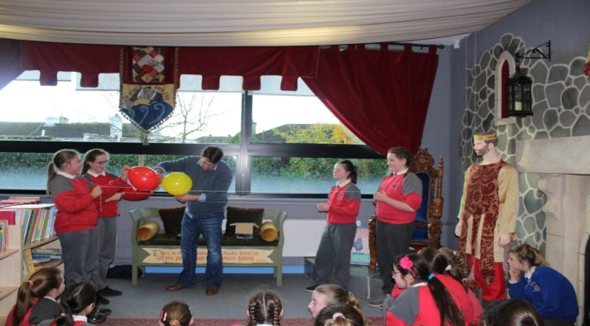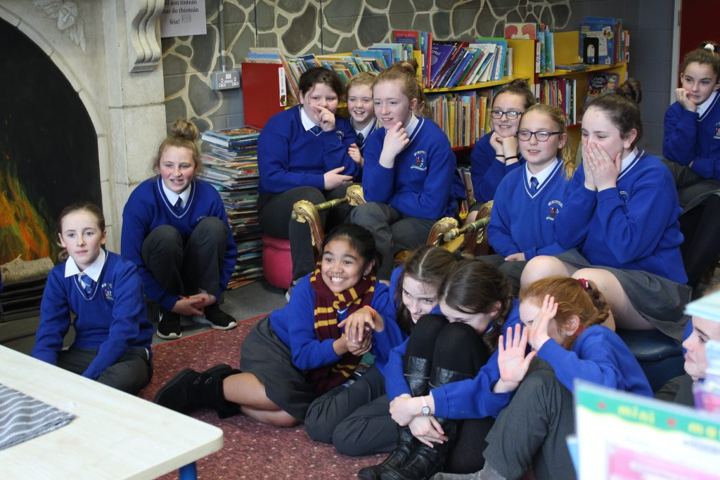

**Dea Nuacht**

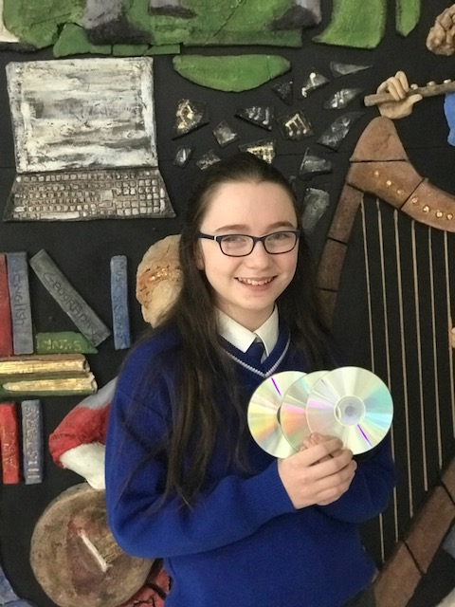

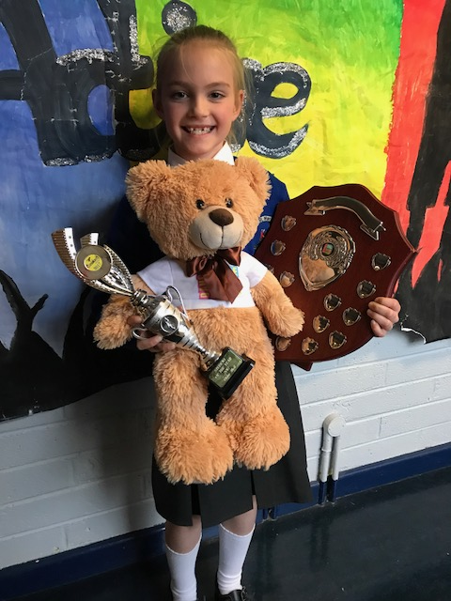

Amy has recently recorded her Christmas single ‘Rockin’ around the Christmas Tree’. It will be launched on Dec 7 in Lenihan’s at 7 pm. (Child friendly - all welcome!)

Congratulations to Chloe who won Student of the Year for Danceforce Academy

Mise le meas,



Cóilín Ó Coigligh, Príomh Oide.

**Green News**

**Community News**

***Nathanna na Seachtaine: Tá tuirse orm***

***Seanfhocal na Míosa:*** *Ní neart go cur le chéile (Strength in togetherness)*

**Dates to Remember**

**Assembly:** Friday @ 9.30am. Light of My Life Cermony. All Welcome

**Meitheal:** Every Tuesday morning 9.30-10.30.

**Badminton:** Mondays 3-4pm for 5th & 6th Classes

**Drama Club:** Every Thursday 3-4pm 4th – 6th Class

**Banna:** Tuesdays @ 3.000 – 4.00

**Communion: Saturday 5th May @ 11.00**

**Confirmation: Saturday 10th Feb @ 11.00**

**Green News**

Our Siopa Glas was a huge success last Friday! As we said we had our own Black Friday...Siopa Dubh! Many thanks to all those who sent in items and those who supported the great cause by purchasing items and raffle tickets. We haven’t calculated the total made yet but Sr Claudia sends her gratitude and assures us that the money raised will be put towards the Flamboyant Special Needs bus. She will send us photographs from Zambia and we will share them with you.

On Thursday we had three wonderful energy workshops with Aidan Gray in our school library. The pupils in Rooms 13, 30 and 31 carried out some exciting experiments and learned a lot about energy sources and the transferring of energy. The photos say it all! Thank you to Aidan for always supporting us along our Green journey.

WOW will continue as normal this week. Meet up at Mornington House or at the Matchbox at 9:00am. Well done to all the pupils and parents who continue to support this initiative and of course to the WOW teachers who make it all possible.

Recycling continues in school. We accept batteries, ink cartridges, mobile phones, card, toilet rolls, cans, footwear and postage stamps. Many charities benefit from our recycling and it is a great habit to cultivate in our pupils**.** Many seasonal art projects require the inside tube of toilet rolls so they will be put to good use! Remember also that gift tags can be made for recycled Christmas cards so we will be encouraging you to recycle these after Christmas.

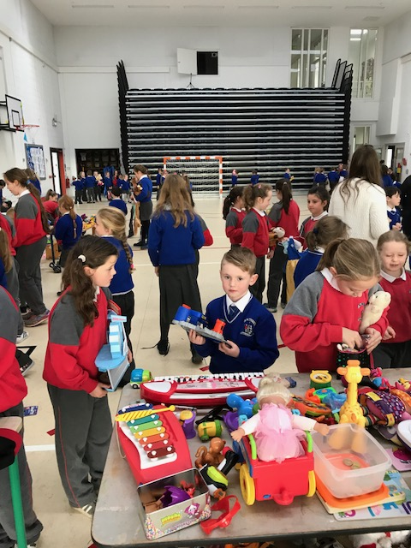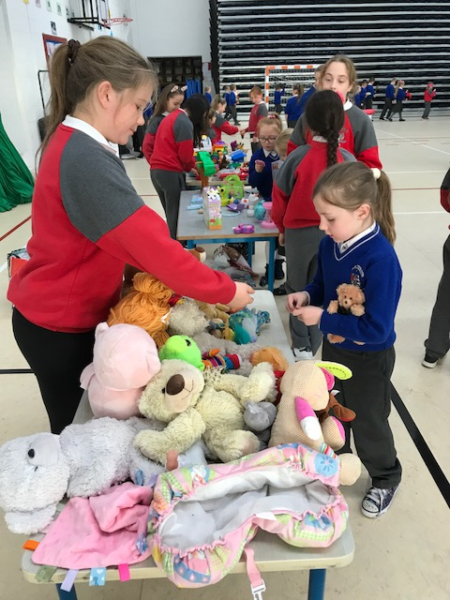

***Remember Green is cool, at home, at school and around the globe!***

St Mary’s Parents’ Association

Thank you to all who helped on the Christmas card project since October. We hope you have all received your little one’s Christmas Cards, which the children were given last Thursday. The artwork this year was brilliant. Well done to all who participated.

Dates for Your Diary:

**December 1st**: Light of my Life Ceremony in the school Hall. 9. 30 Am. A chance to remember all our family and friends who will not be with us this Christmas. The Christmas tree lights will also be switched on. All Parents/Guardians welcome to attend.

**December 6th**: A Classical Evening in St Patrick’s Cathedral featuring 6th class student Amy Rigney and St Mary’s Choir along with a host of amazing talent.

**December 15th**: Parents Association Meeting at 9.30am in the Staffroom. All welcome to attend.

<https://www.facebook.com/stmarysparentsassoc/>

Many thanks for your continued support.

Caroline Smith

Secretary

**Community Notices**

**Homework Club** in St Mary’s for children from 1st – 6th Classes. Application Forms are available from Ms Conaty Room 11 or Ms Lynch Room 31.

**AFTER SCHOOL CLUB** Taking place in St. Mary's School Trim from 2-3pm Mon - Friday in room 5. Only €6 a day or €25 for 5 days Mon-Fri Application forms available from reception. Booking required a week in advance of start date to insure space, and rebooking and payment made the previous Thursday each week after. Kids will be provided a small snack and entertained with Lego, Art & Craft, Board games, quizzes, card games, puzzles and lots more fun activities! Run by an experienced Childcare Professional Parent who is fully Garda Vetted and Insured. Contact Julie O'Donohue to book your child's space by texting 0868505310, emailing [juliekerins@hotmail.com](mailto:juliekerins@hotmail.com) or via a PM on the Facebookpage:[www.facebook.com/TrimAfterSchoolClub](http://www.facebook.com/TrimAfterSchoolClub)  
  
**Jiggle 'n' Jump** Music & Movement classes for little ones (8mths-4yrs) running upstairs in Trim GAA on Tuesdays 9.45-10.45am €7 a class or 4 class card for €25 Only €5 during September and all money raised on Tuesday 5th September is going to Crumlin Children's Hospital via Jack O'Donohue's A Bit of a Walk Fundraiser.   
  
Also available for Kids Party Entertainment! Various characters and themes with fun games, dancing, face painting and prizes! Clown, Pirate, a number of different Princesses, 80's Disco Diva, sporty Diva and Super Heroes available. Birthdays, Weddings, Christenings or family fun events.......in your home or in a venue, packages to suit any needs or budget. Contact Julie on 0868505310 or on Facebook [www.facebook.com/jigglenjump](http://www.facebook.com/jigglenjump)

