***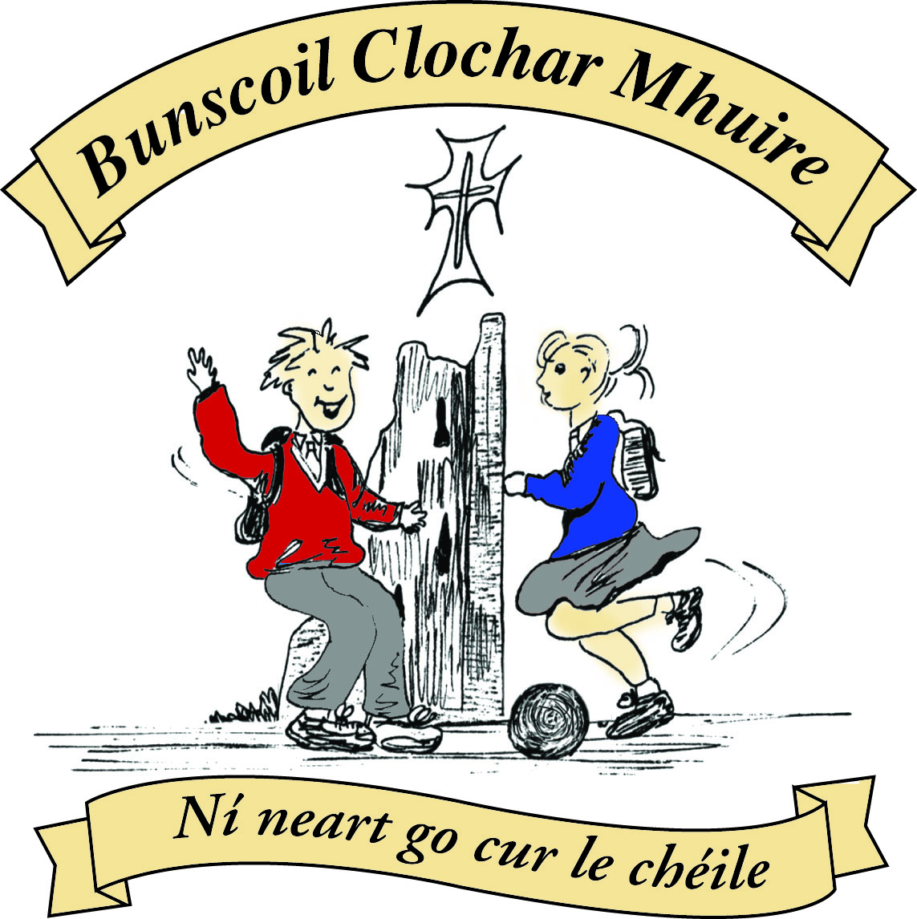* St Mary’s Convent Primary School**

***Bunscoil Clochar Mhuire***

***Trim, Co. Meath.  
Fón: (046) 9431919 ⦁ Faics: (046) 9437942  
Ríomhphost:*** [***marystrim@eircom.net***](mailto:marystrim@eircom.net) ***⦁ Website:*** [***www.stmarystrim.ie***](http://www.stmarystrim.ie) ***Uimhir Rolla: 16646O***

Awarded Green Flag  
June ‘05/’07/11/13

***Imlitir 13***

28th November, 2016

***Every Day Counts at St Mary’s Convent Primary School***

***21st November - 25th November 2016***

|  |  |  |  |  |  |  |  |
| --- | --- | --- | --- | --- | --- | --- | --- |
| **Room** | **Attendance** | **Room** | **Attendance** | **Room** | **Attendance** | **Room** | **Attendance** |
|  |  |  |  |  |  |  |  |
| 01 | 92.6 % | 08 | 92.5% | 16 | 92.6% | 26 | 97.6% |
| 02 | 79.2% | 09 | 91.6% | 17 | 87.7% | 27 | 95.8% |
| 03 | 94.8% | 10 | 95.6% | 18 | 95% | 30 | 96.2% |
| 04 | 90.4% | 12 | 95.6% | 19 | 97.1% | 31 | 91.4% |
| 05 | 93.1% | 13 | 95.3% | 20 | 92.9% |  |  |
| 06 | 92.8% | 14 | 97.1% | 23 & 24 | 95.7% |  |  |
| 07 | 96% | 15 | 95% |  |  |  |  |

*Please note that notification in writing to the teacher is required for all absences. A letter or note in the homework journal will suffice*.

A chairde,

Please note that there is a very bad tummy bug in the lower end of the school and that many pupils and teachers have come down with it in the last week.

**Readalong:** finishes on Wednesday next. Mrs Flattery has a small prize waiting for all those who bring back their cards.

**Christmas Pageant**: December 21st at 1.00 and 6.30 in the Dr Eileen Reilly Hall. Tickets will go on sale shortly. Proceeds to Trim Saint Vincent De Paul and Trim Meals on Wheels.

**Parent Teacher Meetings:** The remainder of meetings take place this Wednesday. Please note that the school closes at 2.45 on this day. The Junior Infants meetings will take place in February and you will be given advance notice of the dates.

**Volunteers:** We are still looking for volunteers to listen to the younger children reading. If you have an hour per week to spare, please contact Helen, in the Office. If you have more time to spare you might consider helping Junior Infants class with Team Teaching or helping out in our school library. The library helpers have made a huge difference to the smooth operation of our library and we would welcome a few more on Friday mornings 9.20-11.00.

**Enrolment Forms** for September 2017 are now available from Helen in the office.

**Folens Christmas Annuals** available from Helen in the office €4.00 each.

**Our Annual Light of My Life Ceremony** to remember departed relatives and friends takes place on Friday 2nd December in the Dr Eileen Reilly Hall @ 9.30. See separate letter from our Parents’ Association. All welcome.

***Board of Management Agreed Report:*** *B.O.M. met on Tuesday 22nd of November. A number of policies were reviewed, which are central in the day-to-day running of the school. These included Administration and storage of medicine, enrolment, long term leave, safety statement, critical incidents, child protection, job-sharing,  substance misuse prevention and the anti-bullying policy. At the next B.O.M meeting code of behaviour and critical incidents policies will be reviewed. The Board will meet again on Tuesday 7th of February. Barbara Munelly*

Mise le meas,



Cóilín Ó Coigligh, Príomh Oide.

**Green News**

**Community News**

**Nathanna na Seachtaine (don Siopa Glas):** **Cé mhéad? Seo duit. Go raibh maith agat**.

**Seanfhocal na Míosa: Nuair a bhíonn an cat amuigh, bíonn na lucha ag rince**

**When the cat’s away, the mice will play.**

**Dates to Remember**

**Assembly: Light of my Life Ceremony Friday 2nd @ 9.30.**

**All Welcome**

**Banna Ceoil:** Every Tuesday. **All classes will finish @ 4.00pm**

**Meitheal:** Every Tuesday morning 9.30-10.30.

**Badminton:** Mondays 3-4pm for 3rd & 4th Classes. No Fee.

**Communion:**  Sat May 13th @ 11.00

**Confirmation:**  Sat 11th March

**Green News**

The week you have all been waiting for has finally arrived, that is the week of the **Siopa Glas**! If you haven’t already sent in your items, you still have tomorrow. The Siopa will open at 9:30 on Wednesday morning. There is no need to start queuing from early morning!!! Every class will be assigned a time and there will be plenty for everyone!

The proceeds of our Siopa Glas will the Special Needs School in Zambia that we try to help every year. Sr Claudia has recently returned from there and will be in to tell us about how our funds have helped the children in Flamboyant Special Education School. We thank all of you who have donated used books, toys, clothes and other items. Please remember to send some money in with your child on Wednesday. Even if they have a few cents, we’ll make sure they get something and that the few cents go towards our very worthy cause. We always try to make a contribution to a local charity also. This year we would like to offer it to the local Civil Defence organisation which wants to help local families who might be struggling this time of the year.

WOW continues every Wednesday. Meet up at Mornington House or at the Matchbox at 9 am. Big thanks to the teachers who turn up every week despite the conditions. Why not surprise them by walking in bigger numbers this week! Remember to wrap up well in coats, hats and scarves this time of year.

Global Citizenship is our Green Theme this year. The emphasis is on Litter and Waste. We recycle batteries, mobile phones, small plastic bottles, cans, card and toilet rolls here at school We are being mindful of how we dispose of our different types of waste. Some classes will make an educational trip up to the Recycling facility in the New Year. It is wonderful to see how vigilant the pupils are about recycling and how much more of a life habit it has become since the start of the Green Flag campaign in St Mary’s. Remember to use recycled clothes when designing costumes for the Christmas plays and when receiving your Christmas Cards, keep the stamps for our used Postage Stamp campaign. Old Christmas Cards can also be nicely converted into gift tags.

***Remember green is cool at home, at school and around the globe!***

**Community Notices**

ZUMBA  TOY  DRIVE :-    THIS WEEK !!

Many of you may know Tina Fagan who does AMAZING work all year round with struggling families and those down on their luck. However at Christmastime, she turns into a cross between Wonder Woman and Santa Clause and really pulls out all the stops to ensure that the children in these families experience Christmas as children should.  
Following on from the HUGE success last Christmas, this year we are hoping to help again!   
Admission to all classes this week will be a toy.......age group & value is up to you :-  
  
Zumba        -  8pm  Monday 28th November,   
ZumbaKids -  3.15pm Tuesday 29th November and   
Zumba        -  8pm  Wednesday 29th November   
Let's help put smiles on kiddies faces on Christmas morning..........please help spread the word, SHARE the event  (see Facebook page  Zumba Trim Lorraine) and maybe drag a couple of friends or family with you to the class. Please note that the toys should be new.        Contact Lorraine 086 8693546

**Christmas Puppet Show.**

Daniel O' Dog is the presenter of The Night Show, a multimedia Christmas puppet show experience in Trim tomorrow evening. All families are welcome to attend this great production, the latest in a series of newly written shows, which explain the meaning of Christmas. On two previous occasions RTE recorded and broadcast the puppet show. Admission free. Venue: Living Hope Church. Time: 7:00pm Tuesday 29th November. The show lasts 45 minutes. Refreshments served after the show.

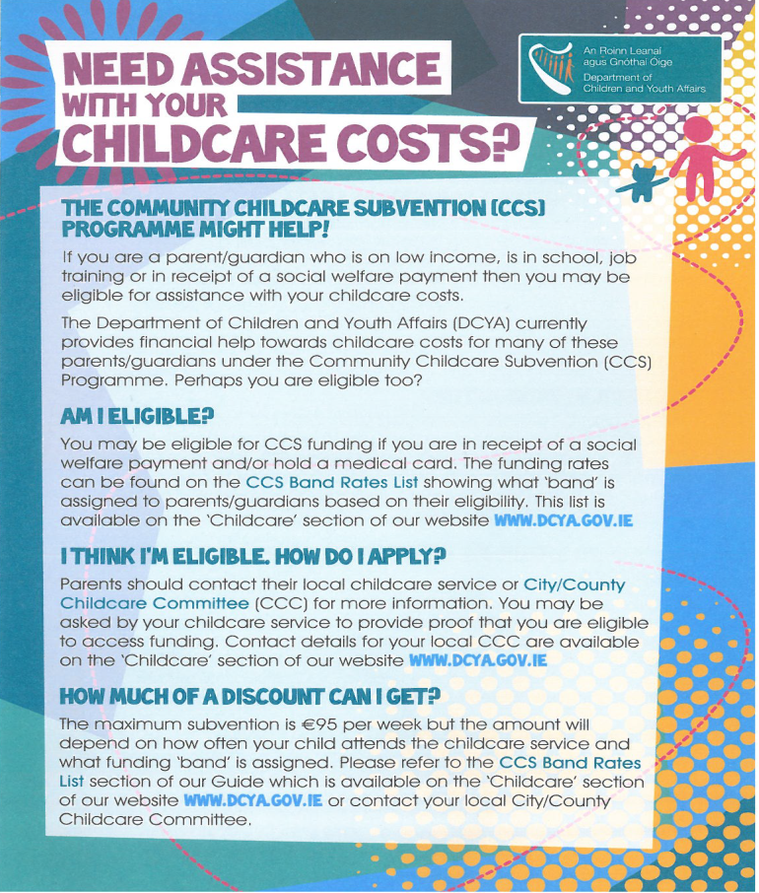

**Judy Moriarty** will be launching her book “Penny Phelan’s Magical Month of December” on Thursday the 8th December between 7 – 8pm in Trim Library. All proceeds to local charities – Meals on Wheels in Trim & Navan Women’s Refuge. All are welcome to attend.

**Basketball** at St Mary’s School. Boys (8-12) every Tuesday from 4-5pm. Girls (8-12) every Wednesday 4-5pm. Limited Spaces Contact [etcprojectsie@gmail.com](mailto:etcprojectsie@gmail.com) or 087-9134334.

**School Cleaner** required to cover sick days. Contact Helen in the office for further information 046-9431919.

**AFTER SCHOOL CLUB**

Taking place in St. Mary's School Trim from 2-3pm

Only €5 a day or €20 for 5 days Mon-Fri

Application forms available in room 6 2-3pm or reception. Booking required at least a day in advance to insure space, and rebooking and payment made the previous Thursday.

Kids will be entertained with Lego, Art & Craft, Board games, quizzes, card games, puzzles and lots more fun activities!

Run by an experienced Childcare Professional Parent who is fully Garda Vetted and Insured.

Contact Julie O'Donohue to book your child's space by texting 0868505310, emailing [juliekerins@hotmail.com](mailto:juliekerins@hotmail.com) or via a PM on our Facebook page: [www.facebook.com/TrimAfterSchoolClub](http://www.facebook.com/TrimAfterSchoolClub)

Jiggle 'n' Jump

Music & Movement classes for little ones (8mths-4yrs) running upstairs in Trim GAA on Tuesday 9.45-10.45am

€7 a class or 4 class card for €25

Also available for Kids Party Entertainment!

Various characters and themes with fun games, dancing, face painting and prizes!

Clown, Pirate, Princess, 80's Disco Diva and Super Hero available.

New Party Package insures 2 hours of non stop entertainment, with face painting by Linda (Flawless Facepaint) while I entertain the kids with singing, dancing, party games and non stop fun!!

Contact Julie on 0868505310 or on Facebook [www.facebook.com/jigglenjump](http://www.facebook.com/jigglenjump)

Trim Parent, Baby & Toddler Group

Running Monday and Wednesdays during school term 9.45-11.45am upstairs in Trim GAA

Only €4 per family

Fun toys, colouring in, play doh, tea, coffee, juice and biscuits with a little sing along at the end.

All welcome......first time parents, grandparents, child minders.....anyone looking to get out and keep the little ones entertained while you can chat and enjoy a cuppa too!