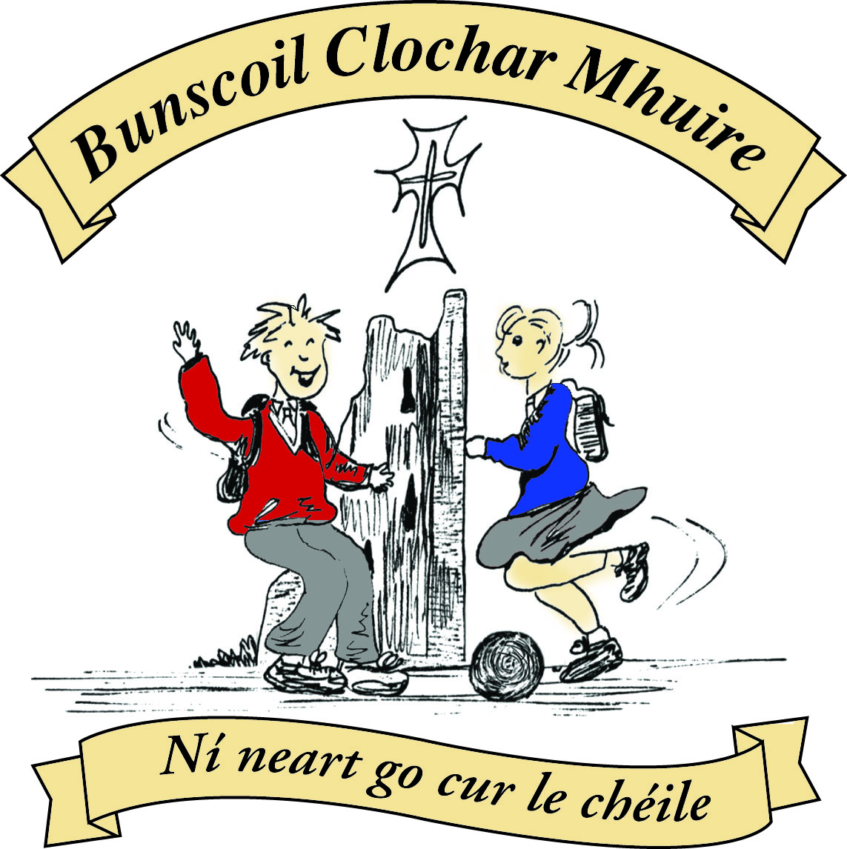
St Mary’s Convent Primary School
Bunscoil Clochar Mhuire
Trim, Co. Meath.
Fón: (046) 9431919 Faics: (046) 9437942
Ríomhphost: marystrim@eircom.net Website: www.stmarystrim.ie
Uimhir Rolla: 16646O
Awarded Green Flag
June ‘05/’07/11/13

Imlitir 13
23rd November, 2015.

Every Day Counts at St Mary’s Convent Primary School
16th – 20th November 2015
Room | Attendance | Room | Attendance | Room | Attendance | Room | Attendance
01 | 94.1% | 08 | 93.6% | 16 | 98.5% | 26 | 96.3%
02 | 97.7% | 09 | 97.8% | 17 | 96% | 27 | 93.6%
03 | 96% | 10 | 92.1% | 18 | 94.3% | 30 | 89%
04 | 86.9% | 12 | 96.2% | 19 | 99.1% | 31 | 95.2%
05 | 90.7% | 13 | 97.7% | 20 | 98.3%
06 | 97.9% | 14 | 94.1% | 23 | 77%
07 | 83.1% | 15 | 95.2% | 24 | 100%

Congratulations to Room 24 on having full attendance last week. Their teacher will let them know this week what their prize is.

A chairde,

Please note that school closes for the pupils @ 2.45 on Wednesday next due to Parent Teacher Meetings.

Our Christmas Pageant, this year, will be performed by Rang 3 & 4 on Wednesday 16th December @ 1.00 pm and 7.00 pm in The Dr Eileen Reilly Hall. Please mark the date on your calendar. Tickets go on sale shortly. Proceeds go to Trim St Vincent De Paul.

Many thanks to all who supported our recent Book Fair. A total of approx €1000 was raised for our school which will be used to purchase new books for our classroom libraries.

Readalong is coming to an end on Monday of next week. We understand that these are difficult financial times but if every family does a little it will add up to a substantial amount for our school. The money will be put into our MUGA (Multi Use Games Area) Fund.

Enrolment Forms for September 2016 are now available from Helen in the office.

Text Service: Mobile numbers are now on our texting system, but in quite a few cases we do not have these numbers. This means that you will not receive reminders or important short notice messages. Please send in a mobile number to the school that can be used in these situations, and to contact you in case of emergencies, if you have not already done so. If you do not have a mobile number, please ask a friend with a child in the same class to keep you informed.

E-mail Address: Most communication to parents/guardians now takes place via email. Please ensure that we have a valid, current email address.

Parent Teacher Meetings: Many thanks for your efforts to attend meetings last week . We hope that it was a positive and worthwhile experience for all. Meetings continue on Wednesday of this week.

Head Lice: Parents/guardians are asked to check your child/ren’s hair on a weekly basis and to treat when necessary. Vigilance by all is required.

New Lines in Yard: As mentioned previously, we will be dividing the yard into separate play areas for the younger and older pupils. This week, possibly Wednesday, there will be a nice new red line put down and the division will start immediately from that moment.

Finally, congratulations to Yvonne Mc Elhinney and Patrick O Donnell on being elected the parents’ nominees on our new Board of Management. We wish them every success.

Community Notices
Green News

Nath na Seachtaine: Tá sé fuar/fluich/scamallach/gaofar. It is cold/wet/cloudy/windy
Seanfhocal na Míosa: Nuair a bhíonn an cat amuigh bíonn na lucha ag damhsa

Dates to Remember

Meitheal: Every Tuesday morning 9.30-10.30.
Banna Ceoil: Every Tuesday @3pm.
All Classes finish @ 4pm.
Do this in Memory of Me Mass: The next Do This in Memory Mass will be on Sunday 13th December. This date has been changed to facilitate the Confirmation preparation mass.
Assembly: Room 10 will have a Junior Assembly on Thursday @ 9.20. All Welcome

Green News

The Earth does not belong to man; Man belongs to the Earth. This we know. All things are connected like the blood which unites one family. Whatever befalls the Earth befalls the sons of the Earth. Man did not weave the web of life, he is merely a strand in it. Whatever he does to the web, he does to himself.’ (Chief Seattle)

These words of wisdom given by Chief Seattle remind us that we must respect Mother Earth and our fellow inhabitants. Everything we do has consequences. Our theme of Global Citizenship highlights this message. Here at St Mary’s over the next two years we will be concentrating once again on the strand ‘Litter and Waste Management’. We will be focussing on how best to recycle materials at school and reduce waste as much as possible. We will conduct waste audits and try to come up with creative ways to recycle materials at school.
At St Mary’s we have a long tradition of recycling. In the school, we recycle batteries, ink cartridges, mobile phones, postage stamps, card, toilet rolls, cans and eye glasses. The company that recycled the footwear for has come up with a new initiative. It will take paired footwear as well as clothing in wearable condition. A contribution will be made to the school when we achieve a certain weight. We would encourage you to send in any items that you are ready to recycle. Thank you in advance for your cooperation.
Our Siopa Glas will be also be held in the near future and the proceeds will be divided between a local charity and Sr Claudia’s special needs school in Zambia.

WOW (Walking on Wednesday) will continue even though the weather has grown very cold! Wrap up well and wear your hats and gloves to keep yourselves warm. It is also very important to remember hi-viz vests for extra safety! Meet up at Mornington House at 9:00am and the WOW teachers will walk you down to the school.

Remember Green is cool at home, at school and around the globe!

Community Notices

ZUMBA :- No experience, partner or booking required - 3 classes to choose from:-
MONDAY 8pm Trim GAA, TUESDAY 10.15am Breathe Yoga Studio, THURSDAY 8pm Dance Force Academy
€8 per class Contact : Lorraine 086 8693546

KIDS DANCE CLASS :- Ages 5-8 TUESDAY 3.15pm TRIM GAA €6 per class (Sibling rate €5)
Zumba, Hip-Hop, Rock 'n Roll, Jive............. Contact : Lorraine 086 8693546 / Jo 086 3381159

Music Lessons.
Learn to play a Musical Instrument Locally. Music classes take place in St. Mary’s on Thursday afternoons. Practical and Theory of music taught. Preparation for Graded examinations. End of term concert. Flute, Saxophone, Keyboard and Violin classes, €200 for 20 lessons. Wind instrument rental, details available on request. Contact Kieran Holt 087-6267477

Kids Brick Club
Thursdays 4-5 in Diocesan Hall, Loman Street, All ages and abilities welcome. Also Athboy Convent Community Centre, Thursdays 6-7. Kathy 086-1700215

Helping ADHD with Homeopathy
Dr Jaume Costa MD MFHom on Thursday 3rd December in Trim Library at 7.00pm. Please leave your name at library desk or contact library on 9430614.

Jiggle ‘n’ Jump
Music and movement classes running for little ones on Tuesdays and Thursdays in Oaktree Business Park. Call Julie on 0868505310 or check Facebook page.

Art Club
Art Club has started in rooms 8 and 19. Children can join on Mondays between 3-4pm. All welcome (from Senior Infants to 6th Class)

Festive 5km Relay
On Sunday 6th Dec @ 10.30am. Location Trim Town. Teams: 1 adult and 4 young people. €20 per team. Festive dress is encouraged. Prize for best dressed team. To register contact Trish\Karen on 087-4146653. All proceeds to The Lorraine O’ Brien Trust.

Personal Bag Appeal
Trim Youth Club is calling on our Community for their support in helping the Homeless this winter. They are looking for donations of essential items and sleeping bags. New and unused please. Local Drop off point every Friday 7-9pm Trim Youth Club, Navan Gate. 085-1447929.

St. Mary's Parents' Association

Dear Parents/Guardians,

Well done and Congratulations to all the pupils from St. Mary's who participated in the Bounce Gymnastics Competition in Navan yesterday, lots of medals won and we heard you were all terrific.

St Mary's Parents' Association will be having a bun sale on Friday November 27th in the hall. Each class will be assigned a time, as per an agreed timetable and will be escorted by their teacher. Each bun will cost 50c and all proceeds will go towards the MUGA fund. An average of €2 per child is recommended, which allows 4 buns per child.
Girls from 2nd, 3rd and 4th classes are being asked to provide buns for the sale open to all classes. Please see below some baking and packaging tips for our bakers to consider.

Tips for the bakers;
Do's
Go straight to the hall from 9am onwards with your buns etc.
Buns, biscuits, and bars are recommended.
Label any special dietary buns/biscuits and hand them in separately.
Cereal boxes with one side cut as a flap/lid and inside covered in tin foil make great boxes to send buns in and can be disposed of after.
For those who send in tubs, these will remain in the hall and can be collected. Please ensure names are on the boxes, so they can be easily identified.
Dont's
Send in whole cakes, as these can be difficult to cut.
Fresh cream not recommended, as these can be messy and buns are taken away in plastic bags.
Nuts are not recommended as an ingredient when baking, due to potential allergies. Please label if included.
We would like to thank in advance, the bakers and families supporting the bun sale. We hope this has helped and If you have any queries or comments, please do not hesitate to contact a member of the Parents Association.
Kind Regards,
Emma Fox
Vice Chairperson

