***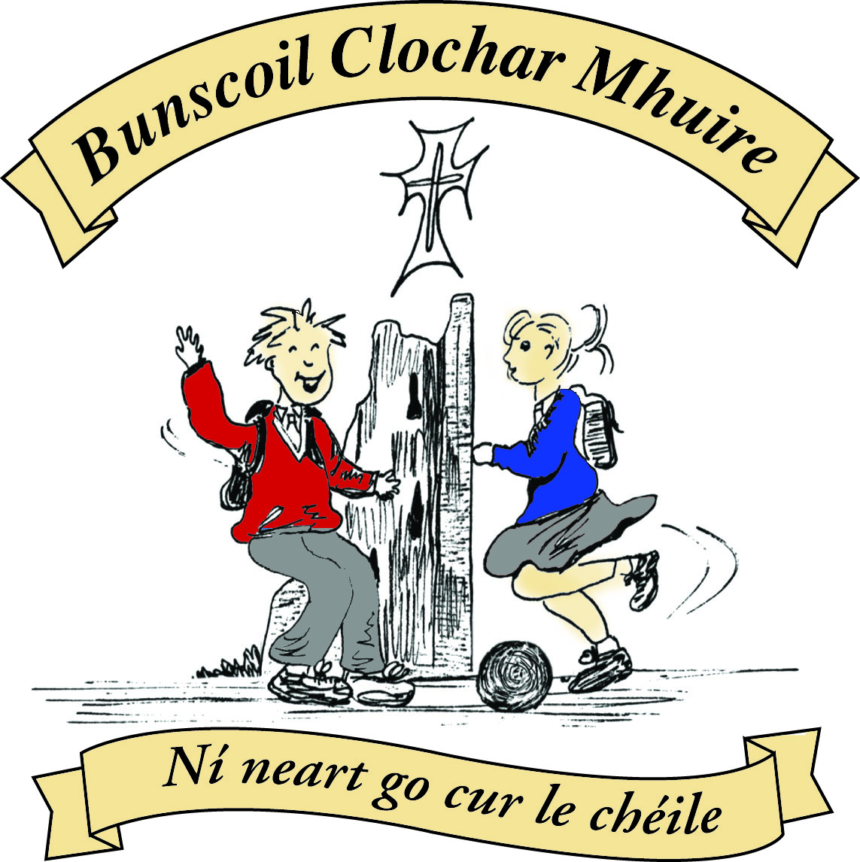* St Mary’s Convent Primary School**

***Bunscoil Clochar Mhuire***

***Trim, Co. Meath.  
Fón: (046) 9431919 ⦁ Faics: (046) 9437942  
Ríomhphost:*** [***marystrim@eircom.net***](mailto:marystrim@eircom.net) ***⦁ Website:*** [***www.stmarystrim.ie***](http://www.stmarystrim.ie) ***Uimhir Rolla: 16646O***

Awarded Green Flag  
June ‘05/’07/11/13

***Imlitir 1***

31st August 2017

A chairde,

*Fáilte ar ais roimh chách* (Welcome back!) I hope that you all had an enjoyable holiday and are well rested for another fruitful year. A special welcome is extended to all our new pupils and new staff: Ms Patricia and Ms Emma. *Go n-éirí go geal leo go léir* (May they all get on well). Welcome back to Ms Foley & Ms Conaty who return after maternity leave and to Mrs. Dixon who returns after Career Break.

Please note that the Junior Infants finish at 12.00 noon until Wednesday September 13th and at 2.00 p.m. thereafter. The Language Classes finish at 12.15 noon until Friday 8th September. First Classes finish at 2.00p.m. until Wednesday 13th September. Pupils from Junior Infants and First Classes will be given an appointment for Literacy and Numeracy Interviews after 12.00 on these dates. This will allow us build a Literacy and Numeracy Profile of pupils at the very beginning of the school year.

Please note that the school opens at 9.20 a.m. and closes at 2.00 p.m. for Infants and the Language Classes and 3.00 p.m. for all other children. No responsibility is accepted for pupils arriving before 9.20 a.m. Parents/guardians are asked not to line up beside their children in the mornings and not to block the walkways the children need to return to their classrooms. If you are unable to “Drop and Go” please wait behind the lines (in the basketball court) to facilitate the lines of children unobstructed entry to the school. Parents who wish to have their children escorted home should make their own arrangements to have them met at the school no later than 2.00 p.m. (Infants and Language Classes) and 3.00 p.m. (others). The school cannot accept responsibility for looking after children after their finishing time. Please note also that the school cannot release children during school hours (e.g. for dental appointments etc.) unless they are collected and a signed release slip given to the class teacher. Please allow the extra time that this may take. Excepting the Language Classes, please let teacher know in writing if your child goes home by bus @ 2.00p.m.

A copy of our school Calendar has been given to the eldest child in each family yesterday. Many thanks to our sponsor Ted Murtagh, Clothing and Footwear, Haggard Street, Trim. Spare copies of our calendar will be available from our sponsor during the school year, should you need a replacement.

Please ensure that all “monies paid to the teacher” are paid as soon as possible. Teachers need to buy materials now, for the coming year. Reminder letters will issue during the first week of October. We are aware of these difficult financial times, there is no problem paying by instalments, to suit you, just contact the teacher or Helen in the office. We now also have an online banking facility available to facilitate payments to the school. Contact Helen in the office for more details.

I would like to remind parents/guardians of the voluntary contribution (€50 per family) for the Computer Room. Without this contribution we would not be in the fortunate position of having an up-to-date Computer Room, I.T. Equipment and having a computer teacher (Debby), who also does repairs and technical support. A full statement of spending was issued on 27th June last with Imlitir No 37. If you would like another copy of same, please ask Helen, in the office. A total of €13,601.96 was spent on I.C.T. last year, of which €13,065.49 came from this voluntary contribution. The family contribution of €50 is greatly needed and much appreciated. Please give it your full consideration. Payments in instalments and online payments can be easily arranged. Thank you.

**Meitheal:** Parents/Guardians do voluntary work for the Infants and First Classes on Tuesday mornings from 9.30 -10.30. They have even been known to have a cup of coffee and a chat while doing so! The group re-starts on Tuesday September 12th Should you wish to be involved or require further information, please contact Helen or just turn up on the day.

**Listeners:** We also have a group of parents/guardians who volunteer to listen to children reading. Please contact Helen for further details or to join up. This will be organised at a time and day to suit you and is done on an individual basis. Volunteers will be contacted by the school, by phone, to finalise details.

**Extra-curricular activities:** Rounders and Camogie for Third to Sixth classes start on Monday 4th and Wednesday 6th respectively, from 3.00pm to 4.00pm. All pupils welcome.

**Please ensure that your child’s name is on his/her jacket and other items of clothing.**

**Text-a-Parent:** The school uses text messaging to communicate with parents, as the need arises. It is particularly useful in emergency situations or for issuing reminders. Please ensure that you nominate which mobile number is to be used for this purpose. Failing this, the school will use the number of the mother/guardian. If you do not have a mobile phone please make arrangements for a friend to pass on this information to you.

***Imlitreacha* (Newsletters):** Weekly newsletters are usually sent out on Mondays. Being a Green School, we issue them by email. This is the second last “hard copy” that will be issued to everyone. They will be available in hard copy by request only to those without an email address after Monday 11th. Parents who are separated may request two copies. Contact Helen in the office. Please check your email on Mondays for future communications. If you have not already done so, please ensure that we have your email address and contact us on Tuesday of the following week if you have not received a copy of next Monday’s newsletter.

Mise le meas



Cóilín Ó Coigligh,

Príomh Oide.

**Green News**

**Community News**

**Nathanna na Seachtaine: Dia duit! / Dia 's Muire duit**

**Seanfhocal na Míosa: Tús maith, leath na hoibre!**

**Dates to Remember**

**Assembly:** Friday @ 11.10 All classes except Junior Infants

**Meitheal:** Every Tuesday morning 9.30-10.30.

**Camogie:** Starts Wednesday 6th 3.00-4.00 p.m. Third – Sixth Classes

**Rounders:** Starts Monday 4th  3.00-4.00 p.m. Third – Sixth Classes

**Green News**

Welcome back everyone to what we hope will be a great year! We will be continuing our Global Citizenship journey with the emphasis on Energy over the next two years. Our WOW and COW initiatives will resume soon and recycling will continue this year.

***Remember Green is cool at home, at school and around the globe!***

**Community Notices**

**Limelight Theatrics** - Performance Singing/Musical Theatre classes.  *Tuesday evening 6.15pm to 7.15pm (Under 12's)  & 7.30pm to 8.30pm (Over 12's) Wednesday 7.15pm to 8.15pm (mixed)

**DRAMA CLASSES**:  Tuesdays  5.15pm to 6.15pm (mixed age)  Wednesday 4.30pm to 5.30pm (mixed age) Wednesday 6pm - 7pm (Over 12's) Classes commence the week of 12th of September. Contact  Carmel McKiernan BA, LIBSD on 0863923334 for further info

**Boyneside Speech & Drama**. Classes take place after school in St Michaels Primary School. And commence on Wed 6th and Thursday 7th September for students from senior infants to leaving cert.

Contact Dorothy on 087-2201981 or email [dorscully@gmail.com](mailto:dorscully@gmail.com)

Something for everyone at **Breathe Yoga & pilates**, Mum & Baby yoga Mondays 11.30am, Baby massage Fridays 11.30am, pregnancy yoga Thursdays 7pm. For more info & to book see [www.breatheyogapilates.ie](http://www.breatheyogapilates.ie)

