***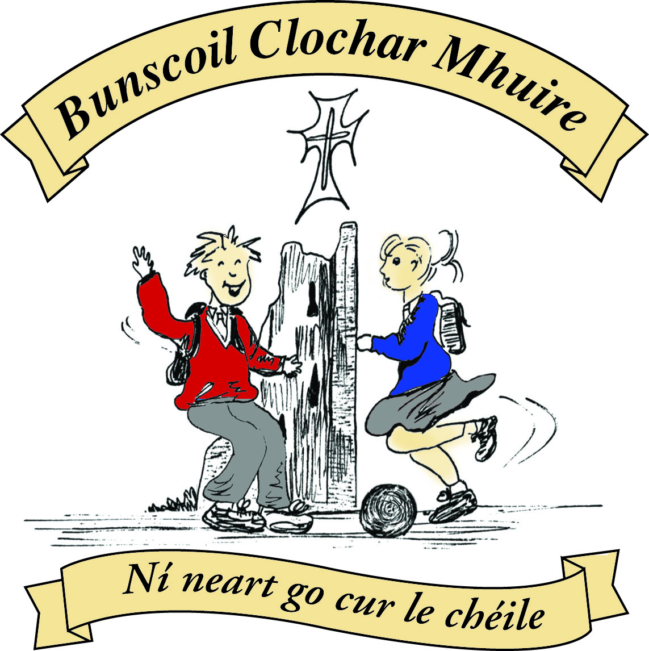* St Mary’s Convent Primary School**

***Bunscoil Clochar Mhuire***

***Trim, Co. Meath.  
Fón: (046) 9431919 ⦁ Faics: (046) 9437942  
Ríomhphost:*** [***marystrim@eircom.net***](mailto:marystrim@eircom.net) ***⦁ Website:*** [***www.stmarystrim.ie***](http://www.stmarystrim.ie) ***Uimhir Rolla: 16646O***

Awarded Green Flag  
June ‘05/’07/11/13

***Imlitir 1***

31st August, 2016

A Chairde,

*Fáilte ar ais roimh chách* (Welcome back!) I hope that you all had an enjoyable holiday and are well rested for another fruitful year. A special welcome is extended to all our new pupils and new staff: Mr Carmody, Mr Madden and Ms Ann Marie. *Go n-éirí go geal leo go léir* (May they all get on well).

Please note that the Junior Infants finish at 12.00 noon until Tuesday September 13th and at 2.00 p.m. thereafter. The Language Classes finish at 12.15 noon until Friday 9th September. First Classes finish at 2.00p.m. until Tuesday 13th September. Pupils from Junior Infants and First Classes will be given an appointment for Literacy and Numeracy Interviews after 12.00 on these dates. This will allow us build a Literacy and Numeracy Profile of pupils at the very beginning of the school year.

Please note that the school opens at 9.20 a.m. and closes at 2.00 p.m. for Infants and the Language Classes and 3.00 p.m. for all other children. No responsibility is accepted for pupils arriving before 9.20 a.m. Parents/guardians are asked not to line up beside their children in the mornings and not to block the walkways the children need to return to their classrooms. If you are unable to “Drop and Go” please wait behind the lines (in the basketball court) to facilitate the lines of children unobstructed entry to the school. Parents who wish to have their children escorted home should make their own arrangements to have them met at the school no later than 2.00 p.m. (Infants and Language Classes) and 3.00 p.m. (others). The school cannot accept responsibility for looking after children after their finishing time. Please note also that the school cannot release children during school hours (e.g. for dental appointments etc.) unless they are collected and a signed release slip given to the class teacher. Please allow the extra time that this may take. Excepting the Language Classes, please let teacher know in writing if your child goes home by bus @ 2.00p.m.

A copy of our school Calendar has been given to the eldest child in each family today. Many thanks to our sponsor Ted Murtagh, Clothing and Footwear, Haggard Street Trim. Spare copies of our calendar will be available from our sponsor during the school year, should you need a replacement.

Please ensure that all “monies paid to the teacher” are paid as soon as possible. Teachers need to buy materials now, for the coming year. Reminder letters will issue during the first week of October. We are aware of these difficult financial times, there is no problem paying by instalments, to suit you, just contact the teacher or Helen in the office. We now also have an online banking facility available to facilitate payments to the school. Contact Helen in the office for more details.

I would like to remind parents/guardians of the voluntary contribution (€50 per family) for the Computer Room. Without this contribution we would not be in the fortunate position of having an up-to-date Computer Room, I.T. Equipment and having a computer teacher (Debby), who also does repairs and technical support. A full statement of spending was issued on 28th June last with Imlitir No. 40. If you would like another copy of same, please ask Helen, in the office. A total of €18,969.28 was spent on I.C.T. last year, of which €13,509.00 came from this voluntary contribution. The family contribution of €50 is greatly needed and much appreciated. Please give it your full consideration. Payments in instalments and online payments can be easily arranged. Thank you.

**Meitheal:** Parents/Guardians do voluntary work for the Infants and First Classes on Tuesday mornings from 9.30 -10.30. They have even been known to have a cup of coffee and a chat while doing so! The group re-starts on Tuesday September 13th Should you wish to be involved or require further information, please contact Helen or just turn up on the day.

**Listeners:** We also have a group of parents/guardians who volunteer to listen to children reading. Please contact Helen for further details or to join up. This will be organised at a time and day to suit you and is done on an individual basis. Volunteers will be contacted by the school, by phone, to finalise details.

**Extra-curricular activities:** Camogie and Rounders for Third to Sixth classes start on Wednesday 7th and Monday 5th respectively, from 3.00pm to 4.00pm. All pupils welcome.

**Please ensure that your child’s name is on his/her jacket and other items of clothing.**

**Text-a-Parent:** The school uses text messaging to communicate with parents, as the need arises. It is particularly useful in emergency situations or for issuing reminders. Please ensure that you nominate which mobile number is to be used for this purpose. Failing this, the school will use the number of the mother/guardian. If you do not have a mobile phone please make arrangements for a friend to pass on this information to you.

***Imlitreacha* (Newsletters):** Weekly newsletters are usually sent out on Mondays. Being a Green School, we issue them by email. This is the second last “hard copy” that will be issued to everyone. They will be available in hard copy by request only to those without an email address after next Monday. Parents who are separated may request two copies. Contact Helen in the office. Please check your email on Mondays for future communications. If you have not already done so, please ensure that we have your email address and contact us on Tuesday of the following week if you have not received a copy of next Monday’s newsletter.

Mise le meas



Cóilín O Coigligh,

Príomhoide.

**Please keep the calendar below in mind while arranging vacations next year**

|  |  |
| --- | --- |
| **School Calendar 2016/2017** | |
|  |  |
| Mid-Term: | Monday 31st October - Friday 4th November 2016 |
| Christmas Break: | Friday 23rd December - Friday 6th January 2017 |
| Spring Mid-term Break | Thursday 23rd - Friday 24th February 2017 |
| Mid-term: | Monday 13th - Friday 17th March 2017 |
| Easter Break | Monday 10th April - Friday 21st April 2017 |
| May Bank Holiday: | 1st May 2017 |
| June Bank Holiday: | 5th June 2017 |
| School closes | Friday 30th June 2017 |

**Green News**

**Community News**

**Nath na Seachtaine**:  **Dia duit! / Dia 's Muire duit!**

**Seanfhocal na Míosa: Tús maith, leath na hoibre!**

**Dates to Remember**

**Meitheal:** Every Tuesday morning 9.30-10.30.

**Camogie:** Starts Wednesday 7th 3.00-4.00 p.m. Third – Sixth Classes

**Rounders:** Starts Monday 5th 3.00-4.00 p.m. Third – Sixth Classes

**Green News**

Welcome back to what we hope will be another very successful green year! We are commencing Year 2 of our Global Citizenship programme with specific emphasis on waste management.

Just before the summer holidays, our very good friend and Environmental Officer, Peter Brady retired from his post in Meath County Council. He was a wonderful support to us here in St Mary’s over the years and we will miss him and his green vision now that he has retired. We wish him and his family good health and continued happiness for their future endeavours and we might even invite him back for a flag raising ceremony, if we are lucky to be awarded one at the end of the year!!

Welcome to any new parents who have joined the St Mary’s Community. If you are interested in becoming part of the Green Flag Committee, please contact the school. We hold meetings once a month and we would love to hear your ideas!

***Remember Green is cool, at home and at school and around the globe!***

**Community Notices**

Jiggle 'n' Jump - Music & Movement classes happening upstairs in the Trim GAA. Tuesday's 9.45am

€5 a class for the month of September (€8 for two siblings)

Also, starting Toddler Art classes, afternoon Music & Movement class and an After School Club!

Face painting & various characters for party entertainment......lots of packages and very reasonable!

[www.facebook.com/jigglenjump](http://www.facebook.com/jigglenjump) Contact Julie on 0868505310

Parent, Baby & Toddler Group for parents, grandparents and child minders to meet, chat and enjoy a cuppa, while the kids play and have fun. Tea/coffee juice and biscuits for all and sing song at the end. Running Monday's 9.45-11.45am and Wednesday's 10-12 noon. Upstairs in the Trim GAA only €4 per family. :)

**Become a Confident communicator, ~Classes for students from 5 years +**

Boyneside Speech and Drama classes will recommence in St Michaels boys Primary School, Trim on Wednesday 7th and Thursday 8th September. Contact Dorothy for class details. 087-2201981 [dorscully@gmail.com](mailto:dorscully@gmail.com)