 St Mary’s Convent Primary School**

***Bunscoil Clochar Mhuire***

***Trim, Co. Meath.  
Fón: (046) 9431919 ⦁ Faics: (046) 9437942  
Ríomhphost:*** [***marystrim@eircom.net***](mailto:marystrim@eircom.net) ***⦁ Website:*** [***www.stmarystrim.ie***](http://www.stmarystrim.ie) ***Uimhir Rolla: 16646O***

Awarded Green Flag  
June ‘05/’07/11/13

***Imlitir 12***

21st November, 2016

***Every Day Counts at St Mary’s Convent Primary School***

***14th November - 18th November 2016***

|  |  |  |  |  |  |  |  |
| --- | --- | --- | --- | --- | --- | --- | --- |
| **Room** | **Attendance** | **Room** | **Attendance** | **Room** | **Attendance** | **Room** | **Attendance** |
|  |  |  |  |  |  |  |  |
| 01 | 96.3 % | 08 | 95.8% | 16 | 95.1% | 26 | 98.7% |
| 02 | 87.8% | 09 | 96.8% | 17 | 86.2% | 27 | 97.2% |
| 03 | 95.7% | 10 | 89.5% | 18 | 95.1% | 30 | 99.4% |
| 04 | 92% | 12 | 96.6% | 19 | 95.8% | 31 | 96.4% |
| 05 | 93.6% | 13 | 98.7% | 20 | 92.9% |  |  |
| 06 | 94.4% | 14 | 96.4% | 23 & 24 | 95.7% |  |  |
| 07 | 90% | 15 | 98.8% |  |  |  |  |

*Congratulations to Room 30 on nearly having full attendance last week*.

*Please note that notification in writing to the teacher is required for all absences. A letter or note in the homework journal will suffice*.

A chairde,

Please note that school closes for the pupils @ 2.45 on Wednesday next due to Parent Teacher Meetings.

Our **Christmas Pageant**, this year, will be performed by Rang 5 & 6 on Wednesday 16th December @ 1.00 pm and again at 6.30 pm in The Dr Eileen Reilly Hall. Please mark the date on your calendar. We have changed to the hall as we were unable to get a suitable date in the church. We are aware that this date clashes with the Scoil Mhuire Pageant, thus the reason for the earlier time and the second option. Tickets go on sale shortly. Proceeds go to Trim St Vincent De Paul and Trim Meals On Wheels.

Many thanks to all who supported our recent **Book Fair**. A total of approx €800 was raised for our school which will be used to purchase new books for our classroom libraries.

**Readalong** is coming to an end on Wednesday of next week. “Keep on Reading!”

**Enrolment Forms** for September 2017 are now available from Helen in the office. Please note that the submission date is January 27th and offers will be posted on February 3rd to be accepted by February 10th. It is a little earlier this year, by agreement of the principals in Trim, to enable schools to meet Special Education deadlines. This means that our Open Day has been moved forward to Thursday January 19th.

**Text Service:** Mobile numbers are now on our texting system, but in quite a few cases we do not have these numbers. This means that you will not receive reminders or important short notice messages. Please send in a mobile number to the school that can be used in these situations, and to contact you in case of emergencies, if you have not already done so. If you do not have a mobile number, please ask a friend with a child in the same class to keep you informed.

**E-mail Address:** Most communication to parents/guardians now takes place via email. Please ensure that we have a valid, current email address.

**Parent Teacher Meetings:** Wednesdays November 23rd and 30th. School closes @ 2.45 on both days.

**Head Lice:** Parents/guardians are asked to check your child/ren’s hair on a weekly basis and to treat when necessary. Vigilance by all is required.

**New Lines in Yard:** As mentioned previously, we will be dividing the yard into separate play areas for the younger and older pupils. Shortly, there will be a nice new red line put down and the division will start immediately from that moment.

***Meath Primary Schools Cross Country Championships***

*Last Wednesday, sixteen pupils from our school participated in the annual Primary Schools’ Cross Country Championships in Bellewstown Racecourse. We brought two teams to the event-under 11s and under 13s.The girls ran very well in cold, damp conditions and were great ambassadors for our school. We were well placed as a school in both events and many of the girls improved on their own personal best.*

*The under 11 team was represented by Sara Harten, Eimear Linsley, Caitlin Linsley, Aoibheann Diamond, Holly O’Donnell, Sarah Forde, Amy Boyle and Rachel Hannon.*

*Our under 13 team included Sarah Caulfield, Niamh Mahon, Ella Curran, Emma Gibney, Grace Vaughan, Bláthnaid Vaughan, Jessica Varley and Abby Moyles.*

*Well done, girls! We are very proud of you all!*

*M. O’Hare & M. Carr*

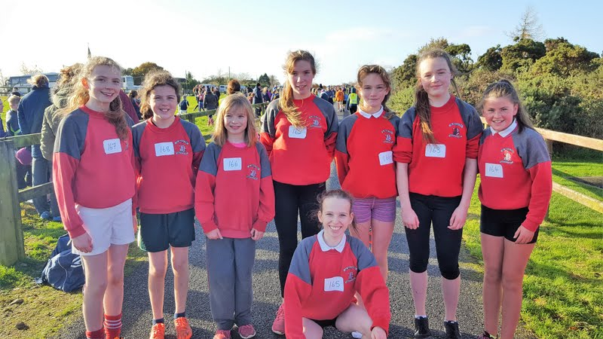

***Christmas Eve 5pm Family/Children's Mass****: To all our singers : Practice of Advent hymns/songs in preparation for Christmas Eve Mass will be held in Parish Centre this Wednesday 23rd  November at 6.30pm. All welcome , boys and girls who participated last year please come along and if you know a friend bring them too !! We had a great turn out at the practice last week - well done to all who came along.*

***Next Family Mass****7pm This coming Saturday 26th November . Ms Mc Gale*

***Commitment Mass for Confirmation Candidates will take place in St Patrick's Church, Trim on Sunday, November 27th at 11am.***

***Badminton for 3rd and 4th Classes on Mondays 3-4pm (no charge) - everyone welcome.*** *Mr. Galligan*

*Dear Parents/Guardians,*

*You are invited to attend the Parents Association Meeting on Friday 25th of November at 10am in the Staff room.  Please come along to meet with other parents where you will have the opportunity to voice any concerns or ideas you may have which will benefit your child and the entire school. Tea/coffee and refreshments will be available. Looking forward to seeing you there.*

*Caroline Smith, Parents Association Secretary*.

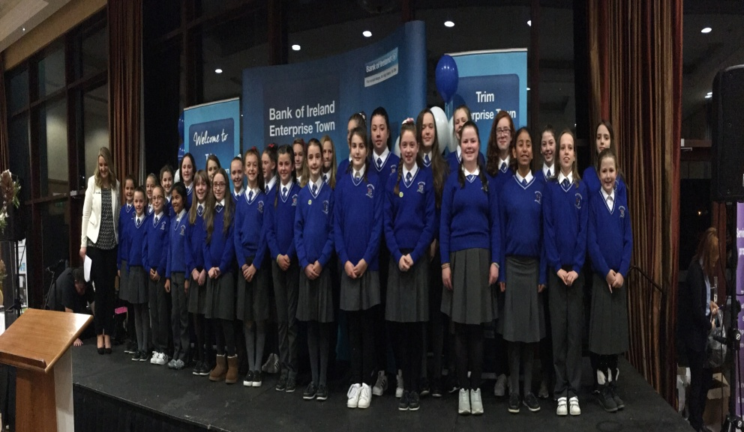***St. Mary’s School Choir*** *opened Trim Enterprise Town’s evening on Thursday 17th last in Trim Castle Hotel. They were the talk of the town!*  *Ms McKenna*

I would like to add my congratulations. They were brilliant. Many thanks to Ms McKenna and Ms O’Connor for the excellent training.

Finally, can I ask parents/guardians to be aware of the pupil lines entering school from the yard in the mornings. Please stand back and give them right of way. It you chose not to leave before the lines move, please stand back behind the lines and wait until all the lines have left. Thanks.

Mise le meas,



Cóilín Ó Coigligh, Príomh Oide.

**Green News**

**Community News**

**Nath na Seachtaine**: **Tá sé fuar (It is cold)**

**Tá sioc at an talamh (There is frost on the ground)**

**Seanfhocal na Míosa: Nuair a bhíonn an cat amuigh, bíonn na lucha ag rince**

**When the cat’s away, the mice will play.**

**Dates to Remember**

**Assembly: Health Promoting Schools** on Tuesday 22nd @ 9.20 Seniors

& 9.35 Juniors. All welcome.

**Banna Ceoil:** Every Tuesday. **All classes will finish @ 4.00pm**

**Meitheal:** Every Tuesday morning 9.30-10.30.

**Badminton:** Mondays 3-4pm for 3rd & 4th Classes. No Fee.

**Communion:**  Sat May 13th @ 11.00

**Confirmation:**  Sat 11th March

**Green News**

***Remember green is cool at home, at school and around the globe!***

Our annual Siopa Glas will take place on November 30. Any donations of toys or items you don’t need anymore are welcome. They will be sold at our Siopa Glas and the proceeds will be divided between a local Charity and the Flamboyant Special Needs School in Zambia. As our Green Flag theme is Global Citizenship, it is a nice way to help our friends here and around the globe.

In case you hadn’t a chance to view the following links, we will attach them again. At an information session recently these links were recommended: <http://worldslargestlesson.globalgoals.org/>

<https://vimeo.com/178464378>

Both of these links refer to the Global Goals that were drawn up by World Leaders in 2015. It is important that young people are taught about these goals as they are the future generation. As Neil Pathman says, ‘Children are the living messages we send to a future we will not see.’

Here at St Mary’s we continue to recycle what we can. We will accept cardboard, small plastic bottles, batteries, ink cartridges, cans, and postage stamps. Room 27 are also looking for used toilet roll centres. They are doing a large art project and they need lots of these if you can send them in too.

WOW continues every Wednesday. Meet up at Mornington House or at the Matchbox at 9 am.

**Community Notices**



**Judy Moriarty** will be launching her book “Penny Phelan’s Magical Month of December” on Thursday the 8th December between 7 – 8pm in Trim Library. All proceeds to local charities – Meals on Wheels in Trim & Navan Women’s Refuge. All are welcome to attend.

**Little Robins Childcare Robinstown.** Opening Jan 2017 and Enrolling Now. Pre School, After School and Breakfast Club. Contact Orla Reilly on 087-9472570 or email [LittleRobinsRobinstown@gmail.com](mailto:LittleRobinsRobinstown@gmail.com)

**ZUMBA**  :-

MONDAY  &  WEDNESDAY  8pm  TRIM GAA.  No booking, partner or experience required......just grab your water and your smile and get ready to dance your cares away!   €8 per class   Contact  :  Lorraine  086 8693546

**ZUMBA KIDS** :- TUESDAY   3.15pm  Trim GAA    No booking required,  €6 per class      Contact : Lorraine  086 8693546

**ZUMBA  TOY  DRIVE** :-    Week Commencing 28th November  (not this week,  next week!!)

Many of you may know Tina Fagan who does AMAZING work all year round with struggling families and those down on their luck. However at Christmastime, she turns into a cross between Wonder Woman and Santa Clause and really pulls out all the stops to ensure that the children in these families experience Christmas as children should.  
Following on from the HUGE success last Christmas, this year we are hoping to help again!   
Admission to class on the following dates will be a toy.......age group & value is up to you :-  
Zumba        -  8pm  Monday 28th November,   
ZumbaKids -  3.15pm Tuesday 29th November and   
Zumba        -  8pm  Wednesday 29th November   
Let's help put smiles on kiddies faces on Christmas morning..........please help spread the word, SHARE the event  (see Facebook page  Zumba Trim Lorraine) and maybe drag a couple of friends or family with you to the class  
Please note that the toys should be new