***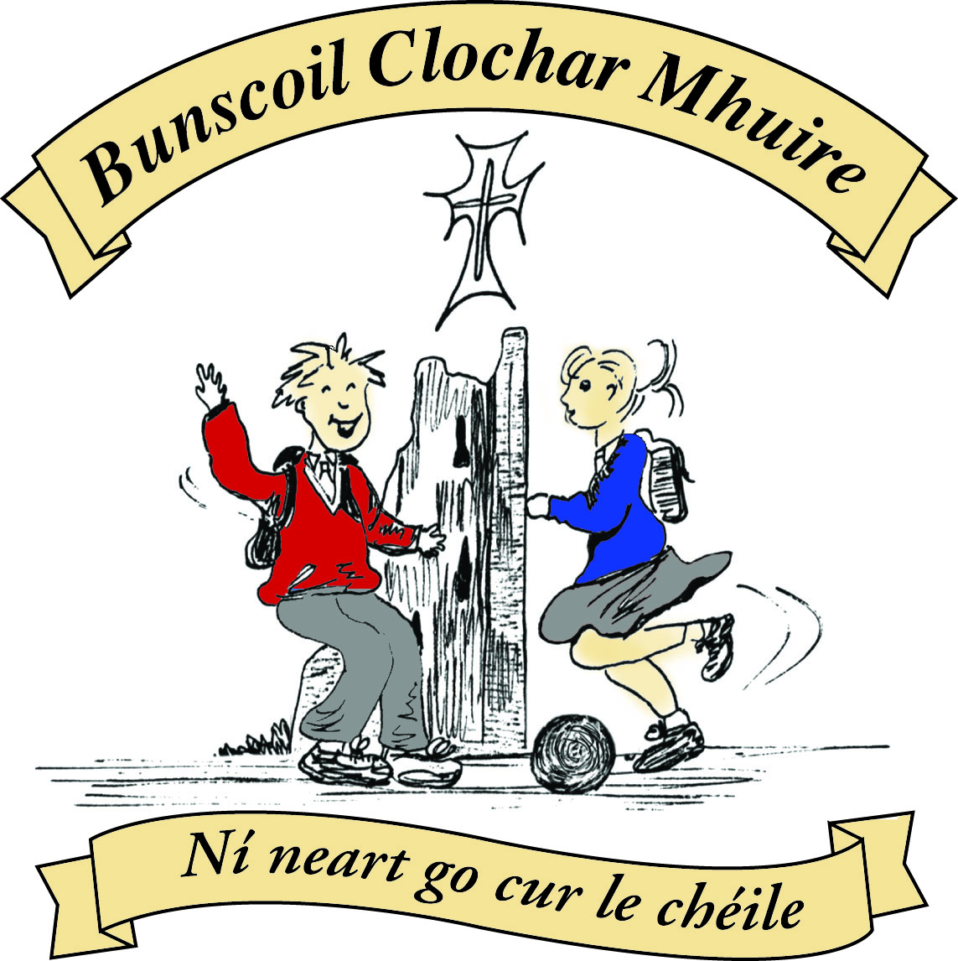* St Mary’s Convent Primary School**

***Bunscoil Clochar Mhuire***

***Trim, Co. Meath.  
Fón: (046) 9431919 ⦁ Faics: (046) 9437942  
Ríomhphost:*** [***marystrim@eircom.net***](mailto:marystrim@eircom.net) ***⦁ Website:*** [***www.stmarystrim.ie***](http://www.stmarystrim.ie) ***Uimhir Rolla: 16646O***

Awarded Green Flag  
June ‘05/’07/11/13

***Imlitir 11***

14th November, 2016

***Every Day Counts at St Mary’s Convent Primary School***

***7th November - 11th November 2016***

|  |  |  |  |  |  |  |  |
| --- | --- | --- | --- | --- | --- | --- | --- |
| **Room** | **Attendance** | **Room** | **Attendance** | **Room** | **Attendance** | **Room** | **Attendance** |
|  |  |  |  |  |  |  |  |
| 01 | 97 % | 08 | 93.3% | 16 | 95.6% | 26 | 98.4% |
| 02 | 93.8% | 09 | 94.8% | 17 | 95.4% | 27 | 91.7% |
| 03 | 98.3% | 10 | 93.3% | 18 | 97.5% | 30 | 95.4% |
| 04 | 96.3% | 12 | 93.8% | 19 | 93.6% | 31 | 98.6% |
| 05 | 96.2% | 13 | 98.7% | 20 | 95.7% |  |  |
| 06 | 94.4% | 14 | 91.4% | 23 & 24 | 95.7% |  |  |
| 07 | 96.8% | 15 | 97.1% |  |  |  |  |

*Congratulations to Rooms 3, 13, 26 & 31 on nearly having full attendance last week*.

*Please note that notification in writing to the teacher is required for all absences. A letter or note in the homework journal will suffice*.

A chairde,

**Parent Teacher Meetings** take place on Wednesday 23rd and Wednesday 30th from 3.00-5.30 each day. School finishes at 2.45 on both those days. You should by now have received your appointment. Please contact the school if you have not. These dates have been on our Calendar and mentioned in various *Imlitreacha*. Please make every effort to attend. If one of the Wednesdays does not suit you, feel free to request the other and we will do our best to facilitate you. Parents/guardians of Junior Infants, please note that your Parent Teacher meetings will not be at this time but in February. You will get more details closer to the time.

Please note that meetings with Special Ed and EAL teachers take place at the same times. We have tried to give these times close to the classroom times. Please contact the school if you have not received a Special Ed or EAL time.

Please note that **smoking** is not permitted anywhere on school grounds. Your co-operation is earnestly requested.

We had planned a Non-uniform Day for this Friday to raise funds for an I-Pad for the Cleft Pallet Team in Crumlin Children’s Hospital. Due to the various recent collections, we are postponing this fundraiser until February 22nd next year.

**Readalong:** Don’t forget to fill in the cards with the books and pages read. November is our Reading Month-see <http://www.reading.ie/content/tips-parents>

**Croke Park Hours:** The School has a total of 36 hours to work this year. To date we have worked a total of 14.5 hours on school planning, professional development and staff meetings. Our next Staff Meeting (after school) will be on Wednesday 16th November 3.00 – 4.30pm.

***Gaelbhratach:*** We are asking parents to come on board by encouraging your children to speak more Irish at home-even if it is only “*Más é do thoil é*” (please) and “*Go raibh maith agat*” (thanks). Have a look at <http://www.isfeidirliom.ie/> for some more assistance. *Go raibh maith agat*!

**Attendance:** in line with a directive from NEWB-the National Educational Welfare Board (<http://www.newb.ie/>) we are reminding parents/guardians of the importance of their child attending school and asking you not to arrange holidays during school term. We are required to inform NEWB if there has been a number of absences stating the reasons. When this happens, parents/guardians will be informed and invited to a meeting on the matter, with the school. We are also encouraging improved attendance. Pupils who arrive late are asked to come in to school through the front door rather that outside classroom doors and to sign The Late Book at reception. Congratulations to Rooms 3 and 18 who had the best class attendance for September and October.

Our annual **Christmas Pageant** will be performed this year by Fifth and Sixth Classes in St Patrick’s Church. The date has not been decided yet. All donations will be given to the local charities. Other classes will also be having **Nativity Plays** in their classrooms and donations will be accepted there for same. Further details of the Nativity Plays will be issued by the relevant class teachers in due course.

**Enrolment Forms** for September 2017 are now available from Helen in the office. Please note that the “Submission Date” is earlier this year, as agreed by the Trim schools: January 27th. Offers of places will posted on February 3rd.

***Banna Ceoil****: Tuesdays 3 - 4 pm for all 2nd  - 6th classes*

***Christmas Eve 5pm Family/Children's Mass****: To all our singers : Practice of Advent hymns/songs in preparation for Christmas Eve Mass will be held in Parish Centre this Wednesday 16th November at 6.30pm. All welcome , boys and girls who participated last year please come along and if you know a friend bring them too !!*

***Next Family Mass****7pm Saturday 26th November Ms McGale*

***Commitment Mass for Confirmation Candidates will take place in St Patrick's Church, Trim on Sunday, November 27th at 11am.***

***Badminton for 3rd and 4th Classes on Mondays 3-4pm (no charge) - everyone welcome.***

*Mr. Galligan*

Mise le meas,



Cóilín Ó Coigligh, Príomh Oide.

**Green News**

**Community News**

**Nath na Seachtaine**: **'......... is ainm dom'  ‘My name is .........’**

**Seanfhocal na Míosa: Nuair a bhíonn an cat amuigh, bíonn na lucha ag rince**

**When the cat’s away, the mice will play.**

**Dates to Remember**

**Assembly:** Greeen Flag @ 9.20 Friday for Juniors

All welcome

**Banna Ceoil:** **From 15th Nov all classes will finish @ 4.00pm**

**Meitheal:** Every Tuesday morning 9.30-10.30.

**Camogie:** Finished until next year

**Rounders:** Finished until next year

**Badminton:** Mondays 3-4pm for 3rd & 4th Classes. No Fee.

**Communion:**  Sat May 13th @ 11.00

**Confirmation:**  Sat 11th March

**Green News**

Global Citizenship is our Green theme this year with a specific emphasis on Litter and Waste. Last week a very interesting speaker from An Taisce presented a talk to the Fifth Classes on Marine Litter and Waste. The girls found it extremely informative and now have a clear understanding of the impact of litter on marine life and habitats. We are very grateful to Mr Gray for giving of his time and sharing his knowledge and expertise so willingly.

At an information session recently the following link and website were recommended: <http://worldslargestlesson.globalgoals.org/> and this little video <https://vimeo.com/178464378>

Both of these links refer to the Global Goals that were drawn up by World Leaders in 2015. It is important that young people are taught about these goals as they are the future generation. As Neil Pathman says, ‘Children are the living messages we send to a future we will not see.’

Here at St Mary’s we continue recycle what we can. We will accept cardboard, small plastic bottles, batteries, ink cartridges, can, toilet rolls and postage stamps.

Our Siopa Glas will take place on December 1st. This involves donating used toys and other items that are in good condition which can be sold at our Siopa. The proceeds from this recycling initiative will go to a Special Needs school in Zambia with which we have close ties. This is very fitting this year as our theme is Global Citizenship.

WOW continues every Wednesday. Meet up at Mornington House or at the Matchbox at 9 am.

***Remember green is cool at home, at school and around the globe!***

**Community Notices**

**Judy Moriarty** will be launching her book “Penny Phelan’s Magical Month of December” on Thursday the 8th December between 7 – 8pm in Trim Library. All proceeds to local charities – Meals on Wheels in Trim & Navan Women’s Refuge. All are welcome to attend.

**Little Robins Childcare Robinstown.** Opening Jan 2017 and Enrolling Now. Pre School, After School and Breakfast Club. Contact Orla Reilly on 087-9472570 or email [LittleRobinsRobinstown@gmail.com](mailto:LittleRobinsRobinstown@gmail.com)

**ZUMBA**  :-    MONDAY  &  WEDNESDAY  8pm  TRIM GAA.  No booking, partner or experience required......just grab your water and your smile and get ready to dance your cares away!   €8 per class   Contact  :  Lorraine  086 8693546

**ZUMBA KIDS** :- TUESDAY   3.15pm  Trim GAA    No booking required,  €6 per class      Contact : Lorraine  086 8693546

**AFTER SCHOOL CLUB** Takes place in St. Mary's School Trim from 2-3pm Only €5 a day or €20 for 5 days Mon-Fri Places are limited and need to be booked by the previous Thursday. Kids will be entertained with Lego, Play Doh, Art, Singing, Board games, quizzes, card games, puzzles and lots more fun activities.  Run by two experienced Childcare Professional Parents who are Garda Vetted.  Contact Julie O'Donohue to book your child's space by texting 0868505310, emailing [juliekerins@hotmail.com](mailto:juliekerins@hotmail.com) or via a PM on our Facebook page: [www.facebook.com/TrimAfterSchoolClub](http://www.facebook.com/TrimAfterSchoolClub)