***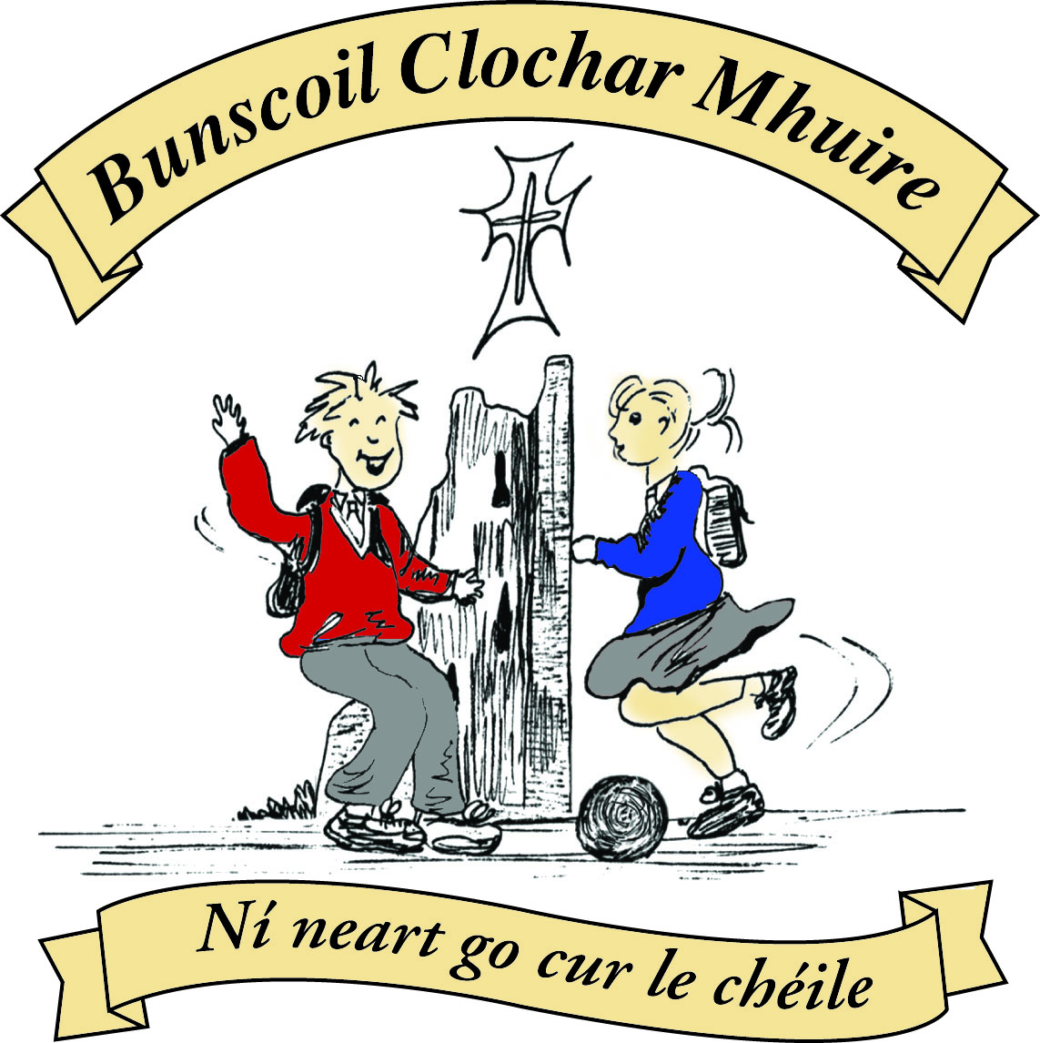* St Mary’s Convent Primary School**

***Bunscoil Clochar Mhuire***

***Trim, Co. Meath.  
Fón: (046) 9431919 ⦁ Faics: (046) 9437942  
Ríomhphost:*** [***marystrim@eircom.net***](mailto:marystrim@eircom.net) ***⦁ Website:*** [***www.stmarystrim.ie***](http://www.stmarystrim.ie) ***Uimhir Rolla: 16646O***

Awarded Green Flag  
June ‘05/’07/11/13

***Imlitir 11***

13th November, 2017

***Every Day Counts at St Mary’s Convent Primary School***

***6th – 10th November 2017***

|  |  |  |  |  |  |  |  |
| --- | --- | --- | --- | --- | --- | --- | --- |
| **Room** | **Attendance** | **Room** | **Attendance** | **Room** | **Attendance** | **Room** | **Attendance** |
| 01 | 92.4 % | 08 | 94.8% | 16 | 91.4% | 26 | 92.6% |
| 02 | 94.5% | 09 | 97.7% | 17 | 93.3% | 27 | 96.9% |
| 03 | 96.6% | 10 | 96.8% | 18 | 96.4% | 30 | 97.6% |
| 04 | 97.9% | 12 | 98.4% | 19 | 95.6% | 31 | 96% |
| 05 | 94.4% | **13** | **100%** | 20 | 97.7% |  |  |
| 06 | 97.6% | 14 | 98.6% | 23 & 24 | 98.5% |  |  |
| 07 | 91.7% | 15 | 93.8% |  |  |  |  |

*Well done to room 13 on having full attendance last week of school. Their teacher will let them know their reward. Please note that notification in writing, with the reason for all absences, to the teacher is required. A letter or note in the homework journal will suffice.*

A chairde,

**Parent Teacher Meetings** take place on Tuesday 21st and Wednesday 22nd from 3.00-5.30 each day. School finishes at 2.45 on both those days. You should by now have received your appointment. Please contact the school if you have not. Parents/guardians of Junior Infants, please note that your Parent Teacher meetings will not be at this time, but in February. You will get more details closer to the time. Parents/guardians of Special Ed and EAL are asked to contact the school if you have not received a Special Ed or EAL time.

Please note that **smoking** is not permitted anywhere on school grounds. Your co-operation is earnestly requested.

**Readalong:** Don’t forget to fill in the cards with the books and pages read. November is our Reading Month-see <http://www.reading.ie/content/tips-parents>

**Croke Park Hours:** The School has a total of 36 hours to work this year. To date we have worked a total of 18 hours on school planning, professional development and staff meetings. Our next Staff Meeting (after school) will be on Wednesday 15th November 3.00 – 4.30pm.

***Gaelbhratach:*** We are asking parents to come on board by encouraging your children to speak more Irish at home-even if it is only “*Más é do thoil é*” (please) and “*Go raibh maith agat*” (thanks). Have a look at <http://www.isfeidirliom.ie/> for some more assistance. *Go raibh maith agat*!

**Attendance:** in line with a directive from NEWB-the National Educational Welfare Board (<http://www.newb.ie/>) we are reminding parents/guardians of the importance of their child attending school and asking you not to arrange holidays during school term. We are required to inform NEWB if there has been a number of absences stating the reasons. When this happens, parents/guardians will be informed and invited to a meeting on the matter, with the school. We are also encouraging improved attendance. Pupils who arrive late are asked to come in to school through the front door rather that outside classroom doors and to sign The Late Book at reception. Congratulations to Rooms 10 and 18 who had the best class attendance for September and October.

Our annual **Christmas Pageant** will be performed this year by Third and Fourth Classes. The date has not been decided yet. All donations will be given to the local charities. Some, but not all, other classes will also be having **Nativity Plays** in their classrooms and donations will be accepted there for same. Further details of the Nativity Plays will be issued by the relevant class teachers in due course.

***Food Dudes***

*Food Dudes will be starting on Nov. 15th for the junior classes i.e. Junior Infants – Second Class. For 16 days the children will be given a variety of fruit and vegetables to taste.*

*Food Dudes will commence on Nov. 27th for the senior classes i.e. Third – Sixth Class. They will be given fruit and vegetables to taste for 8 days. The senior classes complete a shorter programme as they have participated in the full Food Dude programme previously. This is a very good programme that encourages children to eat fruit and vegetables. It is based on positive role models, repeated tasting and rewards. As the children will be given extra food to eat at lunch time less lunch, especially fruit, will be required.*

*Sinéad Minogue*

***Confirmation Meeting and Commitment Mass****: A meeting for all Confirmation candidates and their parents/guardians will take place in St Patrick's Church (Trim) on Wednesday, November 22nd at 7.30pm. Completed application forms will be collected at the meeting and forwarded to Bishop Michael Smith. A Commitment Mass for Confirmation candidates attending St Mary's Primary School will take place in the church on Sunday, December 3rd at 11am.    Ms Lynch and Mr Galligan*

***Shoe Box Appeal*** *A huge THANK YOU to all the children and families who took part in this year’s Christmas Shoebox Appeal. We collected 300 shoeboxes from children in St Mary's and they will make 300 children very happy this Christmas. Thank you to all my little helper elves who helped to pack up the van today with all of our shoeboxes. Thank you for sharing your Christmas with children who have very little.*

*Ms Dalton*



***Banna Ceoil****: Tuesdays 3 - 4 pm for all 2nd  - 6th classes*

***Badminton for 5th and 6th Classes every Monday 3-4pm (commencing Monday 13th November)***

***Mr. Galligan and Ms. D. Walsh***

**Enrolment Forms** for September 2018 are now available from Helen in the office. Offers of places will be posted in early February.

Mise le meas,



Cóilín Ó Coigligh, Príomh Oide.

**Green News**

**Community News**

***Nathanna na Seachtaine:*** *Cuir ort do chóta*

***Seanfhocal na Míosa:*** *Ní neart go cur le chéile (Strength in togetherness)*

**Dates to Remember**

**Meitheal:** Every Tuesday morning 9.30-10.30.

**Rounders:**  **Finished until Mar 2018**

**Badminton:** Mondays 3-4pm for 5th & 6th Classes

**Drama Club:** Every Thursday 3-4pm 4th – 6th Class

**Banna: Tuesday 3 – 4pm 2nd – 6th Class**

**Communion: Saturday 5th May @ 11.00**

**Confirmation: Saturday 10th Feb @ 11.00**

**Green News**

The weather has taken a sharp dip and we are experiencing cooler temperatures. Remember to wrap up warmly and wear coats. ‘Cuir ort do chóta’, our nath na seachtaine tells us this week! Keep doors closed and conserve heat.

Despite the cooler conditions, WOW continues every Wednesday. Meet up at Mornington House or at the Matchbox at 9 am. The teachers will escort the pupils to the school from there. Cycling (COW) will resume in the spring.

Recycling continues at school. We accept batteries, ink cartridges, mobile phones, card, toilet rolls, cans, footwear and postage stamps. Many charities benefit from our recycling and it is a great habit to cultivate in our pupils**.**

Our Siopa Glas will be held at the end of this month, the proceeds from which will go towards funding the school bus for the Flamboyant Special needs school in Zambia. Sr Andrea spoke passionately when she visited our school last year, about the difference the bus has made to the little African children with Special needs, who had no chance of an education until it was provided. If there are any toys or books you are finished with, please keep our Siopa Glas in mind. Remember ‘your junk may be someone else’s treasure!’ The pupils and familiies of St Mary’s have always been so generous when it comes to helping the less fortunate. The Mercy ethos is alive and well. This was evidenced this week from the response to the Showbox Appeal which was supported so well.

Next week we are having a series of Energy workshops in the school. Aidan Gray, of An Taisce will facilitiate and will touch on types of energy sources, transfer of energy, storage of energy in addition to carrying out some exciting and entertaining experiments. We are all looking forwards to this!

***Remember Green is cool, at home, at school and around the globe!***

St Mary’s Parents Association

Thank you again to all who participate dint he Halloween buns sale. A total of 1,080euro was raised for the school. Details of where this money will go will be posted in the future

Dates for Your Diary:

**November 13th:** Christmas card order form being sent to printers.

**November 21st/22nd**: Parent teacher meetings.

**November 21st**: Parents Association meeting at 7.30pm in the Staffroom. All Parents/Guardians and friends of the school welcome to attend.

**December 6th**: A Classical Evening in St Patrick’s Cathedral featuring 6th class student Amy Rigney and St Mary’s Choir along with a host of amazing talent.

<https://www.facebook.com/stmarysparentsassoc/>

Many thanks for your continued support.

Caroline Smith

Secretary

**Community Notices**

**ZUMBA**: -   Monday / Wednesday 8pm Trim GAA   -  €8 per class,  suitable for all fitness levels,  no booking/experience required.  Contact : Lorraine 086 8693546

**ZUMBA KIDS**:-   NOVEMBER TERM NOW BOOKING -  Ages  4-8 Thursdays  2.15pm - 3.00pm,  St. Patrick's Hall Starting 9th November for 4 weeks,  €20 per child.  Contact :  Lorraine 086 8693546 / Jo  086 3381159

**Homework Club** in St Mary’s for children from 1st – 6th Classes. Application Forms are available from Ms Conaty Room 11 or Ms Lynch Room 31.

**AFTER SCHOOL CLUB** Taking place in St. Mary's School Trim from 2-3pm Mon - Friday in room 5 starting on the 18th September Only €6 a day or €25 for 5 days Mon-Fri Application forms available from reception. Booking required a week in advance of start date to insure space, and rebooking and payment made the previous Thursday each week after. Kids will be provided a small snack and entertained with Lego, Art & Craft, Board games, quizzes, card games, puzzles and lots more fun activities! Run by an experienced Childcare Professional Parent who is fully Garda Vetted and Insured. Contact Julie O'Donohue to book your child's space by texting 0868505310, emailing [juliekerins@hotmail.com](mailto:juliekerins@hotmail.com) or via a PM on the Facebookpage:[www.facebook.com/TrimAfterSchoolClub](http://www.facebook.com/TrimAfterSchoolClub)  
  
**Jiggle 'n' Jump** Music & Movement classes for little ones (8mths-4yrs) running upstairs in Trim GAA on Tuesdays 9.45-10.45am €7 a class or 4 class card for €25 Only €5 during September and all money raised on Tuesday 5th September is going to Crumlin Children's Hospital via Jack O'Donohue's A Bit of a Walk Fundraiser.   
  
Also available for Kids Party Entertainment! Various characters and themes with fun games, dancing, face painting and prizes! Clown, Pirate, a number of different Princesses, 80's Disco Diva, sporty Diva and Super Heroes available. Birthdays, Weddings, Christenings or family fun events.......in your home or in a venue, packages to suit any needs or budget. Contact Julie on 0868505310 or on Facebook [www.facebook.com/jigglenjump](http://www.facebook.com/jigglenjump)

 