***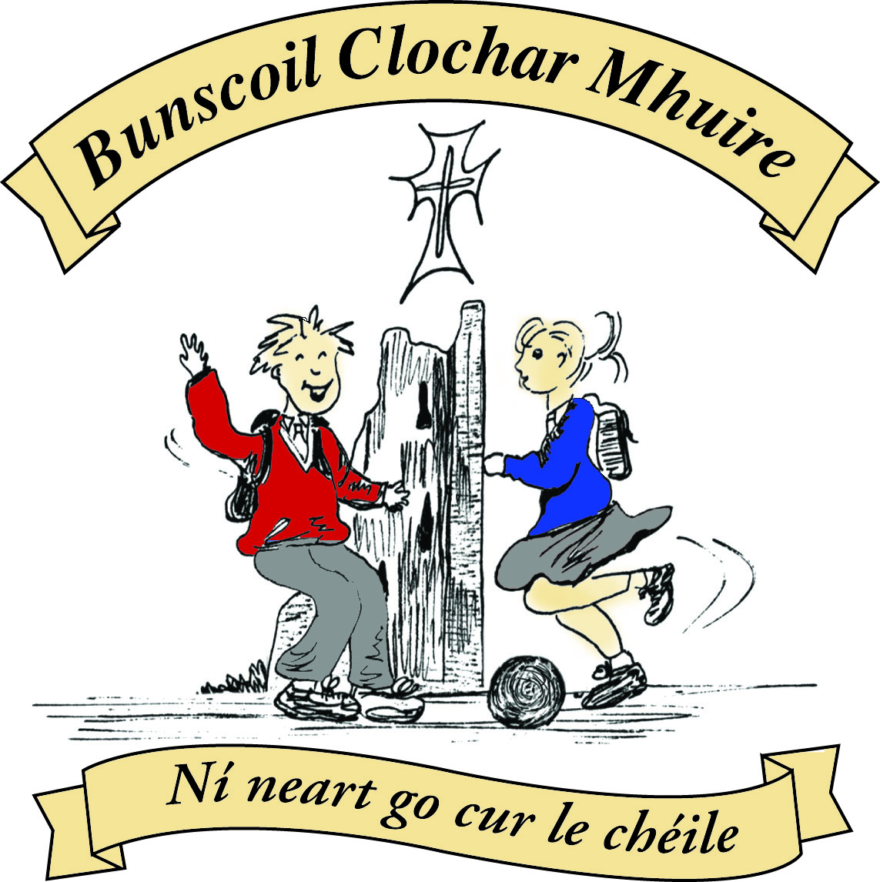* St Mary’s Convent Primary School**

***Bunscoil Clochar Mhuire***

***Trim, Co. Meath.  
Fón: (046) 9431919 ⦁ Faics: (046) 9437942  
Ríomhphost:*** [***marystrim@eircom.net***](mailto:marystrim@eircom.net) ***⦁ Website:*** [***www.stmarystrim.ie***](http://www.stmarystrim.ie) ***Uimhir Rolla: 16646O***

Awarded Green Flag  
June ‘05/’07/11/13

***Imlitir 10***

7th November, 2016

***Every Day Counts at St Mary’s Convent Primary School***

***24th October - 28th October 2016***

|  |  |  |  |  |  |  |  |
| --- | --- | --- | --- | --- | --- | --- | --- |
| **Room** | **Attendance** | **Room** | **Attendance** | **Room** | **Attendance** | **Room** | **Attendance** |
|  |  |  |  |  |  |  |  |
| 01 | 97.8 % | 08 | 97.5% | 16 | 96.3% | 26 | 93.6% |
| 02 | 83.8% | 09 | 96.8% | 17 | 93.8 % | 27 | 99.2% |
| 03 | 91.3% | 10 | **100%** | 18 | 94.2% | 30 | 99.2% |
| 04 | 87.4% | 12 | 95.2% | 19 | 95.6% | 31 | 97.9% |
| 05 | 91.5% | 13 | 97.3% | 20 | 98.6% |  |  |
| 06 | 94.4% | 14 | 95% | 23 & 24 | 91.4% |  |  |
| 07 | 97.6% | 15 | 95.7% |  |  |  |  |

*Congratulations to Room 10 on having full attendance last week of school and to rooms 27 & 30 who almost made it. Please note that notification in writing to the teacher is required for all absences. A letter or note in the homework journal will suffice*.

A chairde,

**Parent/Teacher Meetings**

As mentioned in our most recent Imlitir and our Calendar, Parent-Teacher Meetings will take place on Wednesdays November 23rd and 30th, from 3.00 to 5.30 pm. School will finish at 2.45 on both these days. We hope to facilitate siblings and Special Ed with times close to each other and on the same dates. These meetings are of benefit to your child, yourself and the school. Please make every effort to attend. You are asked to switch off your mobile phone for the duration of all meetings.

**Reading Month/Readalong**

This month is Reading Month and we hope that all pupils will make a special effort to read more. The Readalong cards were given out before the break. Please enter the books read on the card and encourage your children to read as many books as possible, this month. Please return cards by the end of the month. If cards have been mislaid, spares can be got from our school secretaries Helen or Rebecca.

## Book Fair

St Mary’s School annual Book Fair will take place on **Tuesday 8th** and **Wednesday 9th of November** in the school hall. The school runs the Book Fair, in conjunction with Antonia’s Bookstore, our local book shop. Antonia donates 20% of her book sales back to the school in the form of books and resources. We greatly appreciate your support and, as November is our Reading month, the Book Fair is a great opportunity to encourage reading at home and at school.

The average price per book at the Book Fair is €8 approx. but there will also be a limited number of books on special offer, at a lower price. **Parents/guardians of children in Junior Infants and Senior Infants** need to collect their children from their classes, at their allocated times and bring them to the Book Fair, if they wish them to attend.



**Book Fair Timetable**

**Tuesday, 8th & Wednesday, 9th November**

**2016**

|  |  |  |
| --- | --- | --- |
| TIME | TUESDAYNOVEMBER 8th | WEDNESDAYNOVEMBER 9th |
| **9.30-10.00** | Rooms 23, 24 &12-Lang. & First | Room 10-First Class |
| **10.00-10.30** | **Room 31- Sixth Class** | **Room 30-Sixth Class** |
| **10.30-11.00** | **Room 18- Third Class** | **Room 16-Third Class** |
| **11.15-11-45** | **Room 20-Fourth Class** | **Rooms 26 &27-Fifth Class** |
| **11.45-12.15** | **Room 15-Second Class** | **Room 14-Second Class** |
| **1.00-1.30** | **Room 13-First Class** | **Room 19-Fourth Class** |
| **1.30- 2.30** | **Rooms 1, 2, 3 & 4 (with their parents) Junior Infants** | **Rooms 5, 6, 7 & 8 (with their parents) Senior Infants** |
| **2.30-3.00** | **Room 9-First Class** | **Pupils with money from any classes** |
| **3.00-4.00** | *Open to the public* | *Open to the public* |

***Banna Ceoil :*** *There will be****no Banna Ceoil on Tuesday 8th November****due to the Book Fair being held in the hall. From Tuesday 15th Nov.* ***all*** *classes 2nd - 6th finish @ 4pm.*

*Mrs McGale*

*‘Eternal rest grant unto them............’*

*November is the month when we remember our family and friends who have gone before us. One of the most beautiful ways to remember them is to offer Mass for them. In our parish, during November and on the first Friday of every month, Mass is offered for all those whose names are submitted. If you would like to have anyone remembered at these Masses, please write their names on the sheet and place in the accompanying envelope which you will find inside the entrances of the church. The completed forms may be dropped into the Parochial House or the Parish Centre.*

*Fr. Declan*

Congratulations to Ayesha Ednan Rm 16 and Tessa Fennell Rm20 who got Highly Commended in the recent Credit Union Art completion in the Age 8-10 category. The theme was “Dreams are made of this”. Well done again girls.

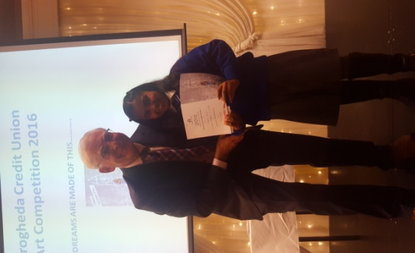

Please note that the school does not provide a facility for parents/guardians to phone their children while they are in their class. If something urgent comes up, please contact me directly.

May I again remind parents/guardians that appointments are required in order to speak to teachers. It is not fair to the other pupils to delay teachers collecting their classes or to interrupt a class that is in progress. Appointments are welcome outside of class contact time and may be arranged through Helen/Rebecca in the office or by note directly to the teacher. Thanks.

**Enrolment Forms** for September 2017 are now available from Helen/Rebecca in the office.

**Book Grant/Book Rental**

At this stage of the year, all Rental and Grant books should be covered. Please remind all pupils not to make any markings (even in pencil) as we need to use these books again next year.

**Parking:** Please do not park in any way that obstructs either entrance to our school and be observant while reversing. The safety of all our children is paramount and vigilance is always required.

Finally, our plan to separate Junior Infants, Senior Infants and First Classes from the rest of the school in the yard to enable safer play times, is still in place. Our plan is to put a line in the yard to designate two separate play areas. I am having difficulty getting a company to put down the line. I will let you know as soon as I get a day, so that you can discuss it with your child/ren if necessary.

**Community Notices**

**Green News**

Mise le meas,



Cóilín Ó Coigligh, Príomh Oide.

**Green News**

**Community News**

**Nath na Seachtaine**: **Is cuimhin liom... I remember...**

**Seanfhocal na Míosa: Nuair a bhíonn an cat amuigh, bíonn na lucha ag rince**

**When the cat’s away, the mice will play.**

**Dates to Remember**

**Assembly:** Attendance Assembly @ 9.20 Friday

All welcome

**Banna Ceoil:** **No Banna on 8th November**

**From 15th Nov all classes will finish @ 4.00pm**

**Meitheal:** Every Tuesday morning 9.30-10.30.

**Camogie:** Finished until next year

**Rounders:** Finished until next year

**Drama Group:**  Thursday 15th – Oct 27th for 6th Class

**Communion:**  Sat May 13th @ 11.00

**Confirmation:**  Sat 11th March

**Green News**

Winter is certainly creeping up! Nature will be taking a rest. There are some beautiful colours still visible. Hopefully with the dry weather, people are getting out for walks and appreciating the splendour of Trim in the fading autumn.

Our COW campaign has concluded for 2016. Once again we extend our thanks to the teachers, pupils and parents who made the initiative possible. Our final outing was a beautiful October morning and we were greeted by many of the community as we cycled down and back from school that day. How lucky we are to have a beautiful route in Trim!

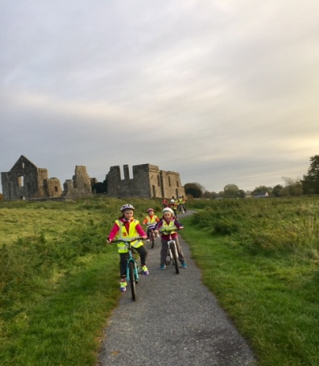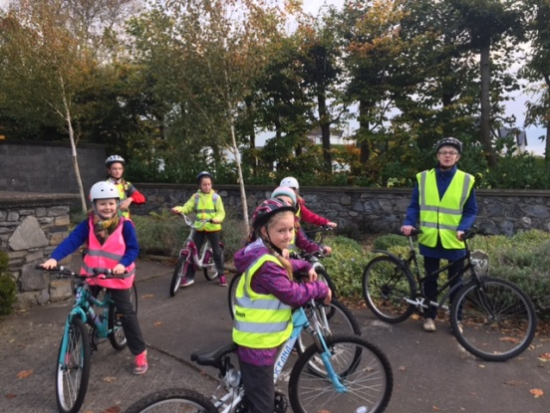

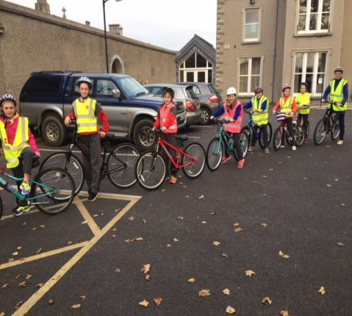

The WOW teachers and pupils will continue walking throughout the year. No hibernating for them! If you would like to join either of these groups, you may meet up at either the Matchbox on Emmet Street or Mornington House at 9:00 am. It is only a short walk but it helps in a small way and reduces the congestion up around the school car park. Thank you to the teachers, pupils and families who walk regularly.

Recycling continues in St Mary’s. We recycle small plastic bottles, cans, batteries, ink cartridges, cards, toilet rolls and postage stamps. We will be having a Siopa Glas towards the end of November. Please start gathering any items that you might be willing to donate. The proceeds of our Siopa Glas will be divided between a local charity and Sr Claudia’s Special Needs school in Zambia. Sr Claudia has recently returned from there and will talk to our Green committee and some classes about how our funds have helped their school in the past. It is great to have a direct contact with such a worthy cause.

The week before the mid-term break Rang a Sé planted yellow crocuses as part of the Holocaust Crocus Project to remember the half-million Jewish children and thousands of other children who died at that time. The bulbs are planted in a star shape which reminds us of the Star of David which all Jews were forced to wear under Nazi rule. In the spring hopefully we will have a lovely yellow bloom which will remind us that even after the most terrible events, new life begins again and we can hope that things will be better than before. The flowers remind us that there is still beauty in the world and hope for our future.

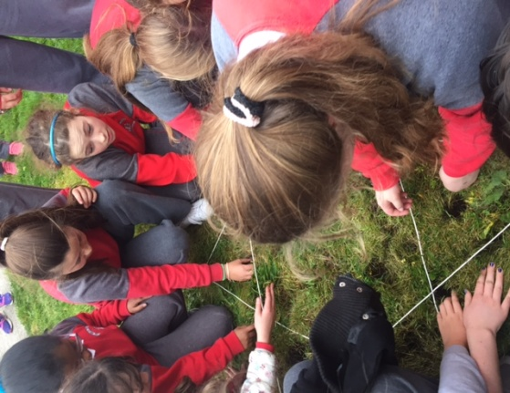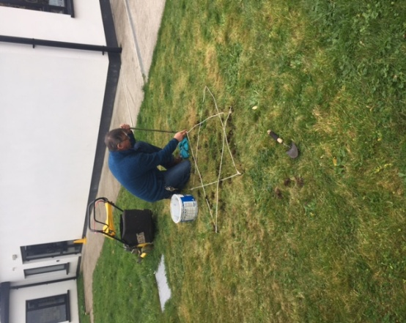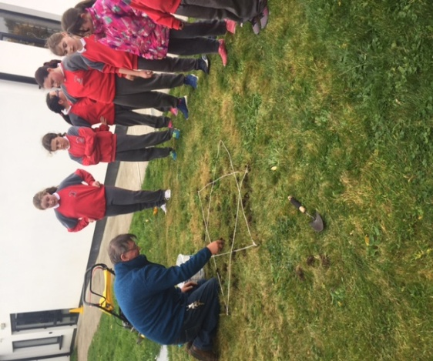

Our Global Citizenship litter and waste theme is in full swing here at St Marys. We have identified 22 different nationalities represented in our school. How exciting is that! We have a number of different projects planned with the different classes which we will keep you informed of.

***Remember green is cool at home, at school and around the globe!***

**Community Notices**

Team Hope are operating their Shoe Box appeal again this year. If you would like to participate, there is a local drop off centre in Trim. It is the Lighthouse Church building (the old FBD premises) which is beside the Stile shop. The final day for donations is November 11. The church cafe is open Tuesday, Wednesday and Thursday from 10 am – 2pm The idea is that people here would send a shoebox full of small gifts to children in need in poorer places of the world. The Team Hope no. is 01-2940222 or the website is [www.teamhope.ie](http://www.teamhope.ie) if you would like more information about what can be included etc. Míle buíochas.

**Little Robins Childcare Robinstown.** Opening Jan 2017 and Enrolling Now. Pre School, After School and Breakfast Club. Contact Orla Reilly on 087-9472570 or email [LittleRobinsRobinstown@gmail.com](mailto:LittleRobinsRobinstown@gmail.com)

**ZUMBA**  :-    MONDAY  &  WEDNESDAY  8pm  TRIM GAA.  No booking, partner or experience required......just grab your water and your smile and get ready to dance your cares away!   €8 per class   Contact  :  Lorraine  086 8693546

**ZUMBA KIDS** :- TUESDAY   3.15pm  Trim GAA    No booking required,  €6 per class      Contact : Lorraine  086 8693546

**AFTER SCHOOL CLUB** Takes place in St. Mary's School Trim from 2-3pm Only €5 a day or €20 for 5 days Mon-Fri Places are limited and need to be booked by the previous Thursday. Kids will be entertained with Lego, Play Doh, Art, Singing, Board games, quizzes, card games, puzzles and lots more fun activities.  Run by two experienced Childcare Professional Parents who are Garda Vetted.  Contact Julie O'Donohue to book your child's space by texting 0868505310, emailing [juliekerins@hotmail.com](mailto:juliekerins@hotmail.com) or via a PM on our Facebook page: [www.facebook.com/TrimAfterSchoolClub](http://www.facebook.com/TrimAfterSchoolClub)

**Go Bounce bouncy castle hire**. Based in Trim, fully insured and safety certified. Taking bookings now for 2017. Check out our Facebook page [www.Facebook.com/gobouncemeath](http://www.facebook.com/gobouncemeath), contact us on 086-8398099 or email [enquiries@gobounce.ie](mailto:enquiries@gobounce.is)