***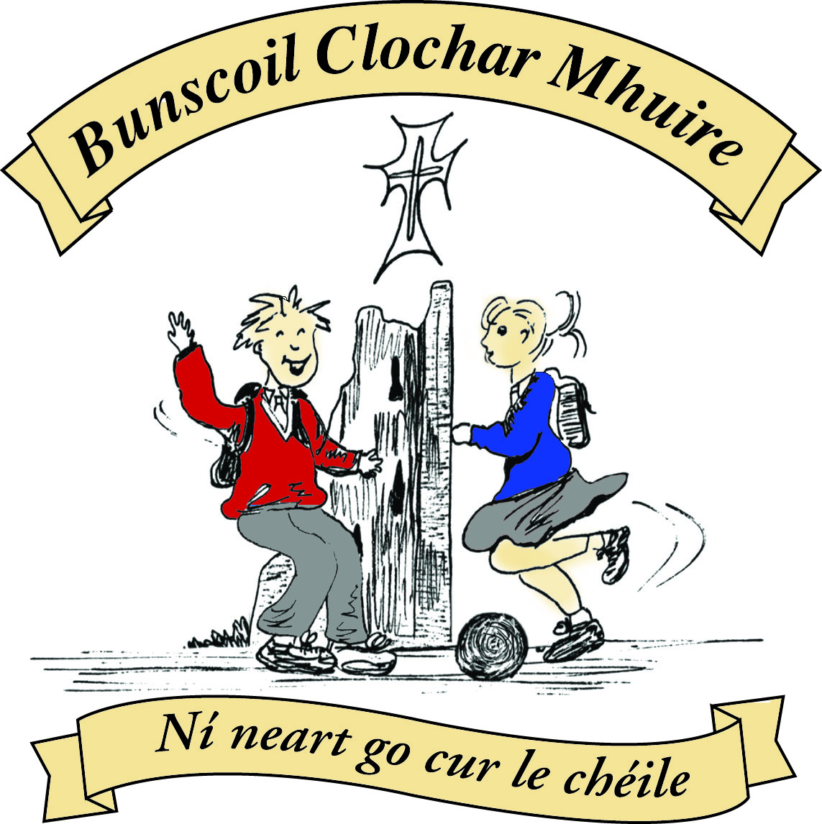* St Mary’s Convent Primary School**

***Bunscoil Clochar Mhuire***

***Trim, Co. Meath.  
Fón: (046) 9431919 ⦁ Faics: (046) 9437942  
Ríomhphost:*** [***marystrim@eircom.net***](mailto:marystrim@eircom.net) ***⦁ Website:*** [***www.stmarystrim.ie***](http://www.stmarystrim.ie) ***Uimhir Rolla: 16646O***

Awarded Green Flag  
June ‘05/’07/11/13

***Imlitir 10***

6th November, 2017

***Every Day Counts at St Mary’s Convent Primary School***

***23rd October - 27th October 2017***

|  |  |  |  |  |  |  |  |
| --- | --- | --- | --- | --- | --- | --- | --- |
| **Room** | **Attendance** | **Room** | **Attendance** | **Room** | **Attendance** | **Room** | **Attendance** |
| 01 | 97.9 % | 08 | 97% | 16 | 95% | 26 | 95.6% |
| 02 | 93.8% | 09 | 96.9% | **17** | **100%** | 27 | 96.2% |
| 03 | 96.6% | 10 | 93.1% | 18 | 93.8% | 30 | 92.8% |
| 04 | 97.1% | 12 | 99.2% | 19 | 98.5% | 31 | 99.2% |
| 05 | 94.4% | 13 | 92.5% | 20 | 94.6% |  |  |
| 06 | 91.2% | 14 | 95% | 23 & 24 | 98.6% |  |  |
| 07 | 94.2% | 15 | 95.2% |  |  |  |  |

*Well done to room 17 on having full attendance last week of school. Their teacher will let them know their reward. Please note that notification in writing, with the reason for all absences, to the teacher is required. A letter or note in the homework journal will suffice.*

A chairde,

**Parent/Teacher Meetings**

Parent-Teacher Meetings will take place on Tuesday November 21st and Wednesdays November 22nd from 3.00 to 5.30 pm. School will finish at 2.45 on both these days. We hope you all have managed to book your meeting times online. If not please contact class teacher immediately and we will assist you. These meetings are of benefit to your child, yourself and the school. Please make every effort to attend. You are asked to switch off your mobile phone for the duration of all meetings.

**Measles**

Due to a recent case in St Michael’s, who had a sibling in our school, the vaccinations have been brought forward to this Wednesday November 8th and Friday November 10th.We have had to change the Book Fair to Thursday to facilitate this-see below.

**Mobile phones**

Mobile phones are not be used during school hours and are to be turned off on entering the school grounds. If a phone is switched on, it will be confiscated and returned in person to parents/guardians.

**“If it’s out, it’s on. If it’s on it’s gone!”**

The use of phones to take photographs or videos is strictly forbidden and will incur penalties up to and including suspension.

**Reading Month/Readalong**

This month is Reading Month and we hope that all pupils will make a special effort to read more. The Readalong cards were given out today. Please enter the books read on the card and encourage your children to read as many books as possible, this month. Please return cards by the end of the month. If cards have been mislaid, spares can be got from our school secretaries Helen or Rebecca.

***Computers***

*1st class are working on the story that was started before the holidays. They were given homework to finish the story and once this is done they will have it printed and will then decorate it. During this lesson they have learnt how to change their font, font size, use the Bold and Underline buttons and to centre a heading.*

*2nd to 6th class will be typing up stories about Halloween and will be doing some research on how Halloween came about.*  *Ms Debby*

***Badminton for 5th and 6th Classes every Monday 3-4pm (commencing Monday 13th November)***

***Mr. Galligan and Ms. D. Walsh***

***Banna Ceoil*** *: There will be****no Banna Ceoil on Tuesday 7th November****due to the Book Fair being held in the hall. All classes will finish on Tuesday 14th Nov. @ 4pm.  Tuesday 21st there will be no Banna as the Parent Teacher meetings will be taking place. Mrs McGale*

## Book Fair

St Mary’s School annual Book Fair will now take place on **Tuesday 7th** and **Thursday 9th of November** in the school hall. The school runs the Book Fair, in conjunction with Antonia’s Bookstore, our local book shop. Antonia donates 20% of her book sales back to the school in the form of books and resources. We greatly appreciate your support and, as November is our Reading month, the Book Fair is a great opportunity to encourage reading at home and at school.

The average price per book at the Book Fair is €8 approx. but there will also be a limited number of books on special offer, at a lower price. **Parents/guardians of children in Junior Infants and Senior Infants** need to collect their children from their classes, at their allocated times and bring them to the Book Fair, if they wish them to attend.



**Book Fair Timetable**

**Tuesday, 7th & Thursday, 9th November**

**2017**

|  |  |  |
| --- | --- | --- |
| TIME | TUESDAY NOVEMBER 7th | THURSDAY NOVEMBER 9th |
| **9.30-10.00** | Rooms 23, 24 & 27 L.U. & 5th | Room 19 4th Class |
| **10.00-10.30** | **Room 31 6th Class** | **Room 26 5th Class** |
| **10.30-11.00** | **Room 18 3rd Class** | **Room 16 3rd Class** |
| **11.15-11-45** | **Room 20 4th Class** | **Room 12 1st Class** |
| **11.45-12.15** | **Room 14 2nd Class** | **Room 15 2nd Class** |
| **1.00-1.30** | **Room 13 1st Class** | **Room 30 6th Class** |
| **1.30- 2.30** | **Rooms 1, 2, 3 & 4**  **Junior Infants**  **(with their parents)** | **Rooms 5, 6, 7 & 8**  **Senior Infants**  **(with their parents)** |
| **2.30-3.00** | **Rooms 9 & 10 1st Classes** | **Pupils with money from any classes** |
| **3.00-4.00** | *Open to the public* | *Open to the public* |

***Christmas Shoebox Appeal***

*Thank you to all of the children and families who have already brought in shoeboxes for the Christmas Shoebox Appeal. These gifts will bring great happiness to little boys and girls around the world this Christmas.*

***The closing date for dropping off shoeboxes to school will be the 9th of November.*** *The shoebox appeal is based on children/families filling a shoebox with* ***4 W's****- something to* ***W****ear(hat, scarf, hairbands etc) something to* ***W****rite with (crayons, pencils, notebooks etc) something to* ***W****ash with(toothbrush, facecloth etc) and something to* ***W****OW (teddy, small toy, sunglasses etc). The appeal also asks for a small donation to cover the transport cost of the gifts. It is a lovely way for children in our school to share with less fortunate children in another country. As previously, it is optional for the children of St Mary’s to get involved with the Shoebox Appeal. Families or friends can pool together gifts to fill one box if they prefer. Míle buíochas for always being so generous with these appeals for very worthy causes.* ***Good things come in small parcels and there are few parcels shared that are as small as a shoebox.***

***Ms Dalton***

***Health Promoting Schools***

*We are happy to announce that the Food Dude programme will be starting in November. Parents/ guardians will be given information shortly on the programme and the role they have to play. This is a very worthwhile healthy eating programme which gives children the chance to try lots of new fruit and vegetables.*

*Please remember our Healthy Eating Policy which states that children are not allowed to bring* ***crisps, chewing gum, sweets, bars including cereal bars, cakes, biscuits, lollipops, chocolate, chocolate spread, winders, rice crispie buns and especially peanuts, to school.***

*Sinéad Minogue*

*HPS coordinator*

Please note that the school does not provide a facility for parents/guardians to phone their children while they are in their class. If something urgent comes up, please contact me directly.

May I again remind parents/guardians that appointments are required in order to speak to teachers. It is not fair to the other pupils to delay teachers collecting their classes or to interrupt a class that is in progress. Appointments are welcome outside of class contact time and may be arranged through Helen/Rebecca in the office or by note directly to the teacher. Thanks.

**Enrolment Forms** for September 2018 are now available from Helen/Rebecca in the office.

**Book Grant/Book Rental**

At this stage of the year, all Rental and Grant books should be covered. Please remind all pupils not to make any markings (even in pencil) as we need to use these books again next year.

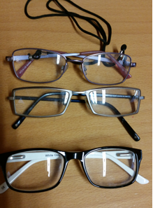

**Lost and Found**

We have 3 pair of glasses in Lost & Found, if your child is missing them please collect them from the office.

**Parking:** Please do not park in any way that obstructs either entrance to our school and be observant while reversing. The safety of all our children is paramount and vigilance is always required.

Mise le meas,



Cóilín Ó Coigligh, Príomh Oide.

**Green News**

**Community News**

***Nathanna na Seachtaine:*** *Bain díot do chóta (Take off your coat)*

***Seanfhocal na Míosa:*** *Ní neart go cur le chéile (Strength in togetherness)*

**Dates to Remember**

**Meitheal:** Every Tuesday morning 9.30-10.30.

**Rounders:**  **Finished until Mar 2018**

**Drama Club:** Every Thursday 3-4pm 4th – 6th Class

**Banna: NO BANNA PRACTICE THIS WEEK**

**Communion: Saturday 5th May @ 11.00**

**Confirmation: Saturday 10th Feb @ 11.00**

**Green News**

We hear today from the UN conference on Climate Change that ‘time to tackle climate change is running out’. The UN is hoping the meeting will deliver a plan towards the next stage of reducing global greenhouse gas emissions.

Climate change is now widely acknowledged as the biggest challenge facing our global environment and human species today.

(See [www.greenschoolsireland.org](http://www.greenschoolsireland.org) for a full description of Climate change and its impacts.

Here at St Mary’s, we will continue to do our bit and hopefully our local efforts will resound globally.

Recycling continues at school. We accept batteries, ink cartridges, mobile phones, card, toilet rolls, cans, footwear and postage stamps. Many charities benefit from our recycling and it is a great habit to cultivate in our pupils**.**

Our Siopa Glas will be held this month, the proceeds from which will go towards funding the school bus for the Flamboyant Special needs school in Zambia. Sr Andrea spoke passionately when she visited our school last year, about the difference the bus has made to the little African children with Special needs, who had no chance of an education until it was provided. If there are any toys or books you are finished with, please keep our Siopa Glas in mind. Remember ‘your junk may be someone else’s treasure!’

WOW continues every Wednesday. Meet up at Mornington House or at the Matchbox at 9 am. The teachers will escort the pupils to the school from there. Cycling (COW) will resume in the spring.

***Remember Green is cool (and necessary) at home, at school and around the globe***

St Mary’s Parents’ Association

Welcome back to all. We hope you all had a lovely mid-term and had great fun trick or treating. Well done to all who participated in the dress up for our annual Halloween Bun Sale! We all had a great day and we hope your little ones enjoyed it too. We hope to have the total amount raised published in next week’s Imlitir. Keep an eye out on our Facebook page too!

Dates for Your Diary:

**Early November:** We hope to receive the sample Christmas Cards soon and then we will give each child their card to bring home along with order form.

**Thursday 9th of November**: Last day for sending in Shoe Boxes for the Shoe Box appeal.

**November 21st/22nd**: Parent teacher meetings.

**November 21st**: Parents Association meeting at 7.30pm in the Staffroom. All Parents/Guardians and friends of the school welcome to attend.

**December 6th**: A Classical Evening in St Patrick’s Cathedral featuring 6th class student Amy Rigney and St Mary’s Choir along with a host of amazing talent.

<https://www.facebook.com/stmarysparentsassoc/>

Many thanks for your continued support.

Caroline Smith

Secretary

**Community Notices**

**ZUMBA**: -   Monday / Wednesday 8pm Trim GAA   -  €8 per class,  suitable for all fitness levels,  no booking/experience required.  Contact : Lorraine 086 8693546

**ZUMBA KIDS**:-   NOVEMBER TERM NOW BOOKING -  Ages  4-8 Thursdays  2.15pm - 3.00pm,  St. Patrick's Hall Starting 9th November for 4 weeks,  €20 per child.  Contact :  Lorraine 086 8693546 / Jo  086 3381159

**Homework Club** in St Mary’s for children from 1st – 6th Classes. Application Forms are available from Ms Conaty Room 11 or Ms Lynch Room 31.

**AFTER SCHOOL CLUB** Taking place in St. Mary's School Trim from 2-3pm Mon - Friday in room 5 starting on the 18th September Only €6 a day or €25 for 5 days Mon-Fri Application forms available from reception. Booking required a week in advance of start date to insure space, and rebooking and payment made the previous Thursday each week after. Kids will be provided a small snack and entertained with Lego, Art & Craft, Board games, quizzes, card games, puzzles and lots more fun activities! Run by an experienced Childcare Professional Parent who is fully Garda Vetted and Insured. Contact Julie O'Donohue to book your child's space by texting 0868505310, emailing [juliekerins@hotmail.com](mailto:juliekerins@hotmail.com) or via a PM on the Facebookpage:[www.facebook.com/TrimAfterSchoolClub](http://www.facebook.com/TrimAfterSchoolClub)  
  
**Jiggle 'n' Jump** Music & Movement classes for little ones (8mths-4yrs) running upstairs in Trim GAA on Tuesdays 9.45-10.45am €7 a class or 4 class card for €25 Only €5 during September and all money raised on Tuesday 5th September is going to Crumlin Children's Hospital via Jack O'Donohue's A Bit of a Walk Fundraiser.   
  
Also available for Kids Party Entertainment! Various characters and themes with fun games, dancing, face painting and prizes! Clown, Pirate, a number of different Princesses, 80's Disco Diva, sporty Diva and Super Heroes available. Birthdays, Weddings, Christenings or family fun events.......in your home or in a venue, packages to suit any needs or budget. Contact Julie on 0868505310 or on Facebook [www.facebook.com/jigglenjump](http://www.facebook.com/jigglenjump)

